TAX INVOICE – ABN: 69 769 481 770
School code
Year 10 and Year 11 overseas full fee-paying student declaration form 2024
1. This form is to be completed by a student who is enrolled as an overseas full fee-paying student studying in a
Western Australian school.
2. The school is responsible for the submission of the student’s enrolment details to the School Curriculum and Standards Authority (the Authority) prior to the completion of this form.
3. The completed form must be returned to the Authority with payment no later than Tuesday, 14 May 2024.
4. Payment of these fees is required before the Western Australian Statement of Student Achievement (WASSA) and Western Australian Certificate of Education (WACE) can be issued by the Authority.
To be completed by student (please print clearly)
 |  |  |  |  |  |  |  |  |  |  |  |  |  | D | D | M | M | Y | Y |  | Y | Y |  |  |  | M | F | O
 | WA student number |  |  |  |  |  |  |  |  |  |  |  |  | Date of birth |  |  |  |  |  |  |  |  |  |  |  | Gender (circle)
 | Title |  |  |  |  | Legal family name
 | (Mr, Mrs, Miss, Ms)
 | First given name |  |  |  |  |  |  |  |  |  |  |  |  |  |  |  | Second given name |  |  |  |  |  |  |  |  |  |  |  |  |  |  |  | Third initial
 | Address (optional)
 |  |  |  |  |  |  |  |  |  |  |  |  |  |  |  |  |  | Postcode
 | Telephone numbers (optional)
 |  |  |  |  |  |  |  |  | Home |  |  |  |  |  |  |  |  |  |  |  |  |  | Mobile
Fees Payable
Student to note the fee payable prior to signing the declaration
- $231 (GST exempt) for Year 11 students studying WACE course units
- $59 (GST exempt) per course for Year 10 students studying WACE course units
Declaration by student
Please place a tick () in the appropriate box.
I declare that I hold a visa eligible to enrol as an overseas full fee-paying student in a Western Australian school and
☐ I have paid the appropriate fee of $231 (for Year 11) or $59 (per course for Year 10) OR
☐ I have attached payment and attached the receipt (if paid by credit card) OR
☐ the Western Australian school in which I am enrolled as an overseas full fee-paying student is responsible to pay the appropriate fee to the Authority.
 | Signature of student |  |  |  |  |  |  |  |  |  |  |  |  |  |  |  |  |  |  |  |  |  | Date
 | Signature of school representative or school stamp |  |  |  |  |  |  |  |  |  |  |  |  |  |  |  |  |  |  |  |  |  | Date
See over for payment options and lodgement methods.
PAYMENT METHODS (Note: Cash is not accepted)

CREDIT CARD (MasterCard/VISA only)
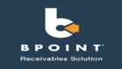
Use this link to pay by credit card: https://www.bpoint.com.au/pay/scsa.eforms/53054314513
Biller Code: 929042
Ref: Please enter your eight-digit WA student number.

Note: print and attach the receipt generated after payment has been approved.

TELEPHONE AND INTERNET BANKING
Log into your online banking portal or contact your bank or financial institution to make this payment from your cheque, savings, debit or transaction account. More info: www.bpay.com.au
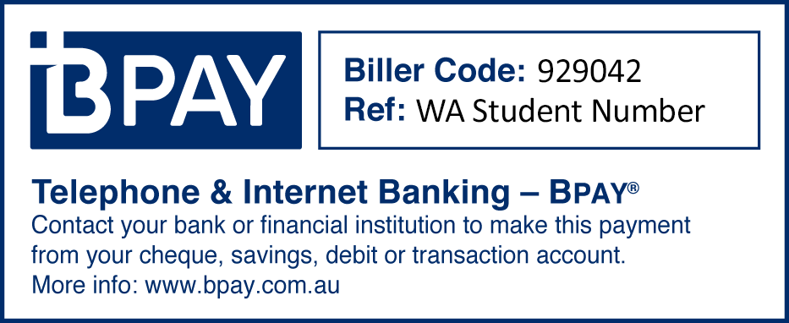
©Registered to BPAY Pty Ltd ABN 69 079 137 518
Note: a copy of the BPAY receipt must be attached to your completed application as proof of payment.

EFTPOS IN PERSON – SCHOOL CURRICULUM AND STANDARDS OFFICE
Level 2 Reception – 303 Sevenoaks Street, Cannington WA 6107
Government building opposite the Cannington Train Station. Parking on Grose Avenue. EFTPOS available.

MONEY ORDER
Personal cheques and bank drafts in foreign currency are not accepted. Money orders must be in Australian Dollars and made out to ‘School Curriculum and Standards Authority’. Available from Australia Post outlets.
LODGEMENT METHOD OPTIONS
The completed form must be returned to the Authority with payment (or confirmation of payment) no later than
Tuesday, 14 May 2024.
Mail: Attention: Programs and Data In person: Mon–Fri from 8.00 am to 4.00 pm
Department of Education School Curriculum and Standards Authority
School Curriculum and Standards Authority Level 2
PO Box 816 303 Sevenoaks Street
Cannington WA 6987 Cannington WA 6107
Email: enrolments@scsa.wa.edu.au

