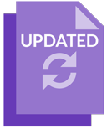

03/08/2026

Student Records Management System
School administrator’s guide for role assignment
Acknowledgement of Country
Kaya. The School Curriculum and Standards Authority (the Authority) acknowledges that our offices are on Whadjuk Noongar boodjar and that we deliver our services on the country of many traditional custodians and language groups throughout Western Australia. The Authority acknowledges the traditional custodians throughout Western Australia and their continuing connection to land, waters and community. We offer our respect to Elders past and present.
Copyright
© School Curriculum and Standards Authority, 2023
This document – apart from any third-party copyright material contained in it – may be freely copied, or communicated on an intranet, for non­commercial purposes in educational institutions, provided that the School Curriculum and Standards Authority (the Authority) is acknowledged as the copyright owner, and that the Authority’s moral rights are not infringed.
Copying or communication for any other purpose can be done only within the terms of the Copyright Act 1968 or with prior written permission of the Authority. Copying or communication of any third-party copyright material can be done only within the terms of the Copyright Act 1968 or with permission of the copyright owners.
Any content in this document that has been derived from the Australian Curriculum may be used under the terms of the Creative Commons Attribution 4.0 International licence.
School Curriculum and Standards Authority
Street address: 303 Sevenoaks Street CANNINGTON WA 6107
Postal address: PO Box 816 CANNINGTON WA 6987
Phone: (08) 9273 6300
General email: info@scsa.wa.edu.au
Web: www.scsa.wa.edu.au
Cover image adapted from: Portra. (2016). [iStock photograph ID: 515444720] Retrieved March, 2025, from https://www.istockphoto.com
Contents
The Student Records Management System 1
Setting up the school administrator role 1
Four steps for the school administrator to assign roles 1
Step 1: Log in to the SRMS portal 2
Step 2: Add a user 5
Step 3: Assign a role 8
Roles required for common activities 9
Step 4: Search for a user 10

The Student Records Management System
The School Curriculum and Standards Authority (the Authority) developed the Student Records Management System (SRMS) to meet its legislated functions for all Kindergarten to Year 12 (K–12) students and schools in Western Australia.
Activities schools can undertake in the SRMS portal include:
- viewing student data in the dashboard including registrations, offerings, enrolments and achievements that have been uploaded to the Student Information Records System (SIRS)
- completing and certifying Year 11 equivalent studies applications for their students
- endorsing Australian Tertiary Admission Rank (ATAR) English as an Additional Language or Dialect (EAL/D) eligibility declarations
- endorsing Western Australian Certificate of Education (WACE) language course enrolment applications.
The student portal provides a range of online services for students, including:
- access to their personal details, enrolments, examination timetable/s and Year 12 results
- ATAR English EAL/D eligibility declarations
- WACE language course enrolment applications.

Setting up the school administrator role
SRMS administrator roles are assigned to the principal and/or deputy principal at every school and can be assigned by SRMS administrators to other users at the school. It is advisable to assign at least two users at the school with this role, so that accounts can be managed in the event that a single administrator is absent or has left the school.
If all SRMS administrators have left your school, a new administrator account will need to be created. To create a new SRMS administrator account, the school principal must email the Authority at srms@scsa.wa.edu.au and confirm the following details for the new administrator account:
- school provider code
- email address (this must be an ‘@education’ email address for government schools, or an official work email address for non-government schools)
- given name
- family name
- TRBWA number
- HRMIS number (only required for government schools)

Four steps for the school administrator to assign roles
Step 1: Log in to the SRMS portal
Step 2: Add a user
Step 3: Assign a role
Step 4: Search for a user

Step 1: Log in to the SRMS portal
Log in to the SRMS portal (https://srms.scsa.wa.edu.au).
Government and non-government schools will see the login screen below.
Government (public) schools
The first time you log in, click on and read the login instructions (highlighted below).
Tick the check box (highlighted below) to show that you have read and understand the terms of use and privacy collection notice.
Click on the education.wa.edu.au LOGIN button (highlighted below) in the government school login panel.
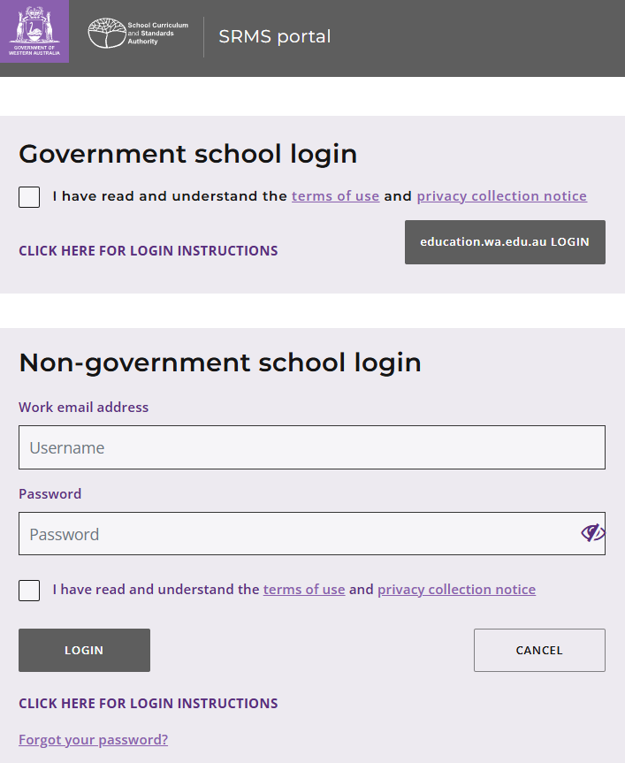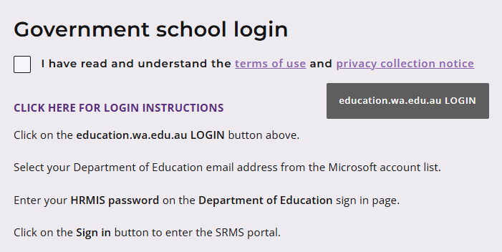
Select your Department of Education (the Department) email address from the Microsoft® account list (shown below).
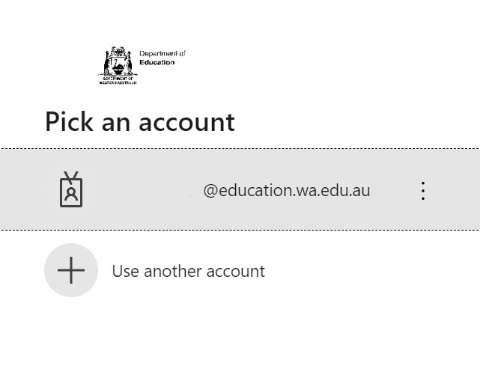
You will be taken to the Department’s sign in page (shown below).
Enter your password and click on the Sign in button (highlighted below) to enter the SRMS portal.
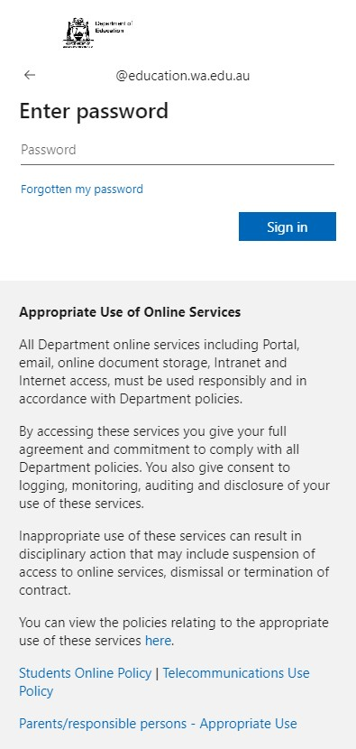

Non-government schools
The first time you log in, click on and read the login instructions (highlighted below). Contact your school administrator if you have not received the email with the link.
Enter your work email address and password in the non-government school login panel.
Tick the check box (highlighted below) to show that you have read and understand the terms of use and privacy collection notice.
Click on the Login button (highlighted below) to enter the SRMS portal. 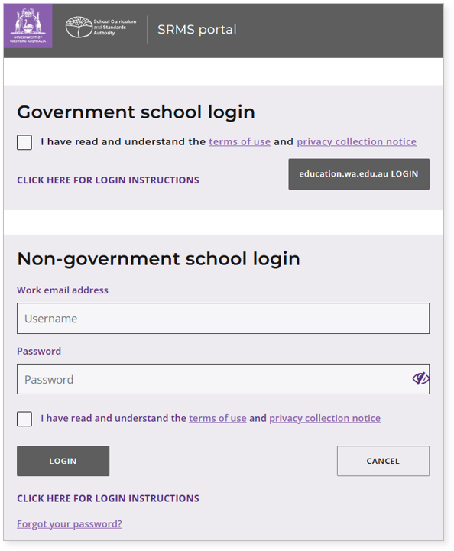 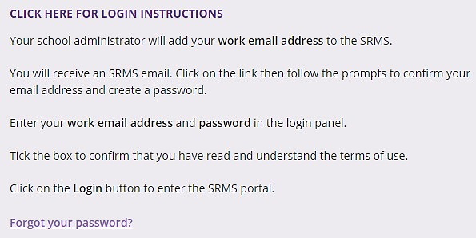

If you forget your password, click on Forgot your password.
Enter your work email address and tick the check box to confirm that you are not a robot. You will be prompted to select images as part of the verification process, and then you can choose another password.

Step 2: Add a user
Wait for the Home screen to load.
Above the purple navigation bar, you will see the Admin login ID and the four-digit provider code and name of your school (example highlighted below).
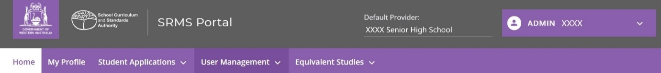
If these details are incorrect, contact the Authority for support at srms@scsa.wa.edu.au.
To add a user, select Add Users (highlighted below) from the User Management drop-down list.
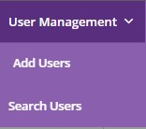
Enter the email address for the user (EAL/D or language/s teacher, principal, deputy principal, languages officer, or other staff member) you want to add to the SRMS. When registering an email for an SRMS account:
- Government (public) school accounts must be created using Department of Education (‘@education') email addresses.
- Non-government school accounts must use their official work email addresses.
Note: personal email addresses (such as Gmail or Hotmail addresses) should not be used when creating SRMS accounts.
Click on the Search button (highlighted below).
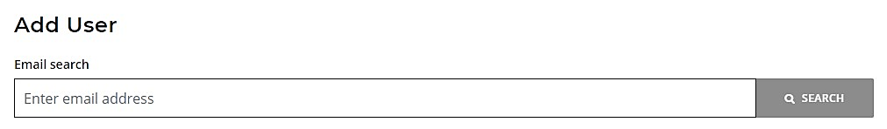
For government schools, the Given name, Family name and Provider details are prepopulated from SIRS. Enter the HRMIS number and Teacher registration number for the user.
For non-government schools, enter the Given name, Family name and Teacher registration number. Use the full given name, rather than any abbreviated or preferred names for the user. The provider details are prepopulated from SIRS.

Click on the Add user button (highlighted below) to create that user.
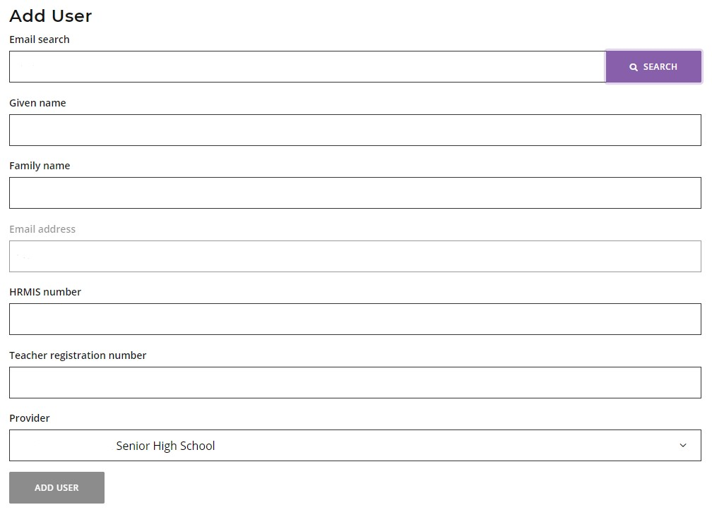
Government school users’ accounts are automatically activated.
Non-government school users will receive a system-generated email in their email inbox. To activate their account, the user must click on the link in the email. They will be prompted to create a password and re-enter it to confirm their password and activate their new account.
Note: for security reasons, this link is only valid for 24 hours. If the link expires, contact the Authority for support at srms@scsa.wa.edu.au.
If you or the new user would like to amend or add any details, type these in the relevant text field/s under the Update user tab, then click on the Update details button (both highlighted below).
Note: you cannot edit the email address or prepopulated details.
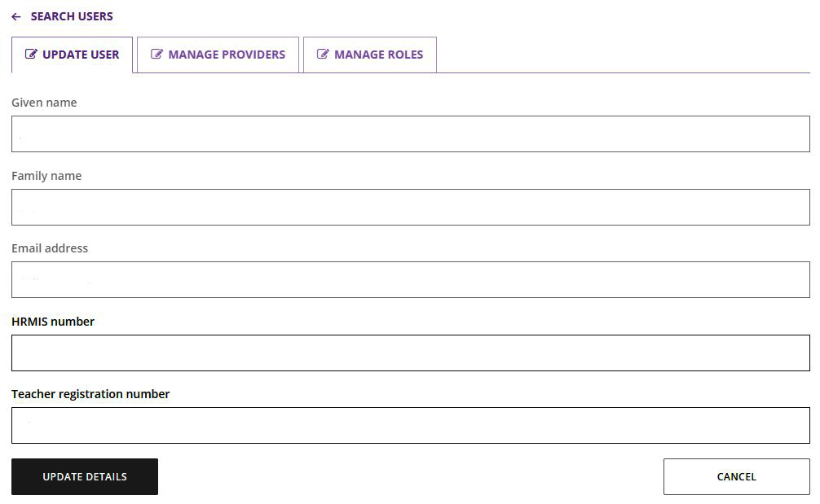
The user is linked automatically to your school’s provider code. When a member of staff leaves, click on the Manage providers tab (highlighted below) to remove their access to your school’s data.
Click on the Delete button (highlighted below) to remove your school’s provider code from a user. That user will no longer have permission to conduct functions for your school in the SRMS.
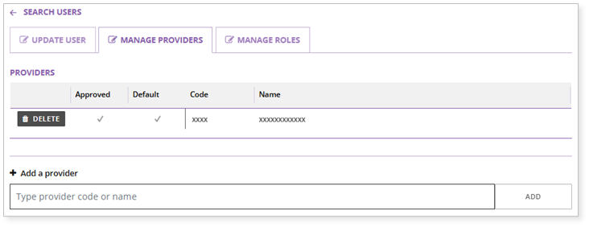
You will see the warning below. Click on the Delete button to delete the provider code or the Cancel button to cancel this request (both highlighted below).
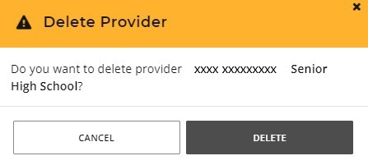
If you delete a user by mistake, type in your four-digit provider code or school name in the Add a provider field.
Select your school’s provider code and name in the purple panel to add the details to the text field, then click on the Add button (both highlighted below). This user will now be linked to your school.
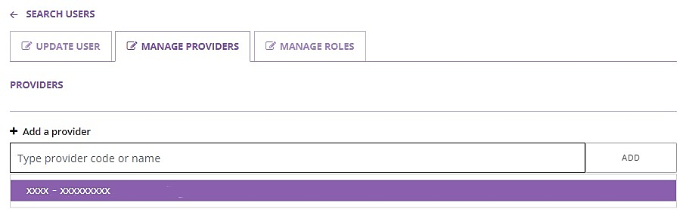
If a staff member returns to your school, repeat Step 2: Add a user. That staff member will be linked automatically to your school’s provider code.
The SRMS will prepopulate the Given name and Family name from the previous user profile, to save you time. You will need to re-enter the HRMIS number and Teacher registration number for the user.
If a new member of staff is still linked to their previous school in the SRMS, contact the Authority to remove them from their previous school and add your school’s provider code to their profile.
Proceed to assign roles to that user as required.

Step 3: Assign a role
To assign a role, click on the Manage roles tab (highlighted below).
Click on the arrow (highlighted below) to see the list of roles at your school.
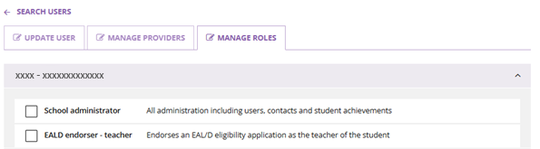
All users are automatically assigned the School dashboard viewer role (highlighted below).
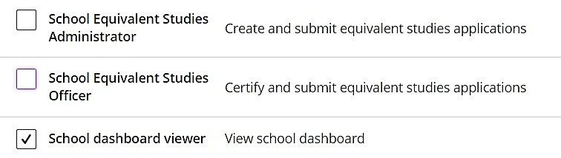
Scroll through the list to find the role/s you need to assign.
Tick the check box/es next to the role/s you want to assign to that user. The SRMS will automatically save these role assignments for that user.
The user will be able to carry out tasks associated with that role, and receive the relevant emails.
This may include EAL/D endorser – teacher, EAL/D endorser – school, EAL/D notification receiver, EAL/D assessment receiver, Languages – school officer, Languages endorser – teacher, Languages endorser – school, Schools Equivalent Studies Administrator, School Equivalent Studies Officer or other roles.
You do not need to tick all the check boxes. Only assign the roles that are relevant to your school’s requirements. Some roles apply to secondary schools only.
Note: do not assign multiple roles to one person unless they have multiple responsibilities at your school. Their inbox will be inundated with multiple emails related to the various roles.
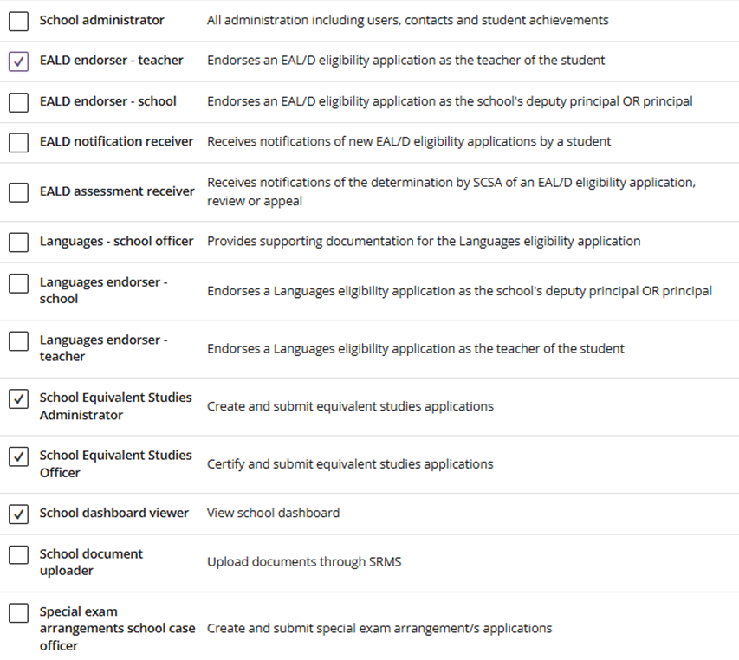

If you have more than one EAL/D or language/s teacher, locate (Step 4) or add (Step 2) an account for each teacher and assign them the relevant role. Each role can be assigned to multiple users.

Roles required for common activities
Year 11 equivalent studies applications:
- School Equivalent Studies Administrator
- School Equivalent Studies Officer
WACE language course enrolment applications:
- Languages – school officer
- Languages endorser – teacher
- Languages endorser – school
ATAR EAL/D eligibility declarations:
- EALD endorser – teacher
- EALD endorser – school
- EALD notification receiver*
- EALD assessment receiver*
* These roles send the user notifications and are not an essential part of the process.

Step 4: Search for a user
To find a user, select Search Users (highlighted below) from the User Management drop-down list.
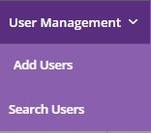
Enter the user’s family and/or given names or email address in the search fields on the left side of the screen and click on the Search button (highlighted below) to retrieve that user’s details.
To make any changes to the user, click on the Edit button (highlighted below) next to their name. You can update their details, assign a role and/or amend the role assignment for that user.
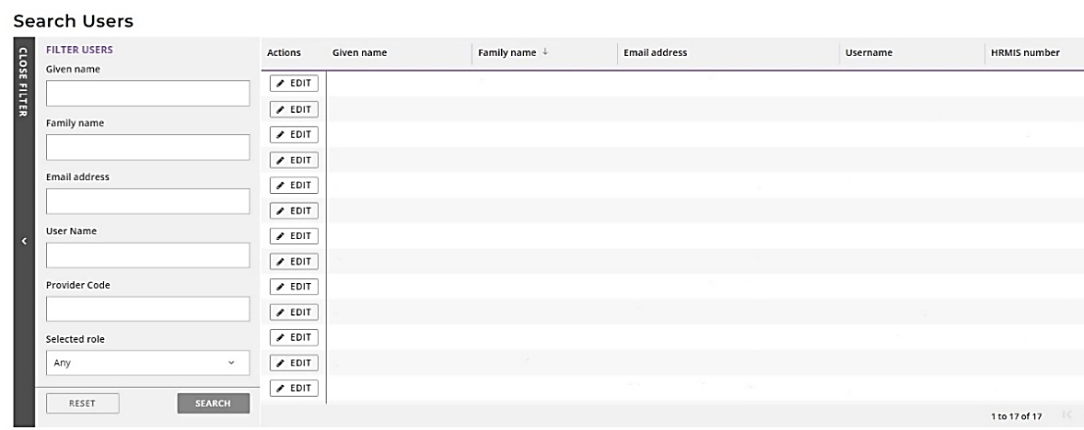
00
To see which members of staff have been assigned a particular role at your school, you can use the Selected role filter option.
Select a role from the drop-down list and then click on the Search button. All staff assigned to this role at your school will be displayed on your screen.
