Student portal
Student guide for applications for WACE language courses
24/06/2024
Acknowledgement of Country
Kaya. The School Curriculum and Standards Authority (the Authority) acknowledges that our offices are on Whadjuk Noongar boodjar and that we deliver our services on the country of many traditional custodians and language groups throughout Western Australia. The Authority acknowledges the traditional custodians throughout Western Australia and their continuing connection to land, waters and community. We offer our respect to Elders past and present.
Copyright
© School Curriculum and Standards Authority, 2019
This document – apart from any third-party copyright material contained in it – may be freely copied, or communicated on an intranet, for non­commercial purposes in educational institutions, provided that the School Curriculum and Standards Authority (the Authority) is acknowledged as the copyright owner, and that the Authority’s moral rights are not infringed.
Copying or communication for any other purpose can be done only within the terms of the Copyright Act 1968 or with prior written permission of the Authority. Copying or communication of any third-party copyright material can be done only within the terms of the Copyright Act 1968 or with permission of the copyright owners.
Any content in this document that has been derived from the Australian Curriculum may be used under the terms of the Creative Commons Attribution 4.0 International (CC BY) licence.
School Curriculum and Standards Authority
Street address: 303 Sevenoaks Street CANNINGTON WA 6107
Postal address: PO Box 816 CANNINGTON WA 6987
Phone: (08) 9273 6300
General email: info@scsa.wa.edu.au
Web: www.scsa.wa.edu.au
2019/26392v5
Cover photo credit: SDI Productions via iStock
Contents
Introduction 1
Enrolment criteria 1
Five steps to apply for a WACE language course 1
Student checklist for WACE Language Applications 2
Step 1: Log in to the student portal 3
Set up your personal email address 4
Set up your new password 5
Complete your Student Declaration and Permission 5
Returning to the student portal 6
Step 2: Start your language application 7
Your details 7
Language application 9
Educational information 10
Residential information 13
Linguistic background 17
Step 3: Upload your supporting documents 20
Supporting documents 20
Step 4: Submit your WACE language application 21
Amend your WACE language application 22
Step 5: Check the student portal for your WACE language application status 24
Appeal process 25

Introduction
To enrol in a Western Australian Certificate of Education (WACE) language course, you are required to submit an Application for permission to enrol in a WACE language course (Language Application) to the School Curriculum and Standards Authority (the Authority).
Information about the language application process is available on the WACE Language applications page of the Authority website (https://www.scsa.wa.edu.au/sirs-and-srms-info/srms-information/wace-language-applications).
This user guide shows you how to submit an application via the student portal (https://studentportal.scsa.wa.edu.au).
You must submit your application to the Authority, with the required supporting documentation, by the deadline, which is published on the Authority website and in the Activities Schedule.
Students complete their application when they are in Year 10, or in Year 9 if they are gifted and talented/accelerated language students. A student’s enrolment status is determined by the Authority on a case-by-case basis.

Enrolment criteria
The information you provide in this application will be assessed against three criteria:
- Education
- Residency and/or time spent in-country
- Use of the language for communication outside the language classroom.

Five steps to apply for a WACE language course
As outlined in this guide, there are five steps to follow to apply for permission to enrol in a WACE language course:
Step 1: Log in to the student portal
Step 2: Start your Language Application
Step 3: Upload your supporting documents
Step 4: Submit your Language Application
Step 5: Check the student portal for the status of your Language Application

Student checklist for WACE Language Applications
Use this checklist to get everything ready before you start your Application for permission to enrol in a WACE Language Course (Language Application). If you have any questions, ask your parent/s or guardian/s, your language teacher or school administration, or you can email the Authority at languagesenrolment@scsa.wa.edu.au.
Logging in to the student portal
1
To log in to the student portal (https://studentportal.scsa.wa.edu.au), you need your WA student number, which you will find on your school report/s. It may also be on your SmartRider. You also need a personal email address and must be able to access your personal email account when you complete your Language Application. Using a personal email address allows you to receive emails after you have left school, and your school email address has expired.
Educational information
2
You need to provide the following education information:
- details of the schools you attended for each school year from Pre-primary:
- name of the school
- main language used for instruction at the school
- language/s studied (if any)
- hours of language study per week (if any)
- school report/s for years where you attended school/s outside Australia (if any)
Residential information
3
You need to provide the following residential details:
- countries you have lived in
- countries you have visited/travelled to/holidayed in, including the reason/s for and length of in-country visit/s. This includes only countries where the language spoken is the same as the one for which you are applying
Linguistic background
4
You need to provide the following linguistic details:
- the first language/s you learned to speak
- other language/s you speak, read and write
- the language/s you speak with your parent/s or guardian/s and with your siblings and friends
5
- the language/s your parent/s or guardian/s speak
Supporting documents
You need to photograph or scan the following documents for upload into your application:
- completed Parent/Guardian Acknowledgement form – mandatory
- passport identification page – if you were born in another country or have lived outside Australia
- school report/s – if you have attended school/s outside Australia
- international movement record/s – if you have lived in or frequently travelled to countries or places where the language for which you are applying is spoken (and if requested by the Authority)
Save the supporting documents to your computer or mobile device as .pdf, .jpg, .jpeg or .png files, with a maximum size of 4MB for each file. Word documents will not be accepted, and you should not use spaces or unrecognisable characters or symbols such as < > ? ! / \ ” * : , # % $ ( ) { } + = @ when naming files.

This page has been left blank intentionally.

Step 1: Log in to the student portal
Log in to the student portal (https://studentportal.scsa.wa.edu.au).
You will find this link on the home page of the Authority website (https://scsa.wa.edu.au/). Click on the Student portal login link in the purple Useful Links panel (highlighted below).
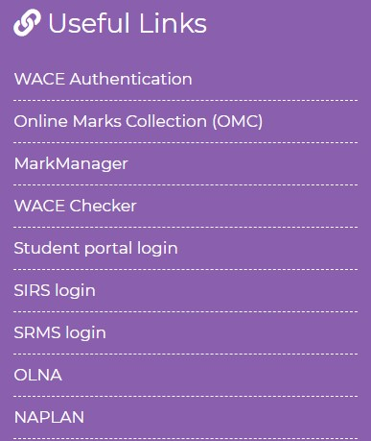
Enter your WA student number, which is on your school report/s. It may also be on your SmartRider.
Your initial password is a combination of your family name and date of birth — Nnddmmyyyy:
- Nn = the first two letters of your family name: the first as a capital letter (A–Z) and the second as a lower case letter (a–z), excluding any punctuation or spaces
- ddmmyyyy = your date of birth in day month year format.
Tick the check box (highlighted below) to show that you have read and understand the terms of use and click on the Login button (highlighted below) to enter the student portal.
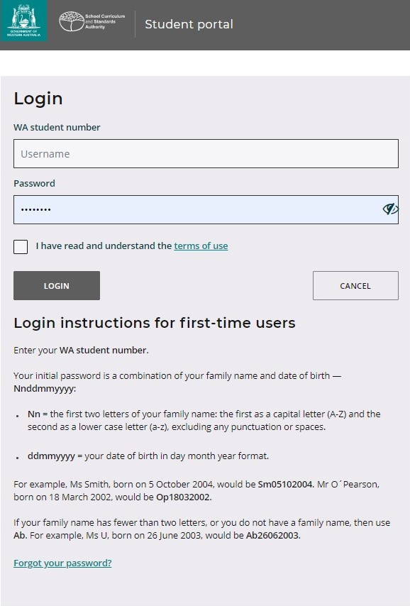

Set up your personal email address
Enter your personal email address, then re-enter it to confirm it. Click on the Set button (highlighted below).
Note: use your personal email address so that you can receive emails after you have left school, and your school email address has expired.
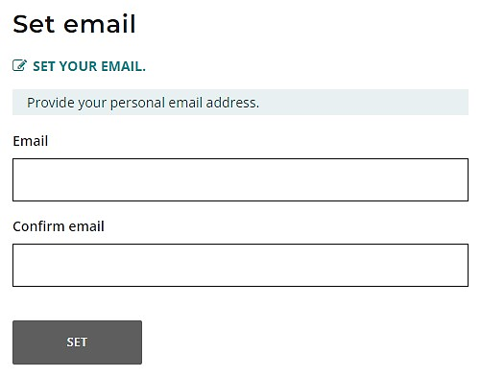
You will see an error message if your email and confirmation email do not match.
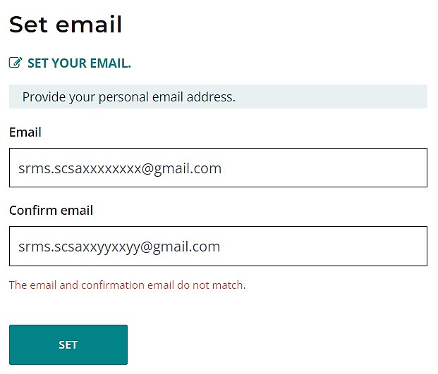
A confirmation email will be sent to this email address.
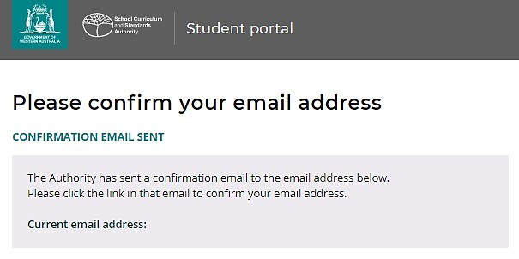
Go to your personal email account and click on the link in the email to confirm your email address and complete your registration. If you cannot log in to your personal email account, contact your school or the Authority’s Help Desk at wacehelp@scsa.wa.edu.au.

Set up your new password
When you have confirmed your email address, you will be asked to reset your password.
Your new password must contain a minimum of eight characters, with at least one digit (0–9), at least one capital letter (A–Z) and at least one lower case letter (a–z). Choose a new password that is easy to remember and keep it in a secure place.
Re-enter your new password to confirm it.
Click on the Reset button (highlighted below) to reset your new password.
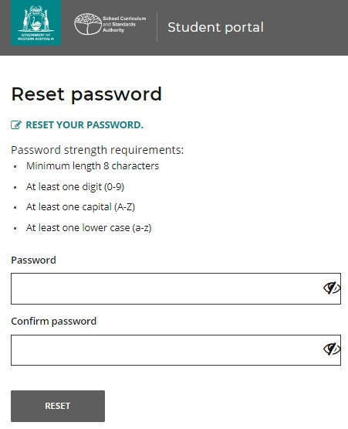

Complete your Student Declaration and Permission
If you are in Year 12, or in Year 10 or Year 11 and enrolled in an Australian Tertiary Admission Rank (ATAR) course, you will be taken to the Student Declaration and Permission page, which includes information about compliance with the WACE requirements and rules as set out in the Year 12 Information Handbook and your awareness of the restrictions on permission to enrol in a WACE language course.
Note: if you are in Year 10 or Year 11 and not ATAR enrolled, you do not need to complete the Student Declaration and Permission in the next section. Go to Step 2: Start your Language Application.

Tick the check box (highlighted below) to confirm that you have read and understand the information, then click on the Submit button (highlighted below).
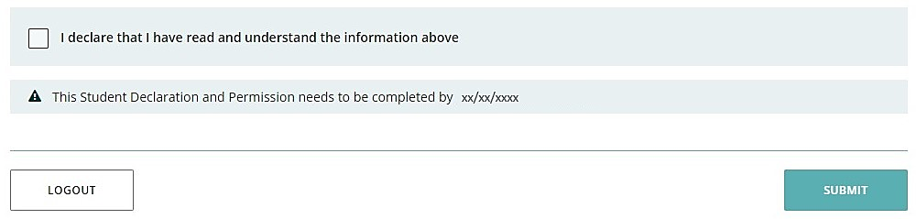
The Authority also asks permission to use your results (should you win an award), and other
schoolwork (without identifying who you are) in media communications.
Click on either Yes or No (highlighted below) for each statement.
When you have responded to each statement, click on the Submit button (highlighted below) to enter the student portal.
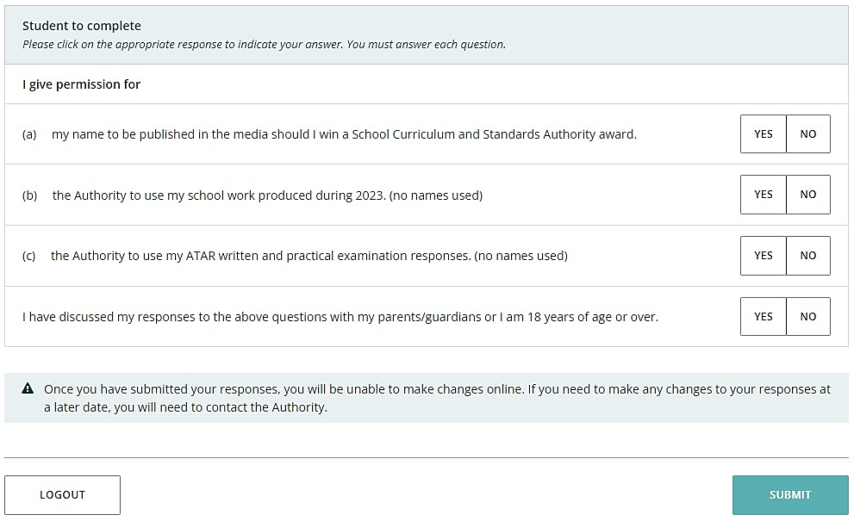

Returning to the student portal
The next time you log in to the student portal, you will only need to enter your WA student number and your new password in the login panel.

Step 2: Start your language application
To start your Language Application, select Language application from the Applications drop-down list in the green horizontal navigation bar (highlighted below).
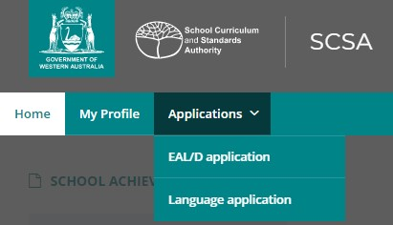

Your details
The personal details you will see cannot be changed as they have been provided by your school to the Authority. If there are any errors, you must contact your school.
Select the language for which you are applying from the drop-down list (highlighted below). All 10 WACE languages are shown in the screenshot below.
Note: if you are applying for more than one language, you will need to complete a separate application for each language.
Click on the Language application button (highlighted below) to get started.
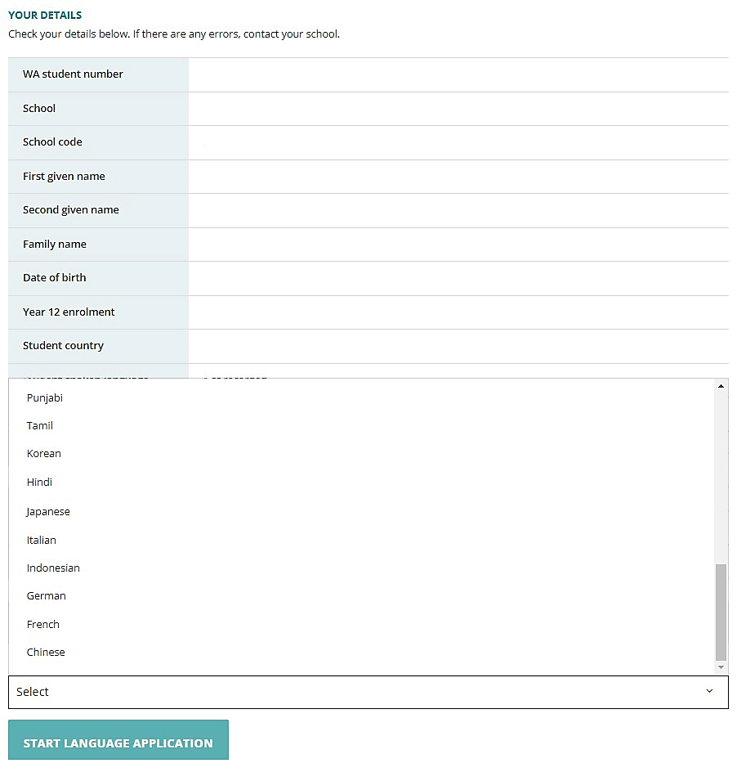

Notes for completing your application
Each time you click on the Next or Back buttons (both highlighted below), your application will be saved automatically.
You can stop at any time and resume your application later (highlighted below).
If you decide not to proceed with your application for any reason, click on the Cancel button (highlighted below) before you submit it in Step 4. After you have submitted your application, you will not be able to cancel it.
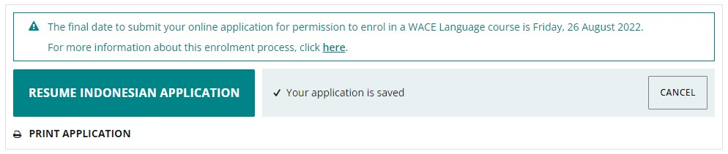
Enrolment criteria
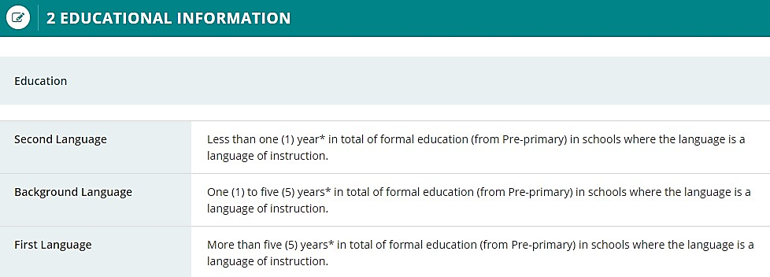
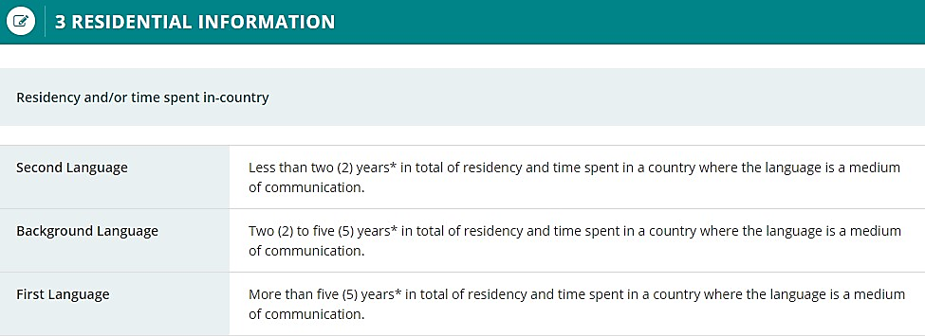
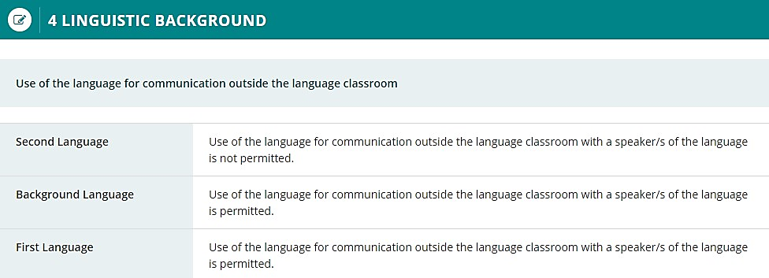

Language application
Select your language teacher’s name from the Select your language teacher drop-down list (highlighted below).
If you do not see your teacher’s name, choose My teacher is not listed here (highlighted below).
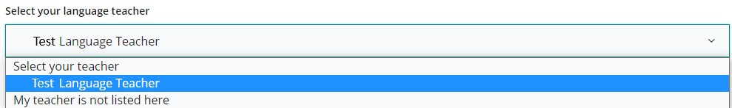
Select Yes or No to the six statements about your application.
Click on the Next button (highlighted below) to take you to the next section. If you do not complete all the required information on this page, you will not be able to proceed.
If you select Yes to the statement The language for which I am applying is my first language, you will only be able to enrol in a first language course (or background language course where no first language course is available).
You will see the first language warning below. Select Close (highlighted below) to return to the statements where you can change your response to this question, if needed.
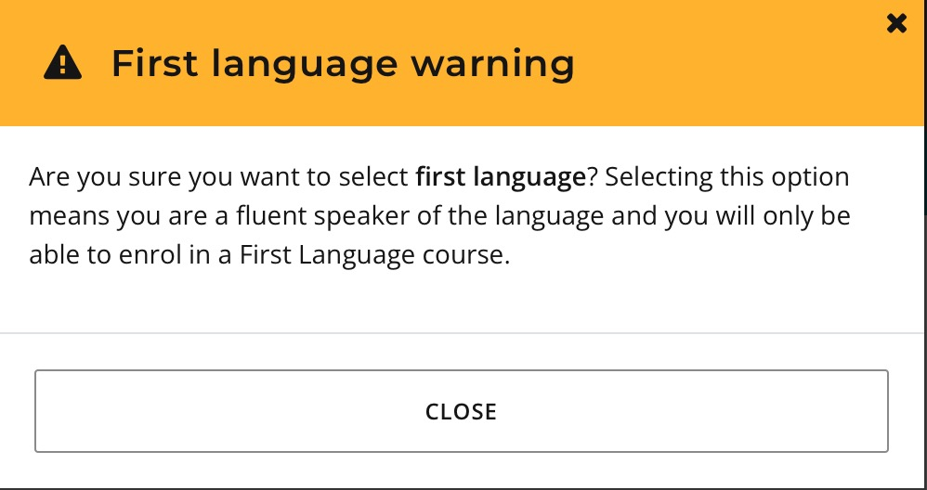
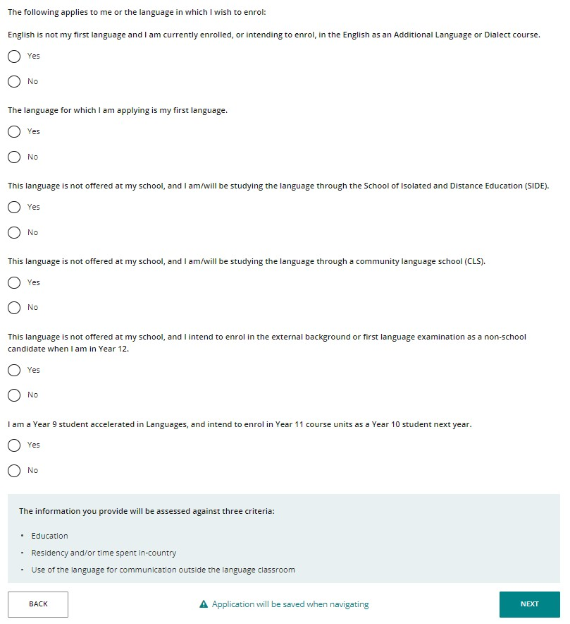
If you select that you are a first language speaker, you will go directly to Submit application.

Educational information
Education criterion
Provide information about all the schools that you have attended in Australia and/or outside Australia, including Pre-primary (or equivalent), primary and secondary. You do not need to include information about education before Pre-primary.
Click on the Add button (highlighted below) next to a calendar year.
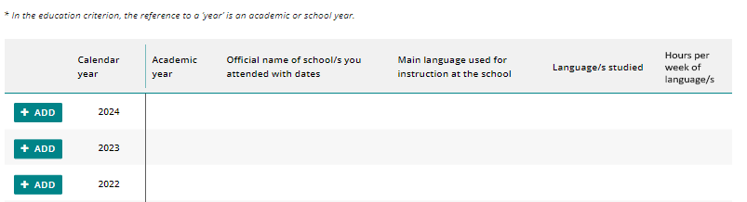
A school details box will appear. Select Yes or No to the question about school attendance in that calendar year. If you select Yes, you must provide information in all the fields: academic year, school name, language/s used for instruction/teaching, language/s studied, and the hours per week that you studied each language.
Note: dates are only required if you attended more than one school in a calendar year.
Click on the Add button (highlighted below) to save these details for that calendar year. Continue the process until all calendar years are completed.
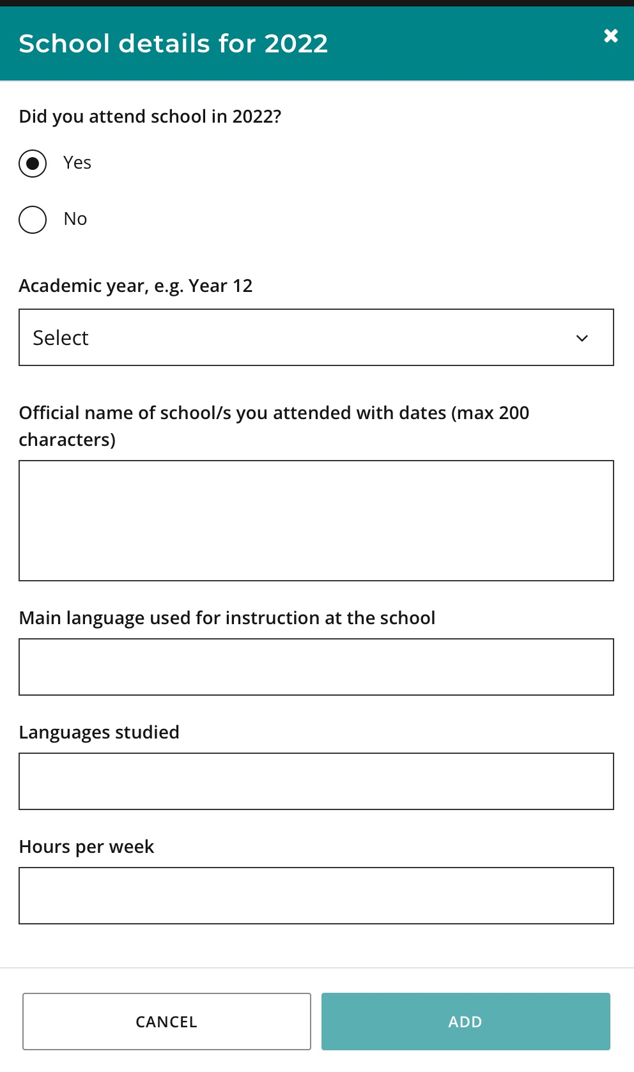
If you went to different schools in a calendar year, include the name of the school/s and dates you attended at each school. You can type up to 200 characters and use brackets, dashes and commas to provide details about the schools you attended.
If you were home schooled in a calendar year, type home schooling as the name of the school.
Select the language used for instruction/teaching in the classroom from the drop-down list. You may type in an additional language/s if more than one language was used for instruction/teaching in the classroom.
Type the language/s that you studied in your language class. Use whole numbers (1, 2, 3) or decimals (1.25, 1.5, 2.75) in the Hours per week field for the hours that you studied that language each week. You will not be able to use symbols (¼, ½ or ¾). Do not include hours for the main language used for instruction at the school.
If you did not study a language in a calendar year, type None in the Language/s studied field and 0, None or NA in the Hours per week field.
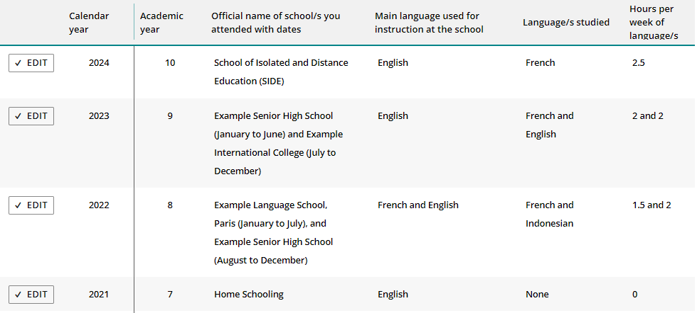
If you did not attend school in a calendar year, select No and click on the Add button (highlighted below) to record No schooling. You can use this option for the years before Pre-primary.
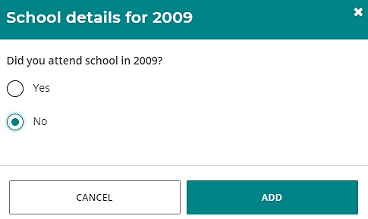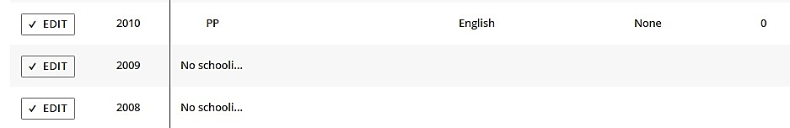
Check all the information you have provided. If you want to change anything, click on the Edit button (highlighted below).
Correct the information, then click on the Update button (highlighted below) to save these new details.
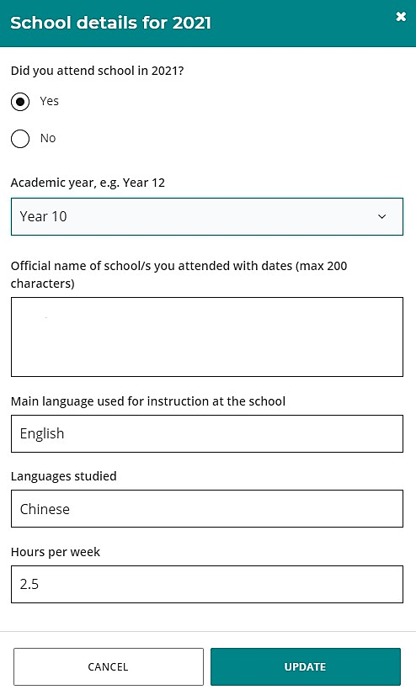
If you do not provide some information for each calendar year, you will not be able to proceed.
Click on the Next button (highlighted below) to go to the next section.

Residential information
Residency and/or time spent in-country criterion
Provide information about the countries you have lived in and those you have visited from birth to the current year.
Note: you only need to provide travel/holiday details for countries where the language spoken is the same as the one for which you are applying.
Click on the Add button (highlighted below) next to a calendar year.
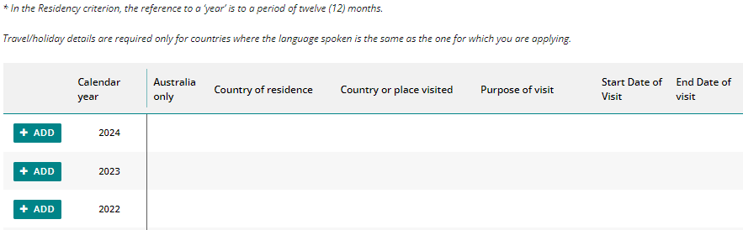
A residential information box will appear for that calendar year. Select Yes if you lived in Australia for the entire year with no overseas visits and click on the Add button (highlighted below).
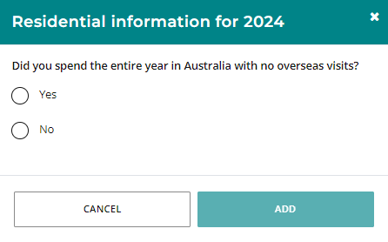
Your response will be displayed as shown below.
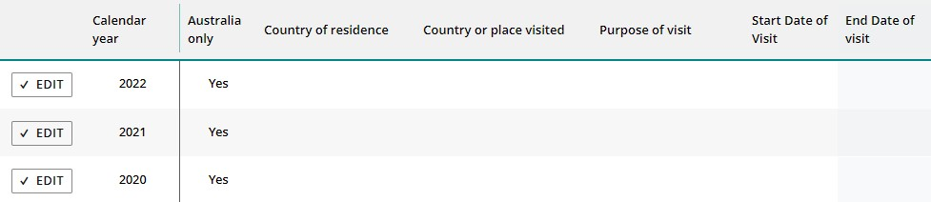

Select No in the residential information box if you did not spend the entire year in Australia. The box will expand so you can provide details for that calendar year.
If you lived in a country other than Australia for the entire year, select this country from the
drop-down list in the Country or place of residence field.
Note: you do not need to provide any more information since this describes your residency in a country other than Australia.
Click on the Add button to save this information (highlighted below).
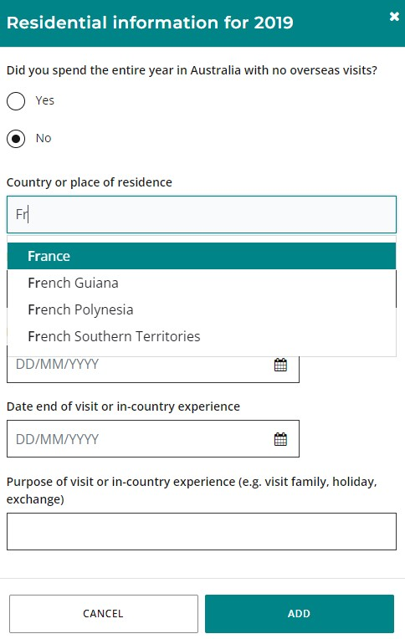
Your response will be displayed as shown below.
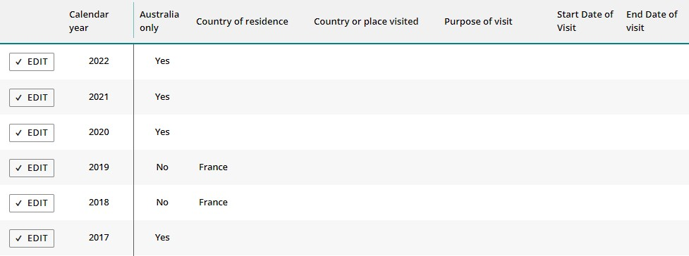

If you visited a country where the language spoken is the same as the one for which you are applying, you must enter your country of residence and provide travel or holiday information in the other three fields.
Use the date picker tool (highlighted below) to enter the start and end dates of your visit.
Click on the Add button to save this information (highlighted below).
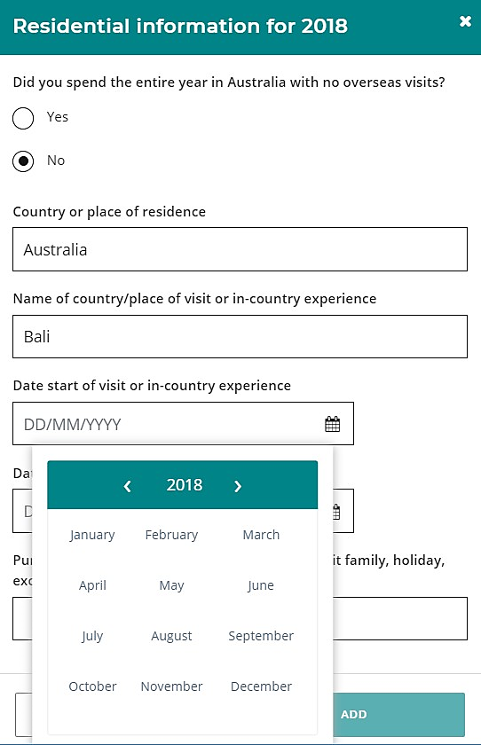
If you went on more than one trip or holiday in a calendar year to a country where the language spoken is the same as the one for which you are applying, provide details about these additional trip/s or holiday/s in the text box below.
You can include information about multiple years in the text box. You can type up to 500 characters and use brackets, dashes, commas and other keystrokes to provide details about your additional visit/s or holiday/s.
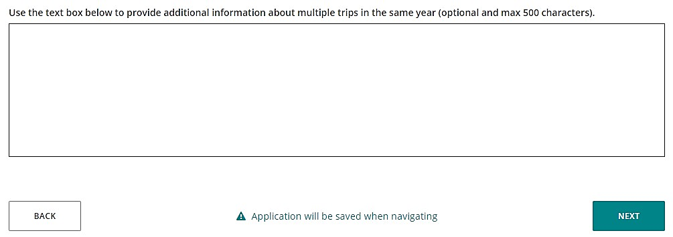
Check all the information you have provided. If you want to change anything, click on the Edit button (highlighted below).
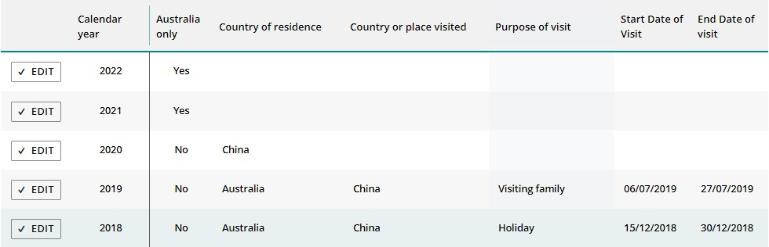
The residential information box for that calendar year will appear again. Correct the details, then click on the Update button (highlighted below) to save this information.
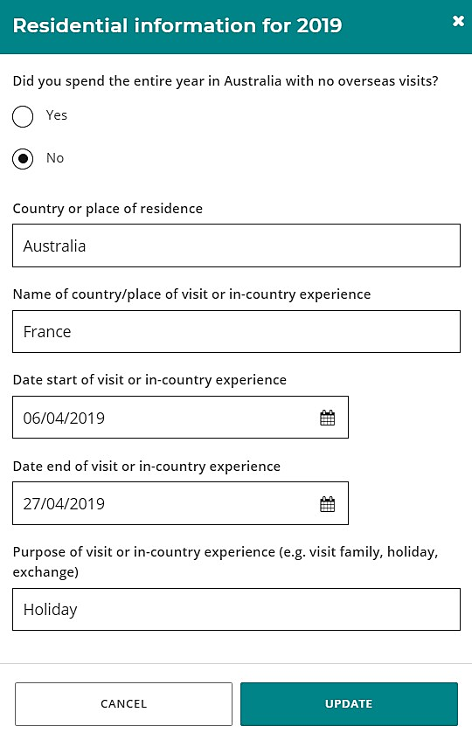
If you do not provide information for each calendar year, you will not be able to proceed.
Click on the Next button (highlighted below) to take you to the next section.

Linguistic background
Use of the language for communication outside the language classroom criterion
You must provide information in all eight fields about your use of language/s for communication outside the language classroom.
The first question relates to the first language/s you learned to speak.
The next three statements relate to the language/s you can speak, read and write, but did not learn at school. If you do not speak, read and write any language/s other than English, you can repeat English for each field.
The remaining statements refer to the language/s you speak with your parent/s or guardian/s at home and with your siblings and friends.
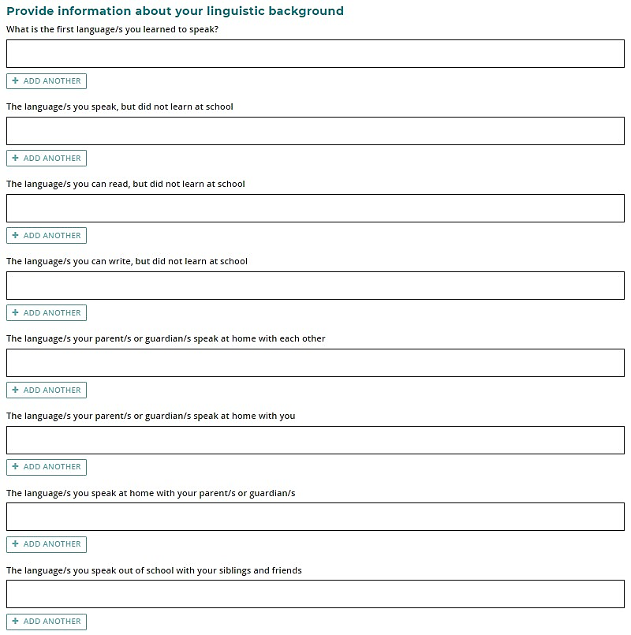
As you start typing, a predictive list of languages will appear as a drop-down list (highlighted below). Select the correct language for your answer.
Click on Add another (highlighted below) and select another language from the drop-down list to add an additional language/s for any of the questions, if required.
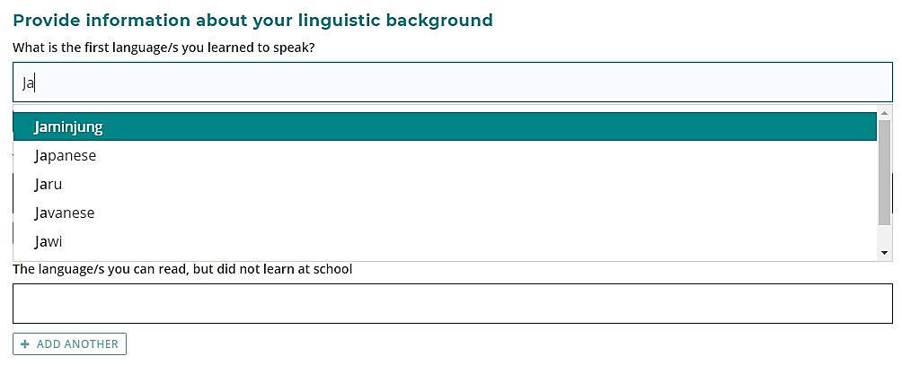
If the language you have selected is the same as or derived from the language for which you are applying, you must provide details in the text box (highlighted below) about how you use this language to communicate outside the language classroom.
You can type up to 500 characters and use brackets, dashes, commas and other keystrokes to enter details about your use of the language for which you are applying.
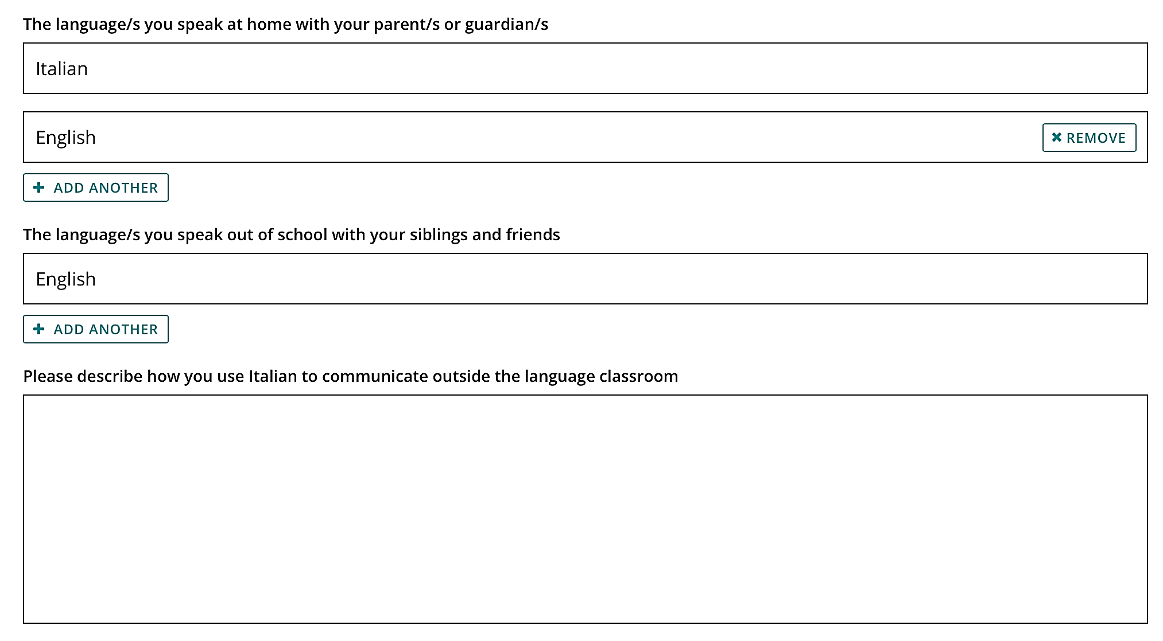

Select Yes or No if you have received instruction in the language for which you are applying at a community language school.
If you attended a community language school outside school hours, provide the academic year, the name of the school, the name of the language course you studied, the language/s of course delivery, and the number of hours you attended each week.
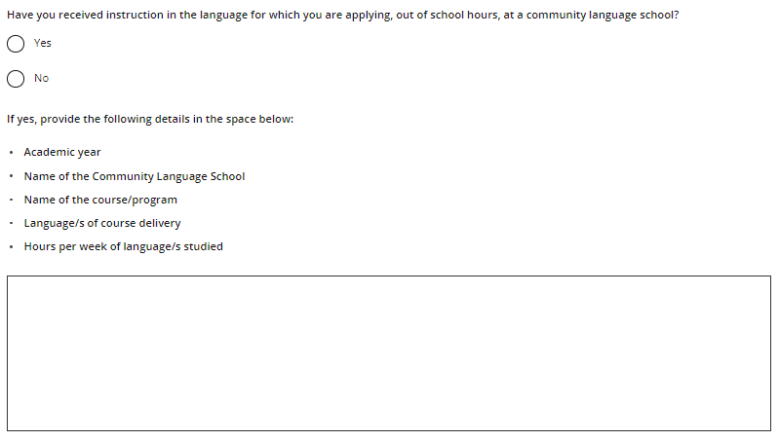
Click on the Next button (highlighted below) to take you to the next section.

Step 3: Upload your supporting documents

Supporting documents
A Parent/Guardian Acknowledgement form is required to support your Language Application. You can download this from the student portal (highlighted below). Ask your parent/guardian to complete and sign the form, then upload it.
If you were born in, have lived in, or attended school in a country where the language in which you wish to apply is used for communication and/or school instruction, you must upload your passport identification page. You must also upload school report/s if you have attended school outside Australia. Usually, you do not have to request and submit an international movement record/s (IMR) document, but you may be asked by the Authority for this after your application has been submitted.
Photograph or scan each supporting document and save the files to your computer or mobile device. Your supporting documents must be saved as .pdf, .jpg, .jpeg or .png files, with a maximum size of 4MB for each file. Word documents will not be accepted. Do not use spaces or unrecognisable characters or symbols, such as < > ? ! / \ " * : , # % & ( ) { } + = @ when naming files.
Select the first document from the drop-down list (highlighted below). Click on the Browse button (highlighted below) to select the file from your computer or mobile device then click on the Open button (Upload button on a Mac) to upload this file. Repeat this process until you have uploaded all your documents. If you have additional information, select Other from the drop-down list, and upload another file. If you want to remove a file, click on the Remove button next to the document.
Click on the Next button (highlighted below) to go to the next section. If you do not upload your Parent/Guardian Acknowledgement form, you will not be able to proceed.
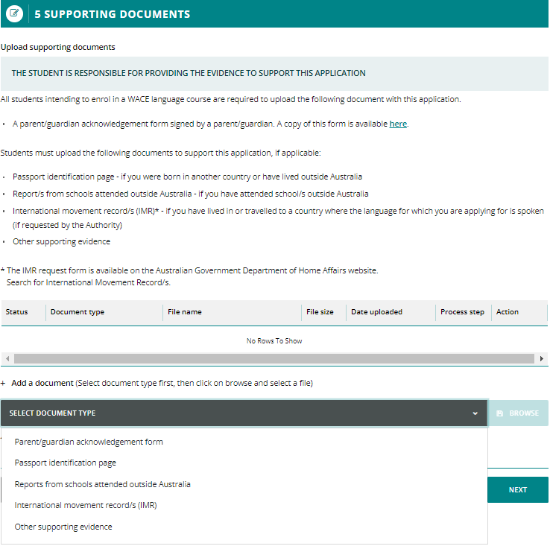

Step 4: Submit your WACE language application
Read the student declaration and tick the check box to confirm that the information you have provided in your application is true and correct. Tick the check box to acknowledge that you understand it is an offence to make a false and misleading declaration.
Check your application to ensure all information is correct. Click on the Print application button (highlighted below) to print your application and check it before submission. Click on the Back button (highlighted below) to make any changes, if required.
Note: after you have submitted your application, you will not be able to change anything until it has been reviewed by the Authority.
Click on the Submit application button (highlighted below).
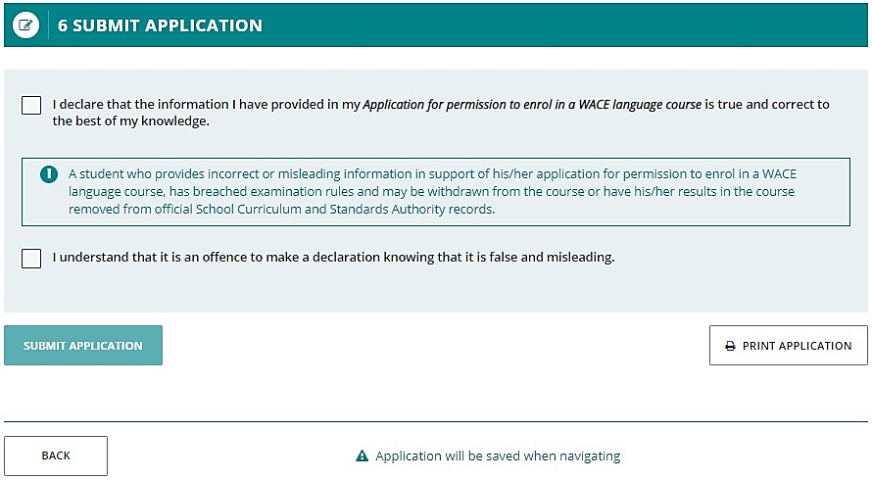
When you have submitted your application, your language teacher and school principal will endorse it.
Click on the View or Print buttons to read or print your application (both highlighted below).
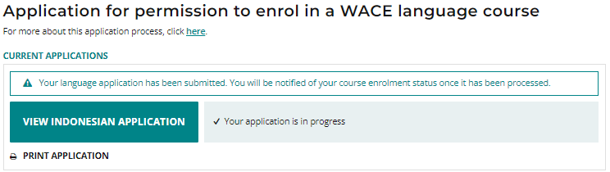

Amend your WACE language application
The Authority will review your application and supporting documents.
If further information or any changes are required, you will receive an email advising you to amend your application. Your school support officer will receive a copy of this email.
Click on the Amend [language] application button (highlighted below) to amend your application or provide further information, as required.
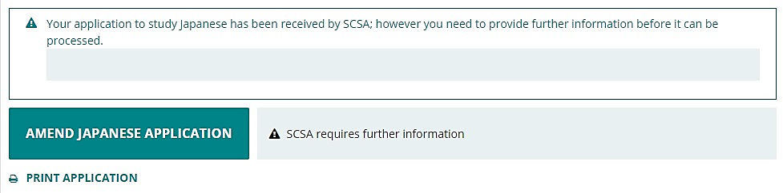
You will only be able to change the information identified by the reviewer, which will be highlighted in yellow (example shown below).
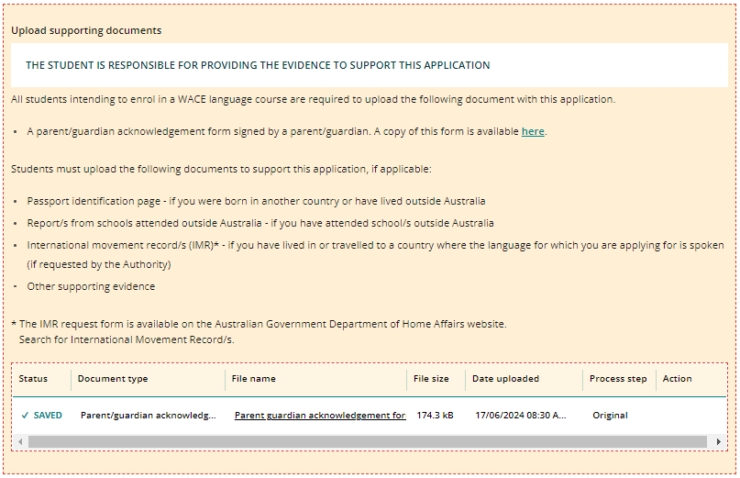
When you have made the change/s requested by the reviewer, click on the Next button (highlighted below) to go to the next section.
Tick the check boxes again and click on the Submit application button (highlighted below) to submit your amended application.
You will see the warning below, reminding you to check that you have provided the required information. If you have done so, click on the Submit application button (highlighted below).

If you need to make more changes, click on the Close button (highlighted below), then click on the Back button to go to the section and add further information.

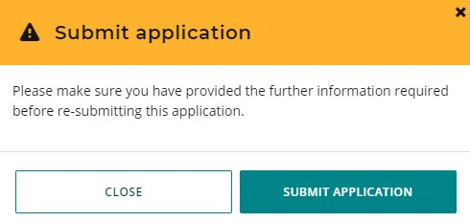
When you have added the required information, repeat the steps above to submit your amended application.

Step 5: Check the student portal for your WACE language application status
You can check the student portal for your WACE language application status. The status will show as In progress (highlighted below) while your application is being processed.
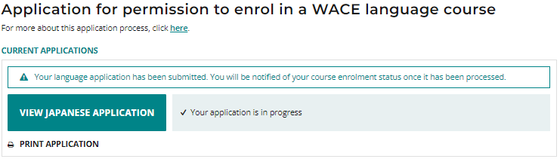
When your application has been finalised, you will see which WACE language course (Second Language, Background Language or First Language) you are permitted to enrol in (examples highlighted below).
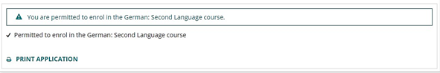
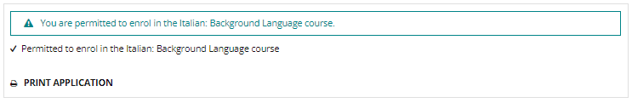
You will receive with an automated email to your personal email address or a notification letter to the email address that you provided in your Parent/Guardian Acknowledgement form, that was uploaded with your application. Please read the letter, so that you are aware of your language enrolment options. Please check the junk/spam folder if the email is not received within 24 hours.

Appeal process
If the Authority determines that you do not meet the enrolment criteria for a course and are therefore not permitted to enrol in a Second or Background Language course, this will be shown in the student portal.
If you have additional information that shows that you do meet the enrolment criteria for the Second or Background Language course, you can lodge an appeal with the Authority.
You must do this within two weeks of receiving your WACE language course enrolment notification in the student portal.
The Language pathway for each student is determined as follows:
Second language – a student will be considered for the second language pathway if the information provided in the Language Application satisfies all three criteria for the Second language pathway
Background language – a student will be considered for the background language pathway if the information in the Language Application satisfies at least one criterion for the Background language pathway
First language – a student will be considered for the first language pathway if the information in the Language Application satisfies, in addition to the Use of the language for communication outside the language classroom criterion, at least one other criterion of the First language pathway.
To request an appeal, download and complete the Application form for appeal against languages enrolment determination, which you can find on the Applications and Order forms page of the Authority Website.
To show that you meet the enrolment criteria, you will need to provide additional information with your Appeal Application form.
You should email your completed Appeal Application form and additional information to languagesenrolment@scsa.wa.edu.au.
Note: you can only lodge one appeal for each Language Application you submit.
The Languages Enrolment Determinations Appeals Committee will review your appeal application form and additional information.
After the appeal is completed, the Authority will notify you and your parent/s or guardian/s by email, of the outcome of the appeal.
At this point, you should contact your school to discuss your study options.

