Student Records Management System
School guide for online EAL/D eligibility applications: international

Student Records Management System
School administrator’s guide for dashboard navigation: international
Acknowledgement of Country
Kaya. The School Curriculum and Standards Authority (the SCSA) acknowledges that our offices are on Whadjuk Noongar boodjar and that we deliver our services on the country of many traditional custodians and language groups throughout Western Australia. The SCSA acknowledges the traditional custodians throughout Western Australia and their continuing connection to land, waters and community. We offer our respect to Elders past and present.
Copyright
© School Curriculum and Standards Authority, 2019
This document – apart from any third party copyright material contained in it – may be freely copied, or communicated on an intranet, for non­commercial purposes in educational institutions, provided that the School Curriculum and Standards Authority (the SCSA) is acknowledged as the copyright owner, and that the SCSA’s moral rights are not infringed.
Copying or communication for any other purpose can be done only within the terms of the Copyright Act 1968 or with prior written permission of the SCSA. Copying or communication of any third party copyright material can be done only within the terms of the Copyright Act 1968 or with permission of the copyright owners.
Any content in this document that has been derived from the Australian Curriculum may be used under the terms of the Creative Commons Attribution 4.0 International licence.
School Curriculum and Standards Authority
Street address: 303 Sevenoaks Street CANNINGTON WA 6107
Postal address: PO Box 816 CANNINGTON WA 6987
Phone: (08) 9273 6300
General email: info@scsa.wa.edu.au
Web: www.scsa.wa.edu.au
Cover photo credit: GlobalStock via iStock

Contents
Online EAL/D eligibility applications 1
Information for teachers 1
Three stages in the online submission process 1
Checklist 2
Five steps for EAL/D teacher endorsement 3
Step 1: Log in to the SRMS portal 3
Step 2: Select students’ EAL/D eligibility applications 4
Step 3: View students’ EAL/D eligibility applications 6
Step 4: Endorse students’ EAL/D eligibility applications 7
Step 5: Check the SRMS portal for students’ EAL/D eligibility status 9
Five steps for school endorsement 10
Step 1: Log in to the SRMS portal 10
Step 2: Select students’ EAL/D eligibility applications 11
Step 3: View students’ EAL/D eligibility applications 13
Step 4: Endorse students’ EAL/D eligibility applications 14
Step 5: Check the SRMS portal for students’ EAL/D eligibility status 17
Review and appeal processes 18
Review 18
Appeal 19

Online EAL/D eligibility applications
To enrol in a Year 12 Australian Tertiary Admission Rank (ATAR) English as an Additional Language or Dialect (EAL/D) course, students must submit an online EAL/D eligibility application to the School Curriculum and Standards Authority (the SCSA).
This user guide is for schools whose students are submitting an ATAR EAL/D eligibility application via the student portal (https://studentportal.scsa.wa.edu.au). Refer to the Student guide for online EAL/D eligibility applications for information relevant to students.
The due dates for submission of applications are published on the EAL/D page (https://senior-secondary.scsa.wa.edu.au/syllabus-and-support-materials/english/english-as-an-additional-language-or-dialect) on the SCSA website.

Information for teachers
If students require support to complete their online EAL/D eligibility applications, it is recommended that they complete the process as a group in the classroom, or computer lab, so teachers can help them and answer any questions.
Make sure that students have all their supporting documents ready before they start their online EAL/D eligibility applications. Refer to the checklist, which lists everything that students need to complete an online EAL/D eligibility application, including file specifications for their supporting documents. A copy of this checklist is also included in the Student guide for online EAL/D eligibility applications.
There are two criteria for EAL/D eligibility and each student must select the one that is applicable to them. Usually, the first criterion will apply.
Before submitting their online EAL/D eligibility applications, the SCSA recommends that students print their applications and check all information carefully before proceeding. Once the application has been submitted to the SCSA, it can be viewed as read-only and no further changes can be made.

Three stages in the online submission process
There are three stages in the submission of an online EAL/D eligibility application.
- Student submission of application in the student portal.
- Teacher endorsement of student’s application in the SRMS portal.
- School endorsement of student’s application in the SRMS portal.
When all three stages have been completed, the application will be processed by the SCSA.

Checklist
Use this checklist to make sure that students have everything they need before they start their application. To complete their online application, students will need to use a computer, either at home or at school. If students have any questions, they can ask their parent/s or EAL/D teacher to help them.
Logging in to the student portal
1
To log in to the student portal, students will need their WA student number, which is on their school report/s. Students will need a personal email address. They must be able to access this personal email account when they complete their online application.
Residential information
2
Students will need to provide the following details:
- country of birth
- total time they have lived in a predominantly English-speaking country*
- country of birth — mother and father (or carer/s)
- countries they have lived in†
- nationality
- languages spoken at home
* countries where English is the primary and/or official language
† countries where they have lived as a resident, not countries that they have visited on holiday
3
Educational background
Make sure they have:
- details of the schools attended for every school year from Year 1:
- name of the school
- country where the school is located
- calendar years they attended the school
- international school status‡
- main language of school delivery
- percentage of course delivery in English
- school report/s for years where they attended school where English was not the main medium of course delivery
‡ schools that teach an international curriculum
4
Supporting documents
Students will need to photograph or scan the following documents:
- passport identification page or identification card
- school report/s
Students should save the supporting documents to their computer or mobile device as .pdf, .jpg, .jpeg or .png files, with a maximum size of 4MB for each file. Word documents will not be accepted.
Students must use English letters to name their files.

Five steps for EAL/D teacher endorsement
When students have submitted their EAL/D eligibility applications, the person or people registered as a teacher endorser will be prompted to endorse these applications in the Student Records Management System (SRMS) portal. The teacher endorser/s must be familiar with the educational and linguistic background and capabilities of the applicant. They must also be able to verify that the applicant is a genuine EAL/D candidate and that the information provided in the application is accurate and correct. The teacher endorser/s must be a practising teacher and would normally be the applicant’s EAL/D or English teacher.

Step 1: Log in to the SRMS portal
Log in to the SRMS portal (https://srms.scsa.wa.edu.au).
The first time you log in, click on and read the login instructions (highlighted below). Contact your school administrator if you have not received the email with the link.
Enter your work email address and password in the non-government school login panel.
Tick the check box (highlighted below) to show that you have read and understand the terms of use.
Click on the Login button (highlighted below) to enter the SRMS portal.
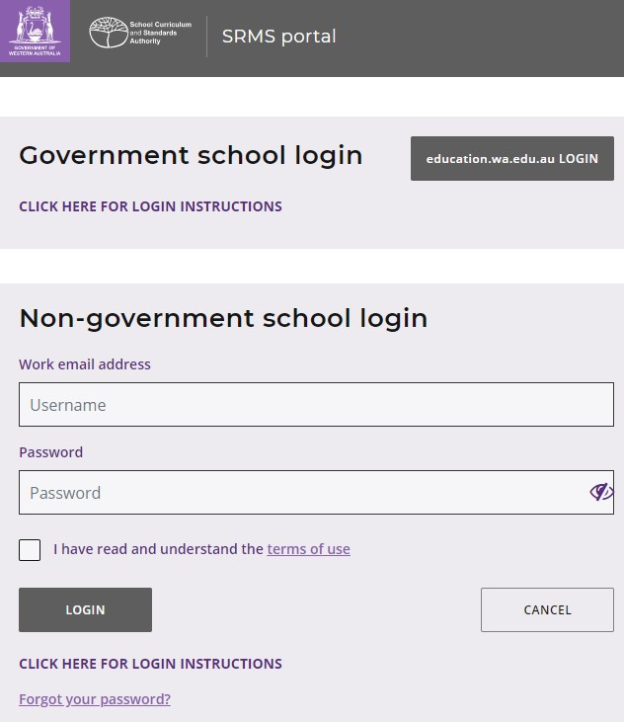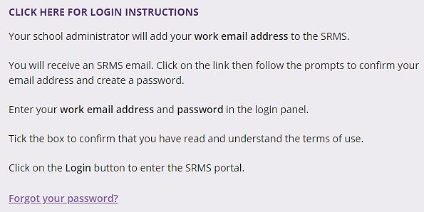

If you have forgotten your password, click on Forgot your password.
Enter your work email address and tick the check box to confirm that you are not a robot. You will be prompted to select images as part of the verification process, then invited to choose another password.

Step 2: Select students’ EAL/D eligibility applications
To retrieve your students’ applications, select EAL/D Applications from the Student Applications drop-down menu (highlighted below).
All submitted EAL/D applications from your students will be displayed on the screen. The Status column shows submitted student applications, with a tick and Submitted (highlighted below).
The Sub status column will be blank. The Requires attention by me column shows as Yes (highlighted below), advising you to take action.
Teachers must endorse each student’s application within three working days of receipt of an email notification that an application requires their attention. This is to ensure that the application can be processed in a timely manner by the SCSA before the Year 12 enrolment deadline.
Note: the oldest application will appear at the top of the list, since this requires your attention first.
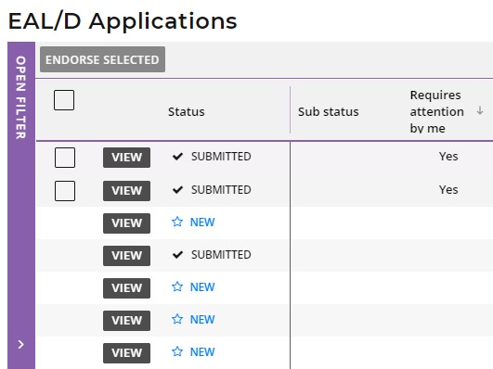

Filter students’ EAL/D eligibility applications
To retrieve applications at a specific stage of the application process, you can use the filter check boxes on the left side of the EAL/D Applications screen. For example, tick the Submitted and In progress check boxes then click on the Search button (both highlighted below) to see all applications awaiting endorsement or progressing through the approval process. The Sub status filter (highlighted below) will select applications that have been Teacher endorsed, School endorsed, EAL/D PC reviewed or that are Ready to publish, to help you view your students’ applications.
Alternatively, type in the student’s Given name and/or Family name, or their WA student number, then click on the Search button (highlighted below) to select that student’s application.
If you want to view applications that students submitted in the previous year/s, select the Show students registered in previous years check box (highlighted below), then click on the Search button (highlighted below). This is very useful at the beginning of a calendar year, when the SCSA changes the portal date to the new academic year. By selecting this check box, you can view and endorse students’ applications that were submitted prior to the change of year.
Click on the Reset button (highlighted below) to reset the filters and view all the applications.
You can see the number of applications that require your attention (highlighted below). This number will update as you complete the required action.
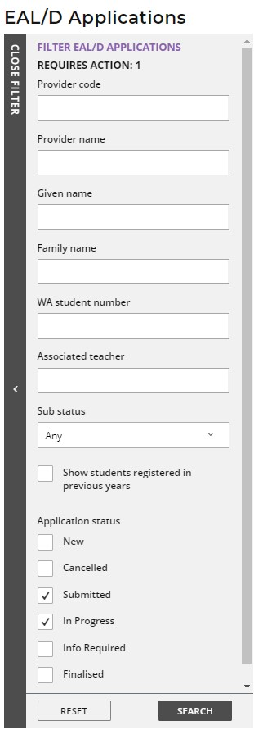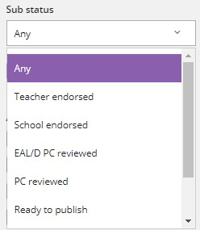

Step 3: View students’ EAL/D eligibility applications
Click on the View button (highlighted below) to the left of the student’s name to read all details and supporting documents in that student’s application (example shown below).
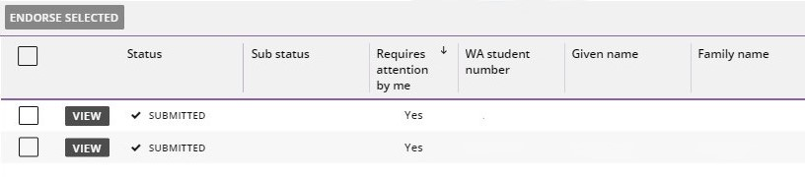
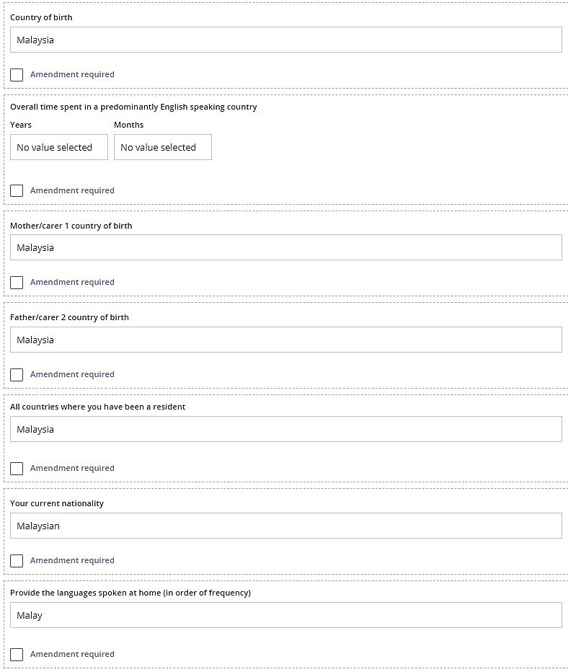
When reviewing the student’s education background, if the school name is very long, it will be abbreviated with an ellipsis. Hover with your mouse over the school name and the name will be displayed in full (highlighted below).
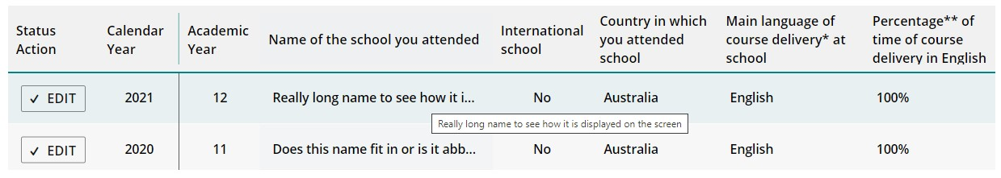

Step 4: Endorse students’ EAL/D eligibility applications
Scroll down to the bottom of the application form to the Endorse Application section. Select either I Endorse or I cannot endorse. If you endorse the application, it is optional to add a comment.
Note: if you see an error in a student’s application, such as an incorrect percentage in the Educational Background table, or the incorrect language/s spoken at home, add this information in the Comment box, but still endorse the application. The SCSA considers this information when reviewing the application and it often means that further action will not be required by the student.
Click on the Submit button (highlighted below), to submit your endorsement.
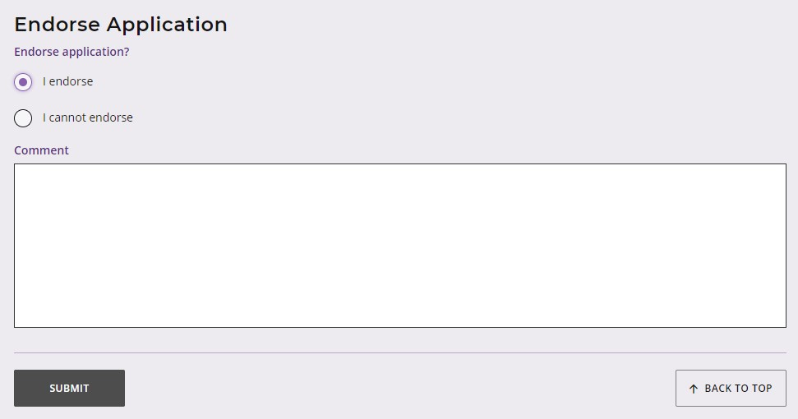
Multiple endorsements
If you wish to endorse multiple applications at the same time, tick the check box underneath the Endorse selected button to select multiple applications (highlighted below).
Click on the Endorse selected button (highlighted below). A warning will appear, asking if you wish to endorse the applications of the selected students. Click on the Endorse button (highlighted below) to endorse the selected applications. Alternatively, click on the Cancel button (highlighted below) to cancel this multiple endorsement.
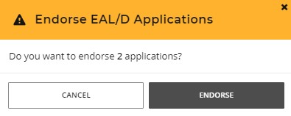
If you choose not to endorse a student’s application, you must add an explanation for your decision. Click on the Submit button (highlighted below), to submit your endorsement.
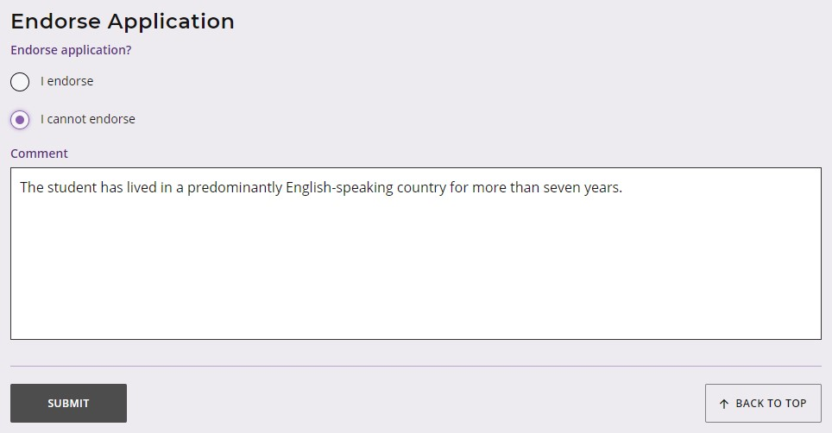
You will see a warning, advising that if you proceed the student may not be eligible to enrol in the Year 12 ATAR EAL/D course.
Click on the Continue button (highlighted below) to proceed. Click on the Cancel button if you decide to return to the Endorse Application panel.
Note: the SCSA reviews all applications that have not been endorsed by the teacher to determine students’ EAL/D eligibility.
You will see advice that the application must now be endorsed by a representative of your school’s administration. Click on the Continue button (highlighted below) to proceed.
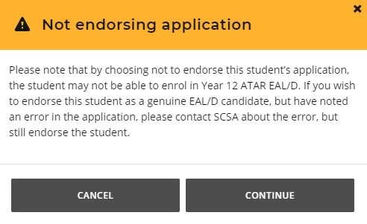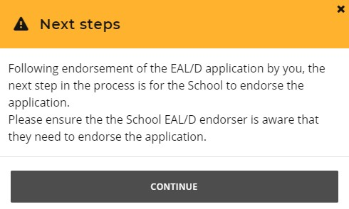
You will return to the EAL/D Applications screen. The Status column shows as Submitted (highlighted below). The Sub status column shows as Teacher endorsed (highlighted below). The Requires attention by me column will now be blank, to show that you have completed endorsement of your students’ EAL/D eligibility applications.

Step 5: Check the SRMS portal for students’ EAL/D eligibility status
You can check the EAL/D Applications screen in the SRMS portal to monitor the progress of students’ applications at any time. The EAL/D Applications screen will update whenever an application advances through the various stages of the application process.
You will notice that the application status will update with the following definitions.
New: new, but incomplete EAL/D eligibility application
Submitted: EAL/D eligibility application has been submitted and is at the teacher endorsement stage
In progress: EAL/D eligibility application that is progressing through the approval stages
Info required: EAL/D eligibility application requires further information or amendment
Finalised: EAL/D eligibility status has been determined for this application
Cancelled: EAL/D eligibility application has been cancelled
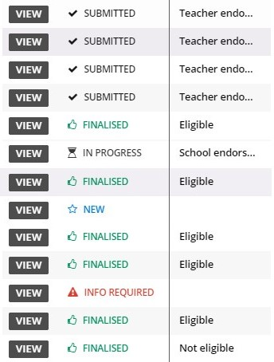
Note: students can check the status of their applications by logging in to the student portal. A decision will usually be made between one and five business days after submission.
The status of students’ applications will change from In progress to either Eligible or Not eligible in the student portal. The SCSA will also email the outcome to the school.

Five steps for school endorsement
After the EAL/D teacher has completed endorsement of students’ applications, the person or people registered as a school endorser will be prompted to endorse students’ applications in the SRMS portal. The school endorser/s must be familiar with EAL/D eligibility policy and, based on their own knowledge or on advice given to them, can endorse that the applicant is a genuine EAL/D candidate and that the school is applying the eligibility policy correctly. The school endorser/s would normally be the principal or someone who is acting on behalf of the principal, such as a deputy principal.
The application will not be forwarded to the SCSA until it has been endorsed by the school.

Step 1: Log in to the SRMS portal
Log in to the SRMS portal (https://srms.scsa.wa.edu.au).
The first time you log in, click on and read the login instructions (highlighted below). Contact your school administrator if you have not received the email with the link.
Enter your work email address and password in the non-government school login panel.
Tick the check box (highlighted below) to show that you have read and understand the terms of use.
Click on the Login button (highlighted below) to enter the SRMS portal.

If you forget your password, click on Forgot your password.
Enter your work email address and tick the check box to confirm that you are not a robot. You will be prompted to select images as part of the verification process, then invited to choose another password.

Step 2: Select students’ EAL/D eligibility applications
Select EAL/D Applications from the Student Applications drop-down menu (highlighted below).
All submitted EAL/D applications from your students will be displayed on the screen.
The Status column shows submitted student applications, with a tick and Submitted (highlighted below). The Sub status column shows as Teacher endorsed (highlighted below). The Requires attention by me column shows as Yes (highlighted below), advising you to take action.
Principals or deputy principals must endorse each student’s application within three working days of receipt of an email notification that an application requires their attention. This is to ensure that the application can be processed in a timely manner by the SCSA before the Year 12 enrolment deadline.
Note: the oldest application will appear at the top of the list, since this requires your attention first.
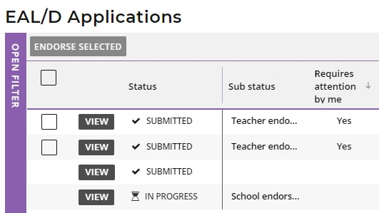

Filter students’ EAL/D eligibility applications
To retrieve applications at a specific stage of the application process, you can use the filter check boxes on the left side of the EAL/D Applications screen. For example, tick the Submitted and In progress check boxes then click on the Search button (both highlighted below) to see all applications awaiting endorsement or progressing through the approval process. The Sub status filter (highlighted below) will select applications that have been Teacher endorsed, School endorsed, EAL/D PC reviewed or that are Ready to publish, to help you view your students’ applications.
Alternatively, type in the student’s Given name and/or Family name, or their WA student number, then click on the Search button (highlighted below) to select that student’s application.
If you want to view applications that students submitted in the previous year/s, select the Show students registered in previous years check box (highlighted below), then click on the Search button (highlighted below). This is very useful at the beginning of a calendar year, when the SCSA changes the portal date to the new academic year. By selecting this check box, you can view and endorse students’ applications that were submitted prior to the change of year.
Click on the Reset button (highlighted below) to reset the filters and view all the applications.
You can see the number of applications that require your attention (highlighted below). This number will update as you complete the required action.
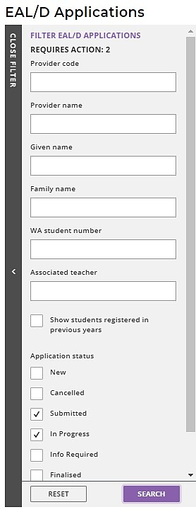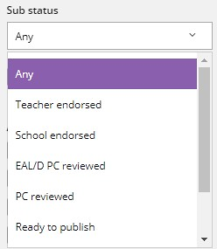
Red highlight box

Step 3: View students’ EAL/D eligibility applications
Click on the View button (highlighted below) to the left of the student’s name to read all details and supporting documents in that student’s application (example shown below).
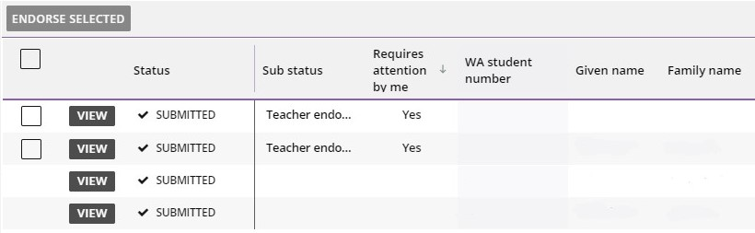
When reviewing the student’s education background, if the school name is very long, it will be abbreviated with an ellipsis. Hover with your mouse over the school name and the full name will display (highlighted below).

Step 4: Endorse students’ EAL/D eligibility applications
Scroll to the bottom of the application to the Endorse Application section. Select either I endorse or I cannot endorse. If you choose to endorse the application, it is optional to add a comment.
Note: if you see an error in a student’s application, such as an incorrect percentage in the Educational Background table, or the incorrect language/s spoken at home, add this information in the Comment box, but still endorse the application. The SCSA considers this information when reviewing the application and it often means that further action will not be required by the student.
Click on the Submit button (highlighted below) to submit your endorsement.
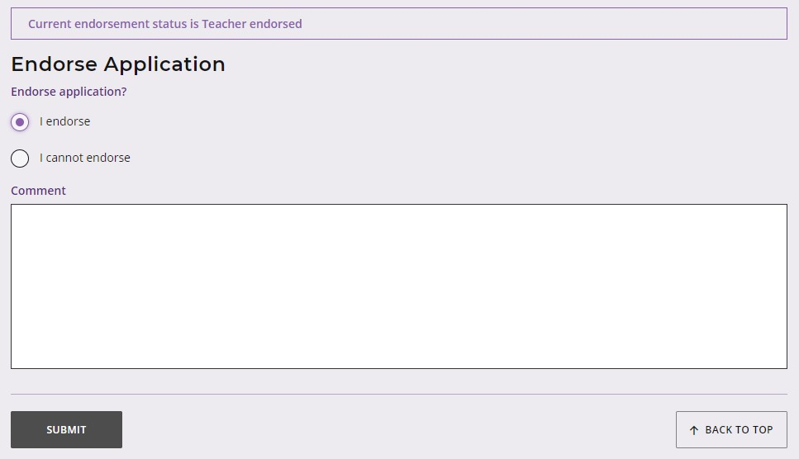
Multiple endorsements
If you wish to endorse multiple applications at the same time, tick the check box underneath the Endorse selected button to select multiple applications (highlighted below).
Click on the Endorse selected button (highlighted below).
A warning will appear, asking if you wish to endorse the applications of the selected students. Click on the Endorse button (highlighted below) to endorse the selected applications. Alternatively, click on the Cancel button (highlighted below) to cancel this multiple endorsement.
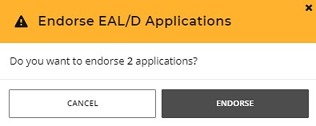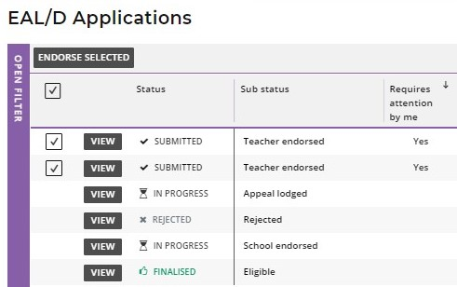
If you choose not to endorse a student’s application, you must add an explanation for your decision. Click on the Submit button (highlighted below), to submit your endorsement.
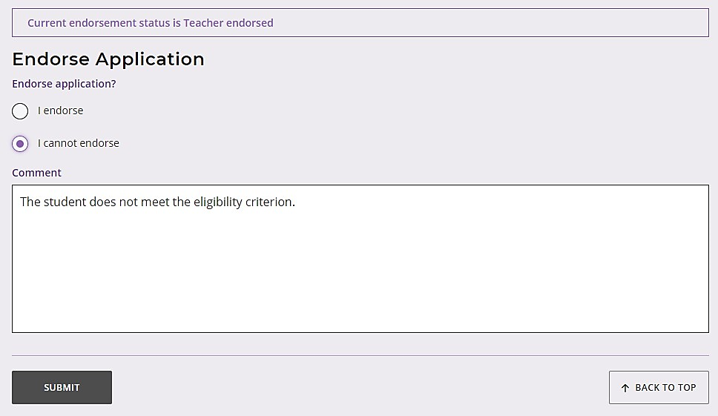
You will see a warning, advising that if you proceed the student may not be eligible to enrol in the Year 12 ATAR EAL/D course.
Click on the Continue button (highlighted below) to proceed. Click on the Cancel button if you decide to return to the Endorse Application panel.
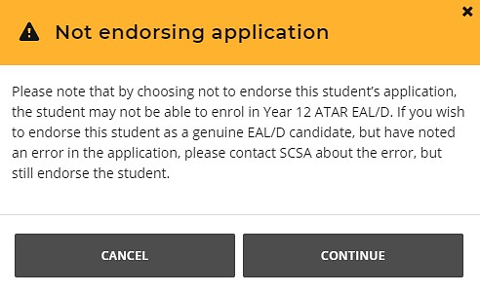
Note: the SCSA reviews all applications that have not been endorsed by the school to determine students’ EAL/D eligibility.
You will return to the EAL/D Applications screen. The Status will show as an hourglass icon and In progress (highlighted below). The Sub status will show as School endorsed (highlighted below). The Requires attention by me column will now be blank, to show that you have completed endorsement of your students’ eligibility applications.
What happens next?
When the EAL/D teacher and principal or deputy principal have endorsed their students’ EAL/D eligibility applications, the SCSA will review the applications and all supporting documents.
If any amendments are required, the student will receive an email. The school cannot make any changes on a student’s behalf. Any further information must be provided by the student in the student portal.
Based on the information provided in each student’s application, and teacher and school endorsement, the SCSA will decide each student’s eligibility to enrol in the Year 12 ATAR EAL/D course.
This determination will show as Eligible or Not eligible in the student portal. The SCSA will also email the outcome to the school.

Step 5: Check the SRMS portal for students’ EAL/D eligibility status
Principals or deputy principals can check the EAL/D Applications screen in the SRMS portal to monitor the progress of students’ applications at any time. The EAL/D Applications screen will update whenever an application advances through the various stages of the application process.
You will notice that the application status will update with the following definitions.
New: new, but incomplete EAL/D eligibility application
Submitted: EAL/D eligibility application has been submitted and is at the teacher endorsement stage
In progress: EAL/D eligibility application that is progressing through the approval stages
Info required: EAL/D eligibility application requires further information or amendment
Finalised: EAL/D eligibility status has been determined for this application
Cancelled: EAL/D eligibility application has been cancelled
Note: students can check the status of their applications by logging in to the student portal. A determination will usually be made between one and five business days after submission.
The status of students’ applications will change from In progress to either Eligible or Not eligible in the student portal. The SCSA will also email the outcome to the school.

Review and appeal processes

Review
If the SCSA decides that a student is Ineligible to enrol, this will be shown in the student portal (highlighted below). If the student thinks that they do meet the criteria, they can request a review of their EAL/D eligibility application by the SCSA. This must be done before the due date, which is shown on the EAL/D notification screen in the student portal.
Note: the review and appeal due dates are also published in the Activities Schedule. If students have any questions, they should contact their school.
To request a review of their EAL/D eligibility application, the student should click on the Request review button (highlighted below) in the student portal. The school cannot request a review on the student’s behalf.
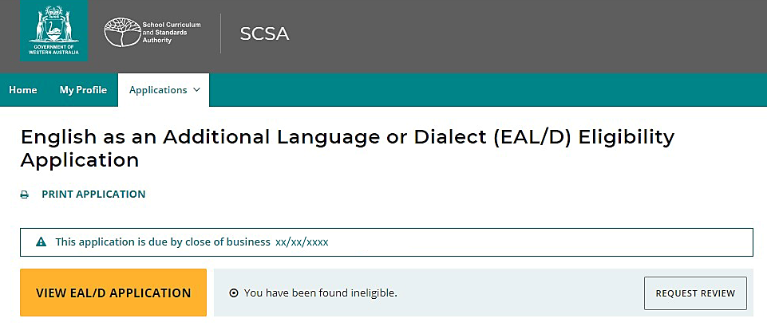
To show that they meet the criteria, the student needs to provide additional evidence, by photographing or scanning one or more documents not previously submitted, uploading it/them and/or typing in additional information. The student should check their document/s and/or comments that they provide because, after submission of the request, they cannot upload other documents or make any changes. They can still view them in read-only mode.
Once all supporting documents have been uploaded, the student should click on the Submit button. If they have not attached at least one additional document, or provided a comment, the request for a review cannot be submitted.
Note: a student can only request one review.
The SCSA will review the student’s application and all additional documentation and/or supporting evidence provided for the review. After the review has been completed, the SCSA will notify the school by email, stating the outcome of the review. The student can also see the outcome of the review in the student portal. The review eligibility status will be either Eligible or Ineligible and the student will be able to view a comment explaining the decision.

Appeal
Following the review of the student’s EAL/D eligibility application, if the SCSA decides that the student is still Ineligible to enrol, this will be shown in the student portal (highlighted below). After the review has been completed, the student can request an appeal of their EAL/D eligibility application by an external EAL/D Eligibility Appeal Panel. This must be done before the due date, which is shown on the EAL/D notification screen in the student portal.
Note: the review and appeal due dates are also published in the Activities Schedule. If students have any questions, they should contact their school.
To request an appeal of their EAL/D eligibility application, the student should click on the Request appeal button (highlighted below) in the student portal. The school cannot request an appeal on the student’s behalf.
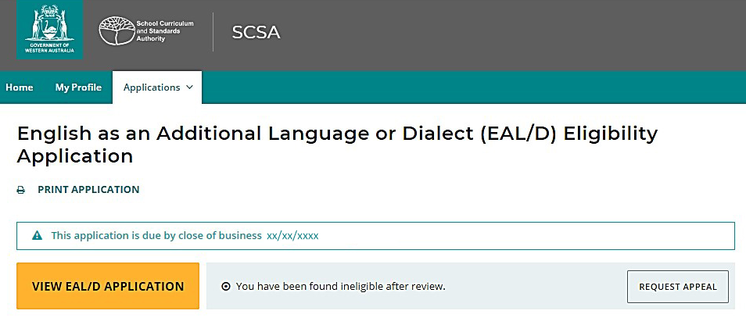
To show that they meet the criteria, the student needs to provide additional evidence, by photographing or scanning one or more documents not previously submitted, uploading it/them and/or typing in additional information. The student should check the document/s and/or comments that they provide because, after submission of the request, they cannot upload other documents or make any changes.
Once all supporting documents have been uploaded, the student should click on the Submit button. If they have not attached at least one additional document, or provided a comment, the request for an appeal cannot be submitted.
Note: a student can only request one appeal.
The EAL/D Eligibility Appeal Panel will review the student’s application and all additional documentation and/or supporting evidence provided for the review and the appeal. After the appeal has been completed, the SCSA will notify the school by email, stating the outcome of the appeal. The student can also see the outcome of the appeal in the student portal. The appeal eligibility status will be either Eligible or Ineligible and the student will be able to view a comment explaining the decision. At this point, the SCSA recommends that the student contact the school to discuss their study options.

