School Curriculum and Standards Authority

Explanation of how school marks and WACE examination marks are used in the calculation of WACE course scores

Introduction

A student who completes a Stage 2 or Stage 3 WACE examination is issued with a WACE course report, which features the WACE course score achieved and the associated standard.

Under these standards, a WACE course score:
- of 75 or more represents excellent achievement
- between 65 and 74.9 represents high achievement
- between 50 and 64.9 represents satisfactory achievement
- between 35 and 49.9 represents limited achievement
- of 34.9 or less represents inadequate achievement.

The course report also includes the school mark and WACE examination mark, which have been used to calculate the student’s WACE course score.

These notes explain how, for each course/stage, a school mark and WACE examination mark are used to create a WACE course score.

The figure at the end of this document shows a pictorial summary of the notes provided below. For the sake of simplicity, these notes refer only to the calculation of a combined mark for the written component of an examination. If a course/stage also has a practical examination (e.g. Dance), exactly the same process is used to produce a combined mark for the practical component.

School marks

A student’s ‘school mark’ for a course/stage is the average of the student’s school marks for the last two units studied.

WACE examination marks

At the end of the year, the School Curriculum and Standards Authority conducts Stage 2 and Stage 3 WACE examinations.

Each WACE examination is set by an independent, expert panel. This ensures the examinations reflect the syllabus and are a fair test of student achievement.

A student’s examination is separately marked by at least two qualified markers under the supervision of a chief marker. The markers have access only to the student number. A student’s name and school are not known to the markers.

If the two markers disagree on a student’s mark for a particular question, or a total mark for a particular section, or for the total mark, they will work together to decide which mark is correct. Where they can’t agree, another marker will re-mark the student’s paper, before the final WACE examination mark is decided.

Standardised WACE examination marks

Each year, course examiners aim to set a WACE examination so that (i) the average WACE examination mark is close to 60 per cent, and (ii) the spread of WACE examination marks provides sufficient discrimination among candidates. In order to prevent perceptions of advantage/disadvantage, particularly when the average is not close to 60 (i.e. it has been particularly easy or difficult to earn marks), the WACE examination marks for a course/stage are ‘standardised’.

As a result of standardisation:
- the top student in each course/stage is given a standardised WACE examination mark of 100
- the average standardised WACE examination mark for each course/stage is approximately 60
- the distribution of standardised WACE examination marks is the same, regardless of the calendar year, course or stage
- there is an assured 50:50 weighting of information from the WACE examination and school mark when creating a combined mark.

If a WACE examination is more difficult than usual, a student’s standardised WACE examination mark in that course/stage may be higher than the student’s WACE examination mark. If, on the other hand, the WACE examination is less difficult than usual, a student’s standardised WACE examination mark in that course/stage may be lower than the student’s WACE examination mark.

Statistical moderation of school marks

It is unlikely that the school marks for a course/stage at different schools are comparable. However, the standardised WACE examination marks of students at all schools are on the same scale and are therefore comparable. Statistical moderation of school marks places them on the same scale as the standardised WACE examination marks at the school. Thus, statistically moderated school marks are comparable in all schools. This process is equivalent to the currency conversion process for amounts of money in different currencies – each amount needs to be converted to a common currency before the values of these amounts can be compared.

Within any particular school, there are likely to be at least small random variations between the school mark and the moderated school mark of individual students. Variations which are largely positive or largely negative suggest a difference between the scale of the standardised WACE examination marks and the scale used by the school when reporting school marks to the Authority.

The ranking of students according to the moderated school marks is the same as their ranking according to the un-moderated school marks, regardless of whether the school’s marks are moderated up or down.

Note that statistical moderation is applied separately to written WACE examination marks and to practical WACE examination marks, where they exist.

Standardising the moderated school mark

The set of state-wide moderated school marks is also standardised using the same process as is used to standardise the WACE examination marks.

Calculating the combined mark

A student’s combined mark for a course/stage is the average of the standardised WACE examination mark and the standardised moderated school mark.

For course/stages with a practical examination, a student’s combined mark for a course/stage is the average of the combined marks for the written component and the practical component.

Calculating the WACE course score

A student’s combined mark for a course/stage is used to determine the student’s WACE course score which provides an assessment of achievement in terms of the standards for the course at that stage.

Each year, a group of experienced educators matches the annual distribution of combined marks for a course/stage with five standards of achievement for the course/stage – Excellent, High, Satisfactory, Limited and Inadequate.

Combined marks at the four boundaries of the standards (Excellent/High, High/Satisfactory, Satisfactory/Limited and Limited/Inadequate) are linked to WACE course scores of 75, 65, 50 and 35 respectively. Based on these points, all other combined marks for the course/stage are converted into WACE course scores. The proportion of students in each achievement band (i.e. at the standards of Excellent, High etc.) varies from course to course and stage to stage. It may also vary from calendar year to calendar year, depending on the overall performance of students in a course/stage in a particular year.

Standards are specific to each stage of a course, and there is no direct comparison between WACE course scores for the two stages of a course. Standards are specific to each course, and there is no direct comparison between WACE course scores for different courses at the same stage.

A student’s WACE course score is likely to differ from the student’s school, examination and combined marks for a course/stage.

For a detailed account of the processes used to standardise examination marks, moderate school marks, and produce WACE course scores, see www.scsa.wa.edu.au/internet/Senior_Secondary/WACE_Examinations/Your_Marks.

Calculating the scaled score (for tertiary admission)

Scaling adjusts for differences in difficulty between courses and aims to ensure that, in terms of access to university, students are not disadvantaged if they choose to study difficult course/stages. The Tertiary Institutions Services Centre (TISC) and the Authority apply the average marks scaling (AMS) method to the combined course marks (see above) of all students who have completed at least four course/stages. This method uses the overall achievements, in other courses, of the group of students studying a particular course/stage to adjust the combined marks of the course/stage to create ‘scaled’ scores.

A student’s scaled score for a course/stage is likely to be different from the student’s school mark, examination mark and combined mark and WACE course score. Because scaled scores from all courses are on a common scale they are used to calculate the tertiary entrance aggregate (TEA) and the Australian tertiary admission rank (ATAR) for university admission purposes. More detailed information about the calculation of scaled scores, the TEA and ATAR is available on the TISC website at www.tisc.edu.au.

WACE
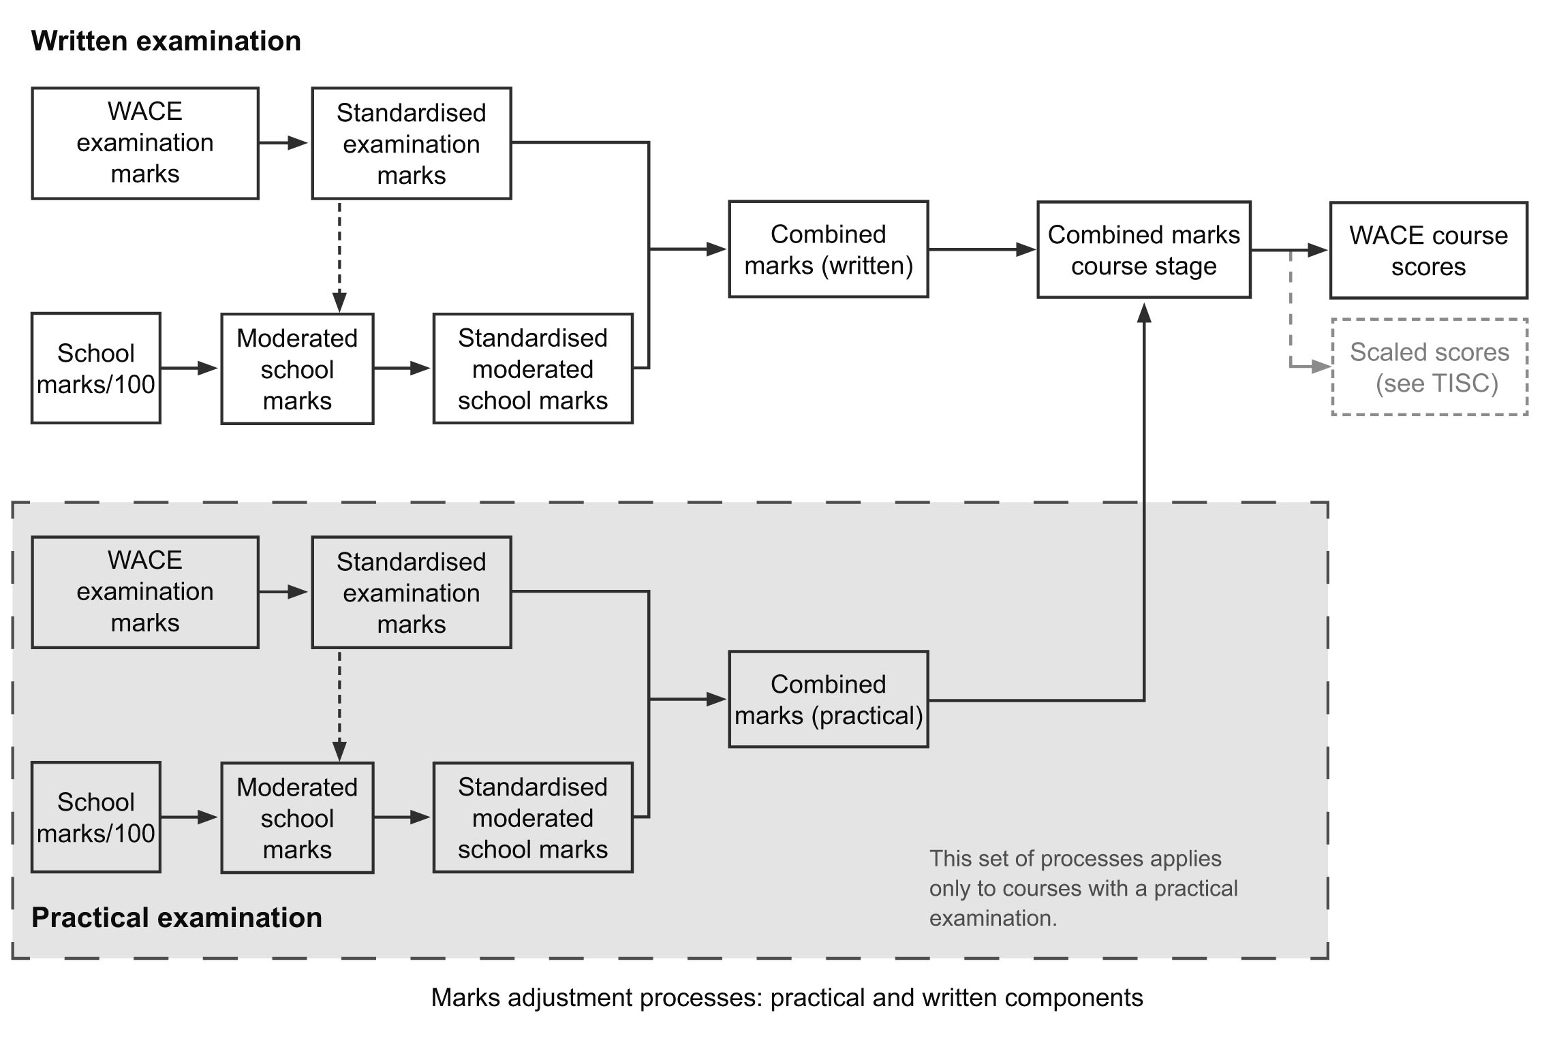

This excludes private candidates.
In fact, this is a weighted average, as specified in the syllabus of the particular course/stage concerned.

