24/06/2024
Student Records Management System
School guide for applications for WACE language courses

Acknowledgement of Country
Kaya. The School Curriculum and Standards Authority (the Authority) acknowledges that our offices are on Whadjuk Noongar boodjar and that we deliver our services on the country of many traditional custodians and language groups throughout Western Australia. The Authority acknowledges the traditional custodians throughout Western Australia and their continuing connection to land, waters and community. We offer our respect to Elders past and present.
Copyright
© School Curriculum and Standards Authority, 2019
This document – apart from any third-party copyright material contained in it – may be freely copied, or communicated on an intranet, for non­commercial purposes in educational institutions, provided that the School Curriculum and Standards Authority (the Authority) is acknowledged as the copyright owner, and that the Authority’s moral rights are not infringed.
Copying or communication for any other purpose can be done only within the terms of the Copyright Act 1968 or with prior written permission of the Authority. Copying or communication of any third-party copyright material can be done only within the terms of the Copyright Act 1968 or with permission of the copyright owners.
Any content in this document that has been derived from the Australian Curriculum may be used under the terms of the Creative Commons Attribution 4.0 International (CC BY) licence.
School Curriculum and Standards Authority
Street address: 303 Sevenoaks Street CANNINGTON WA 6107
Postal address: PO Box 816 CANNINGTON WA 6987
Phone: (08) 9273 6300
General email: info@scsa.wa.edu.au
Web: www.scsa.wa.edu.au
2019/27215v5
Cover photo credit: PeopleImages via iStock

Contents
WACE Language Applications 1
Information for schools 1
School checklist for WACE Language Applications 2
Student checklist for WACE Language Applications 3
Six steps for school support officer documentation 4
Step 1: Log in to the SRMS portal 4
Step 2: Select students’ language applications 7
Step 3: View a student’s language application 9
Step 4: Upload school documents 10
Step 5: Amend a student’s language application 12
Step 6: Check the SRMS portal for language course enrolment status 13
Five steps for language teacher declaration 14
Step 1: Log in to the SRMS portal 14
Step 2: Select students’ language applications 17
Step 3: View a student’s language application 19
Step 4: Complete language teacher declaration 20
Step 5: Check the SRMS portal for WACE language course enrolment status 22
Five steps for principal or deputy principal endorsement 23
Step 1: Log in to the SRMS portal 23
Step 2: Select students’ language applications 26
Step 3: View a student’s language application 28
Step 4: Complete principal or deputy principal endorsement 29
Step 5: Check the SRMS portal for WACE language course enrolment status 31
Appeal process 32

WACE Language Applications
To enrol in a Western Australian Certificate of Education (WACE) language course, students are required to submit an Application for permission to enrol in a WACE Language course (Language Application) to the School Curriculum and Standards Authority (the Authority) via the student portal.
Information about the application process for permission to enrol in a WACE language course is available on the WACE Language applications page of the Authority website (https://senior-secondary.scsa.wa.edu.au/syllabus-and-support-materials/languages).
This user guide is for schools whose students are applying via the student portal (https://studentportal.scsa.wa.edu.au). Refer to the Student guide for applications for WACE language courses, which can be found on the WACE Language applications webpage (https://www.scsa.wa.edu.au/sirs-and-srms-info/srms-information/wace-language-applications).
The due dates for submission of applications are published on the Authority website and in the Activities Schedule.
School support officers will upload documents for each application and language teachers and principals or deputy principals will endorse these applications in the Student Records Management System (SRMS) portal.

Information for schools
We recommend that students complete the application as a group in the classroom, or computer lab, so that teachers can help them and answer any questions. Refer to the student checklist, which lists everything that students need to complete a Language Application.
The personal details that appear at the start of a student’s application are drawn from information in the Student Information Records System (SIRS) that has been provided by the school for that student. Students can see these personal details in the student portal, under My details. If there are any errors in these personal details, the school must amend the information and upload it to SIRS.
The Authority recommends that students print their application and check all information carefully before submission. Students should show their application to their parent/s or guardian/s and ask them to complete and sign the Parent/Guardian Acknowledgement form. When an application has been submitted, it can be viewed as read-only and no further changes can be made, unless requested by the Authority. If changes are required, the school administrator who is assigned the SRMS Languages – school officer role will receive an email.
Refer to the school checklist, which will help school staff prepare for the language application process.
The school support officer should prepare all school documents before commencing the document upload step. Photograph or scan the three school documents for each student and save them as .pdf, .jpg, .jpeg or .png files (maximum size of 4MB for each file) in desktop folders, so that they are ready to upload for each Language Application.

School checklist for WACE Language Applications
Use this checklist to prepare students and school staff for the language application process. If you have any questions, email the Authority at languagesenrolment@scsa.wa.edu.au.
Note: it is important that the assignment of language roles in the SRMS is current.
Logging in to the student portal
1
Students complete their Application for permission to enrol in a WACE Language Course (Language Application) by logging in to the student portal (https://studentportal.scsa.wa.edu.au).
The Authority ensures all students in Years 10, 11 and 12 can access the student portal to complete their Language Applications. Schools with gifted and talented/accelerated language students in Year 9, intending to enrol in a Year 11 Language course, need to request access for those students.
Student submission
2
The Student Checklist helps students prepare to complete their Language Application. Encourage students to save their supporting documents to their computer or mobile device before they start. Students can complete their application at home or at school. The Authority recommends that students intending to enrol in a Year 11 Language course complete their applications as a group in the classroom, or computer lab, so that the language teacher can help them and answer any questions. It should be noted that a Parent/Guardian Acknowledgement form must also be completed and uploaded once a parent/guardian has viewed the application.
School support officer documentation
3
The school support officer is required to upload the three school documents into each student’s Language Application in the SRMS portal (https://srms.scsa.wa.edu.au).
Note: this is not required for students planning to enrol in the Australian Tertiary Admission Rank (ATAR) examination as non-school candidates in Year 12.
To speed up the school document upload step, the school support officer should prepare the school enrolment form, Year 10 Semester 1 school report and the Student Background Data Collection form (previously known as the Ministerial Council on Education, Employment, Training and Youth Affairs (MCEETYA) data collection form) for each student in desktop folders. Photograph or scan the documents and save them as .pdf, .jpg, .jpeg or .png files (maximum size of 4MB for each file). Word documents will not be accepted. Do not use spaces or unrecognisable characters or symbols such as < > ? ! / \ ” * : , # % $ ( ) { } + = @ when naming files.
Teacher and school endorsement
4
The student’s language teacher is required to endorse the Language Application in the SRMS portal (https://srms.scsa.wa.edu.au).
All applications require a teacher declaration to be completed. If the language for which a student is applying is not taught at the school, any teacher at the school who is assigned to the role of Language endorser – teacher in the SRMS can complete the declaration.
Once the teacher has read and endorsed each application, a representative of the school (principal or deputy principal) must also endorse each application on behalf of the school. When completed, the application will proceed to the Authority for processing.
Authority determination
5
The Authority determines each student’s WACE language course enrolment status. Students see this WACE language course determination in the student portal, and it will update to the Student Information Records System (SIRS).

Student checklist for WACE Language Applications
Use this checklist to help students get everything ready before they start their Application for permission to enrol in a WACE Language Course (Language Application). If students have any questions, they can ask their parent/s or guardian/s, their language teacher or school administration, or they can email the Authority at languagesenrolment@scsa.wa.edu.au.
Logging in to the student portal
1
To log in to the student portal (https://studentportal.scsa.wa.edu.au), students need their WA student number, which is on their school report/s. It may also be on their SmartRider. They also need a personal email address and must be able to access their personal email account when they complete their Language Application. Using a personal email address allows students to receive emails after they have left school, and their school email address has expired.
Educational information
2
Students need to provide the following education information:
- details of the schools they attended for each school year from Pre-primary:
- name of the school
- main language used for instruction at the school
- language/s studied (if any)
- hours of language study per week (if any)
- school report/s for years where they attended school/s outside Australia (if any)
3
Residential information
Students need to provide the following residential details:
- countries they have lived in
- countries they have visited/travelled to/holidayed in, including the reason/s for and length of in-country visit/s. This includes only countries where the language spoken is the same as the one for which they are applying
Linguistic background
4
Students need to provide the following linguistic details:
- the first language/s they learned to speak
- other language/s they speak, read and write
- the language/s they speak with their parent/s or guardian/s and with their siblings and friends
- the language/s their parent/s or guardian/s speak
5
Supporting documents
Students need to photograph or scan the following documents for upload into their applications:
- completed Parent/Guardian Acknowledgement form – mandatory
- passport identification page – if they were born in another country or have lived outside Australia
- school report/s – if they have attended school/s outside Australia
- international movement record/s – if they have lived in or frequently travelled to countries or places where the language for which they are applying is spoken (and if requested by the Authority)
Students should save their supporting documents to their computer or mobile device as .pdf, .jpg, .jpeg or .png files (maximum size of 4MB each). They will not be able to upload Word documents, and should not use spaces or unrecognisable characters or symbols such as < > ? ! / \ ” * : , # % $ ( )
{ } + = @ when naming files.

Six steps for school support officer documentation
A system-generated email will prompt the school support officer (the school administrator who is assigned the SRMS Languages – school officer role) to view all applications received for their students and upload the required school documents in the SRMS portal.

Step 1: Log in to the SRMS portal
Log in to the SRMS portal (https://srms.scsa.wa.edu.au).
Government and non-government schools will see the login screen below.
Government (public) schools
The first time you log in, click on and read the login instructions (highlighted below).
Click on the education.wa.edu.au LOGIN button (highlighted below) in the government school login panel.
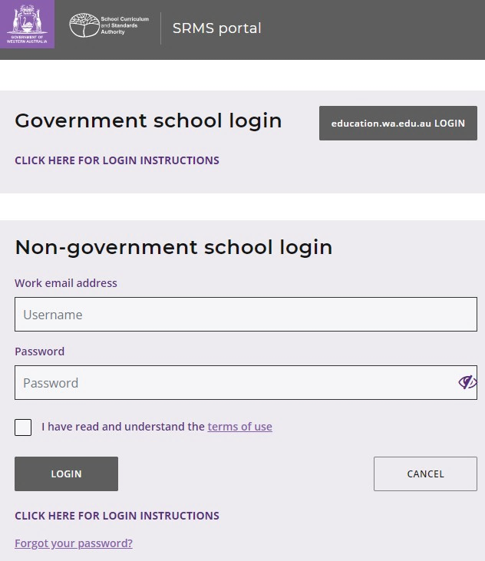
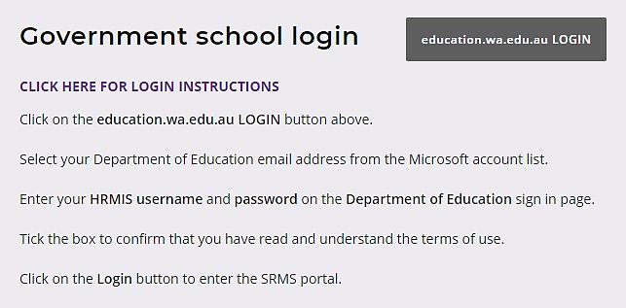
Select your Department of Education (Department) email address from the Microsoft account list (shown below).
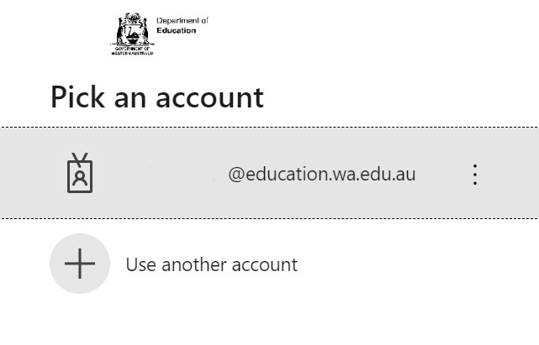
You will be taken to the Department sign in page.
Enter your password and click on the Sign in button (highlighted below) to enter the SRMS portal.
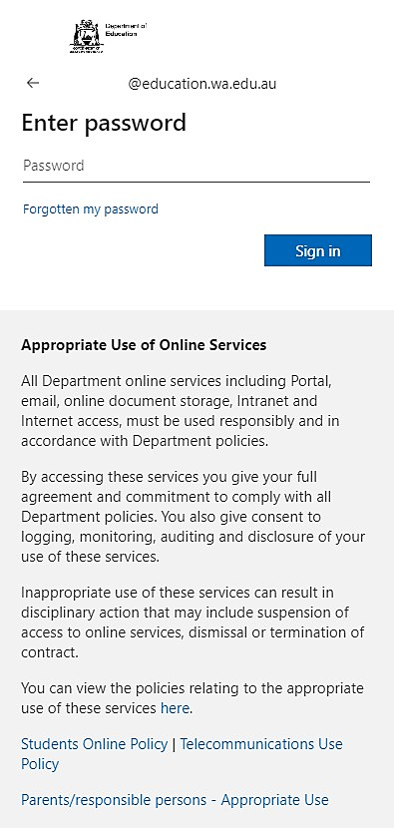
Non-government schools
The first time you log in, click on and read the login instructions (highlighted below). Contact your school administrator if you have not received the email with the link.
Enter your work email address and password in the non-government school login panel.
Tick the check box (highlighted below) to show that you have read and understand the terms of use.
Click on the Login button (highlighted below) to enter the SRMS portal.
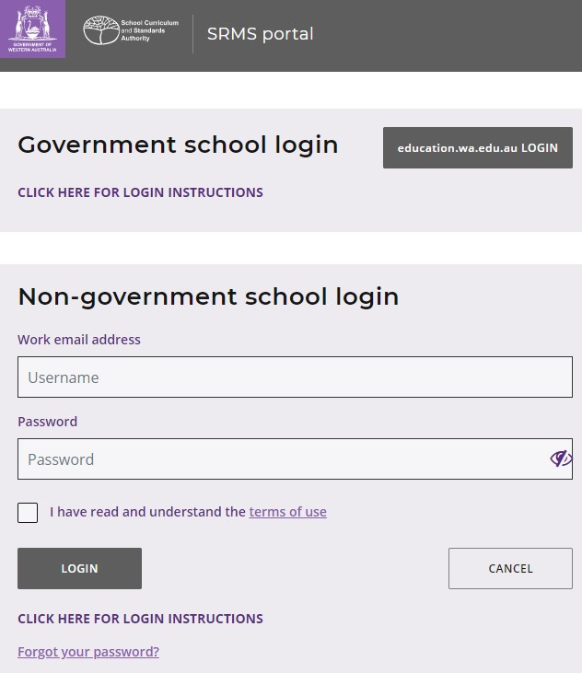

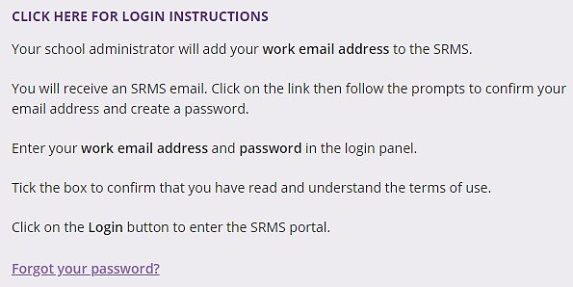
If you forget your password, click on Forgot your password.
Enter your work email address and tick the check box to confirm that you are not a robot. You will be prompted to select images as part of the verification process, then invited to choose another password.

Step 2: Select students’ language applications
Select Language Applications from the Student Applications drop-down list (highlighted below).
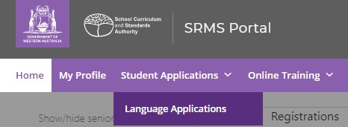
All submitted language applications from students at your school will be displayed on the screen.
You will see the list of all 10 WACE languages in the filter section on the left of the screen.
The Status column shows submitted student applications, with a tick and Submitted (highlighted below). The Sub status column shows as Documents (highlighted below), which is the first stage for schools to complete in the WACE language application process.
The Requires attention by me column shows as Yes (highlighted below), advising you to upload the school documents for each student’s application.
The applications that require your attention will appear at the top of the list.
You will see the number of applications that require your attention (highlighted below). This number will update as you complete the required action.
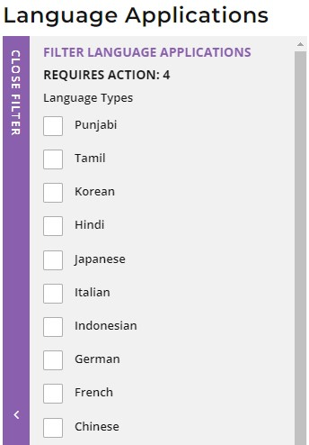
Filter students’ language applications
To retrieve specific applications, you can use the filter options on the left side of the Language Applications screen. For example, tick the Japanese check box (highlighted below) and click on the Search button (highlighted below) to see all submitted Japanese applications.
To retrieve a specific student’s application, type their Given name and/or Family name, or Student number into the search fields, then click on the Search button (all highlighted below).
Click on the Reset button (highlighted below) to reset the filters and view all the applications.
You can choose to display the filter options or not by clicking on the Close filter/Open filter command on the left side of the Language Applications screen.
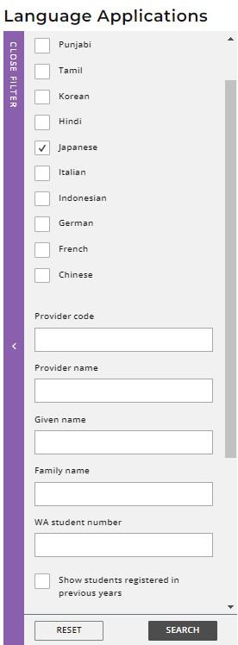
C
Use the Application status check boxes to filter applications by their status. The Submitted and In progress check boxes are preselected to show all submitted applications that are at the school stage and those that are being processed by the Authority (highlighted below).
Tick the New check box to see applications that students have started but not submitted, tick the Info required check box to show all submitted applications where additional information is required from the student or tick the Finalised check box to see all finalised applications.
Tick any of the additional filter check box/es and click on the Search button (both highlighted below) to view these categories of applications.
Click on the Reset button (highlighted below) to reset the filters to the preselected view.
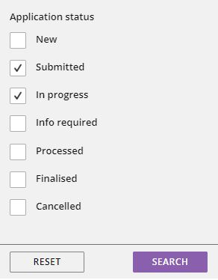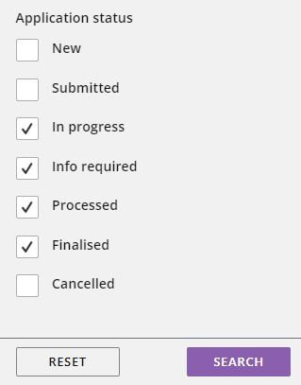

Step 3: View a student’s language application
Click on the View button (highlighted below) to view the details and supporting document/s in that student’s application.
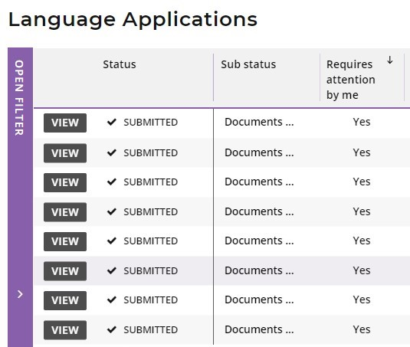

Step 4: Upload school documents
Scroll down to the School support officer section. Click on the Select document type tab to see the list of required school documents:
- School enrolment form
- Year 10 Semester 1 school report
- Student Background Data Collection form (previously known as Ministerial Council on Education, Employment, Training and Youth Affairs (MCEETYA) Data Collection form).
If your school enrolment form includes the language/s spoken at home by the student, parent/guardian 1 and parent/guardian 2, you can upload the school enrolment form twice; i.e. the same document for the school enrolment form, and for the Student Background Data Collection form (previously known as MCEETYA Data Collection form). It should be noted, however, the Student Background Data Collection form will not be accepted in lieu of the student’s school enrolment form.
Documents must be saved as .pdf, .jpg, .jpeg or .png files, with a maximum size of 4MB for each file. You will not be able to upload Word documents. Do not use spaces or unrecognisable characters or symbols, such as < > ? ! / \ " * : , ‘ # % & ( ) { } + = @ when naming files.
Select the first document from the drop-down list (highlighted below). Click on the Browse button (highlighted below) to select the file from your computer and click on the Open button (Upload button on a Mac) to upload this file. When you have uploaded the first document, the status will show as Saved. Repeat this process for all three documents.
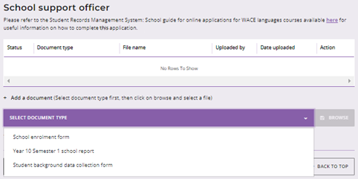
If you upload a document by mistake, click on the Remove button (highlighted below) then upload the correct document. Click on the Submit button (highlighted below) to submit these documents.
If a student has not uploaded a required document, you can upload it here (using any Document Type).

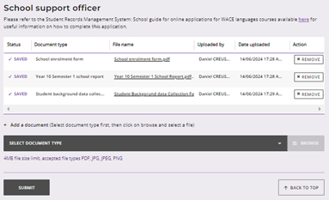
You will return to the Language Applications screen. The Status column will show a tick and Submitted. The Sub status column shows as Teacher (highlighted below), to indicate the application has moved to the teacher declaration stage of the language application process. The Requires attention by me column will be blank, to show that you have uploaded the required school documentation for that student.
Note: the application that you have just completed will now appear at the bottom of your list.
Once you have submitted the application, you will not be able to make any changes unless requested by the Authority.
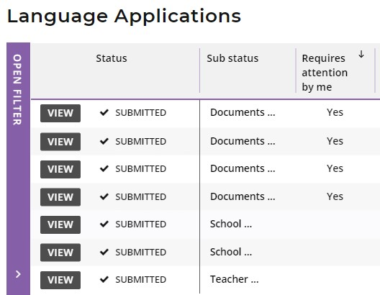
Non-school candidates
If a student has selected Yes to the statement about enrolment as a non-school candidate (NSC), this will show as Yes (highlighted below) in the Non School column on the Language Applications screen.
The school support officer does not need to upload any supporting documents for a student’s NSC language application.
The Status column will show a tick and Submitted, but any NSC applications will skip the Documents stage in the Sub status column.
These NSC applications will show as Teacher (highlighted below) in the Sub status column, to indicate that the application has moved to the teacher declaration stage.
The Requires attention by me column will be blank for the school support officer. When the language teacher views this NSC application, they will be prompted to complete their teacher declaration.
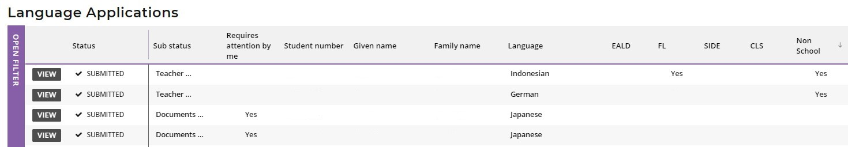

Step 5: Amend a student’s language application
The Authority will review the application and supporting documents. If further information or any changes are required to the application by the student, you will be copied into an email requesting the student to amend their application.
If the Authority requests an amendment/s by the school to a student’s application, you will see this on the Language Applications screen. If the student also needs to amend the application, you will need to wait until those amendments have been submitted before making your changes.
The Authority may request an amendment/s if incorrect document/s have been uploaded to a student’s application, if the document/s were blank or could not be opened, or if the document/s do not provide sufficient information about that student’s linguistic background.
The Sub status shows as Documents again and the Requires attention by me column shows as Yes (both highlighted below), prompting you to upload any new or amended document/s, as required.
Click on the View button (highlighted below) to see the change/s for that student’s application.
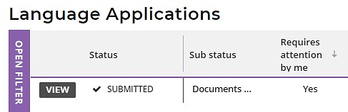
The amendment/s required will be listed.
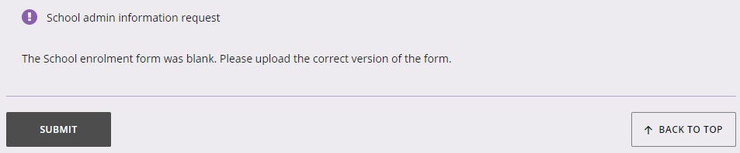
Repeat the process of uploading the new or amended document/s and click on the Submit button (highlighted below) to submit the amended application.
This student’s application will now proceed to the processing stage with the Authority.

Step 6: Check the SRMS portal for language course enrolment status
At any time, you can check the Language Applications screen in the SRMS portal to monitor the progress of students’ applications.
The Language Applications screen will update whenever an application advances through the stages of the enrolment process.
Below are terms you will see throughout the language application process that relate to the status and sub status of students’ applications.
Status
New | Language application has been started, but not submitted
Submitted | Language application has been submitted by the student
In progress | Language application is progressing through the processing stages
Info required | Language application is being amended by the student
Finalised | WACE language course status has been published and received by the student
Cancelled | Language application has been cancelled

Sub status
Documents | School support officer to upload new or amended documents
Teacher | Language teacher to complete declaration of language application
School | Principal or deputy principal to complete endorsement of language application
Received | Language application received by the Authority
Languages PC1 | Principal Consultant 1 to determine which WACE language course the student may enrol in
Languages PC2 | Principal Consultant 2 to determine which WACE language course the student may enrol in
Manager | Manager to review Principal Consultants’ determinations
To publish | Principal Consultant 1 or Principal Consultant 2 to publish WACE language course enrolment determination
Language | Publication of Second Language, Background Language or First Language status for WACE language course enrolment

Five steps for language teacher declaration
A system-generated email will alert the language teacher/s who are assigned the SRMS Languages endorser – teacher role to all applications received for their students on that day and prompt them to complete the teacher declaration in the SRMS portal.

Step 1: Log in to the SRMS portal
Log in to the SRMS portal (https://srms.scsa.wa.edu.au).
Government and non-government schools will see the login screen below.
Government (public) schools
The first time you log in, click on and read the login instructions (highlighted below).
Click on the education.wa.edu.au LOGIN button (highlighted below) in the government school login panel.
Select your Department of Education (Department) email address from the Microsoft account list (shown below).
You will be taken to the Department sign in page.
Enter your password and click on the Sign in button (highlighted below) to enter the SRMS portal.
Non-government schools
The first time you log in, click on and read the login instructions (highlighted below). Contact your school administrator if you have not received the email with the link.
Enter your work email address and password in the non-government school login panel.
Tick the check box (highlighted below) to show that you have read and understand the terms of use.
Click on the Login button (highlighted below) to enter the SRMS portal.

If you forget your password, click on Forgot your password.
Enter your work email address and tick the check box to confirm that you are not a robot. You will be prompted to select images as part of the verification process, then invited to choose another password.

Step 2: Select students’ language applications
Select Language Applications from the Student Applications drop-down list (highlighted below).
All submitted language applications from students at your school will be displayed on the screen.
You will see all 10 WACE languages in the filter section on the left of the screen.
The Status column shows a tick and Submitted, and the Sub status column will say Teacher (both highlighted below) indicating that the application is at the teacher declaration stage. The Requires attention by me column shows as Yes (highlighted below) for any application where the student selected your name as their teacher, advising you to complete your teacher declaration.
You may see other students’ applications, but with no action required by you. Other language teacher/s at your school will be prompted to act, because the students selected their name/s. For applications where the student has selected My teacher is not listed here, the Sub status column will show as Teacher, but the Requires attention by me column will be blank. Anyone with the role of Languages endorser – teacher can complete the teacher declaration for these language applications. Your school administration will assign a teacher to action these applications. The applications that require your attention will appear at the top of the list.
You will see the total number of applications that require attention by language teacher/s at your school (highlighted below). This number is calculated using the role of language teacher, rather than a named teacher, so the number may be greater than the number of applications that require your attention. This number will update as each teacher completes the required action.
Filter students’ language applications
To retrieve specific applications, you can use the filter options on the left side of the Language Applications screen. For example, tick the French check box (highlighted below) and click on the Search button (highlighted below) to see all French applications.
To retrieve a specific student’s application, type their Given name and/or Family name or Student number into the search fields, and then click on the Search button (all highlighted below).
Click on the Reset button (highlighted below) to reset the filters and view all the applications.
You can choose to display the filter options or not by clicking on the Close filter/Open filter command on the left side of the Language Applications screen.
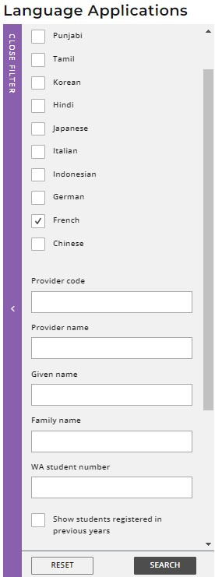
C
Use the Application status check boxes to filter applications by their status. The Submitted and In progress check boxes are preselected to show all submitted applications that are at the school stage and those that are being processed by the Authority (highlighted below).
Tick the New check box to see applications that students have started but not submitted, tick the Info required check box to show all submitted applications where additional information is required from the student or tick the Finalised check box to see all finalised applications.
Tick any of the additional filter check box/es and click on the Search button (both highlighted below) to view these categories of applications.
Click on the Reset button (highlighted below) to reset the filters to the preselected view.

Step 3: View a student’s language application
Click on the View button (highlighted below) to view the details and supporting documents in that student’s application.
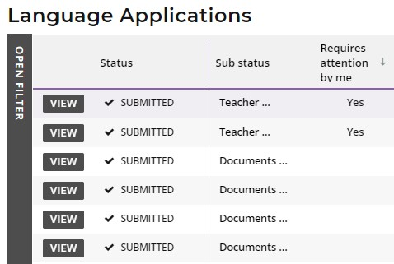

Step 4: Complete language teacher declaration
After reviewing the student’s Language Application, scroll down to the Teacher declaration section. Select your teacher declaration from the seven options shown below.
You may enter an explanation for your declaration in the Comment text box, but this is optional.
If you see any errors in the student’s application, add these details in the Comment text box to assist the Authority.
Click on the Submit button (highlighted below) to submit your declaration.
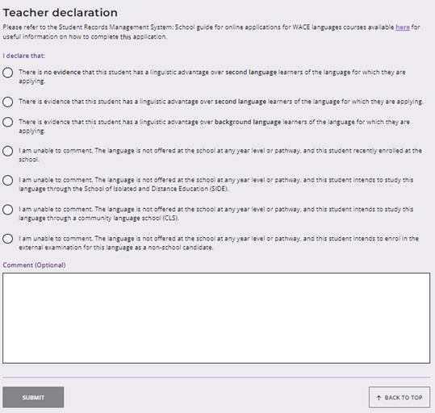
You will return to the Language Applications screen. The Status column will show as Submitted and the Sub status column will show as School (highlighted below), indicating that the application has moved to the principal/deputy principal endorsement stage.
The Requires attention by me column will be blank to show that you have completed your declaration for that student’s application, which will appear at the bottom of your list.
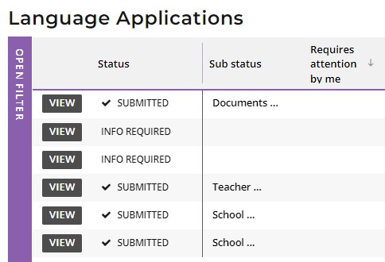

The Teacher declaration column will show your selection: Second Language (SL), Background Language (BL), First Language (FL), recently enrolled (NEW), non-school candidate (NSC), School of Isolated and Distance Education (SIDE), or community language school (CLS).
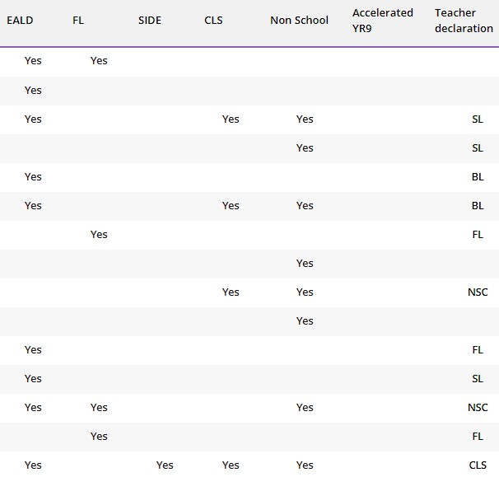

Step 5: Check the SRMS portal for WACE language course enrolment status
Language teachers can check the Language Applications screen in the SRMS portal to monitor the progress of students’ applications at any time.
The Language Applications screen will update whenever an application advances through the stages of the enrolment process.
Below are terms you will see throughout the language application process that relate to the status of students’ applications.
Status
New | Language application has been started, but not submitted
Submitted | Language application has been submitted by the student
In progress | Language application is progressing through the processing stages
Info required | Language application is being amended by the student
Finalised | WACE language course status has been published and received by the student
Cancelled | Language application has been cancelled

Sub status
Documents | School support officer to upload new or amended documents
Teacher | Language teacher to complete declaration of language application
School | Principal or deputy principal to complete endorsement of language application
Received | Language application received by the Authority
Languages PC1 | Principal Consultant 1 to determine which WACE language course the student may enrol in
Languages PC2 | Principal Consultant 2 to determine which WACE language course the student may enrol in
Manager | Manager to review Principal Consultants’ determinations
To publish | Principal Consultant 1 or Principal Consultant 2 to publish WACE language course enrolment determination
Language | Publication of Second Language, Background Language or First Language status for WACE language course enrolment

Five steps for principal or deputy principal endorsement
A system-generated email will prompt the principal or deputy principal who is assigned the SRMS Languages endorser – school role to endorse a student’s application in the SRMS portal.

Step 1: Log in to the SRMS portal
Log in to the SRMS portal (https://srms.scsa.wa.edu.au).
Government and non-government schools will see the login screen below.
Government (public) schools
The first time you log in, click on and read the login instructions (highlighted below).
Click on the education.wa.edu.au LOGIN button (highlighted below) in the government school login panel.
Select your Department of Education (Department) email address from the Microsoft account list (shown below).
You will be taken to the Department sign in page.
Enter your password and click on the Sign in button (highlighted below) to enter the SRMS portal.
Non-government schools
The first time you log in, click on and read the login instructions (highlighted below). Contact your school administrator if you have not received the email with the link.
Enter your work email address and password in the non-government school login panel.
Tick the check box (highlighted below) to show that you have read and understand the terms of use.
Click on the Login button (highlighted below) to enter the SRMS portal.

If you forget your password, click on Forgot your password.
Enter your work email address and tick the check box to confirm that you are not a robot. You will be prompted to select images as part of the verification process, then invited to choose another password.

Step 2: Select students’ language applications
Select Language Applications from the Student Applications drop-down list (highlighted below).
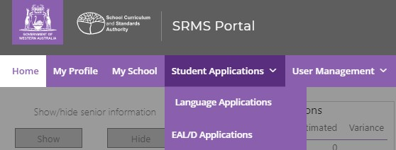
All submitted language applications from students at your school will be displayed on the screen.
You will see the list of all 10 WACE languages in the filter section on the left of the screen.
The Status column shows submitted language applications, with a tick and Submitted and the Sub status column shows as School (both highlighted below).
The Requires attention by me column shows as Yes (highlighted below), advising you to certify each student’s application.
The applications that require your attention will appear at the top of the list.
You will see the number of applications that require your attention (highlighted below). This number will update as you complete the required action.
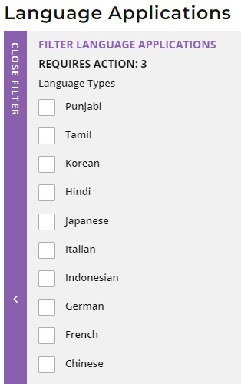
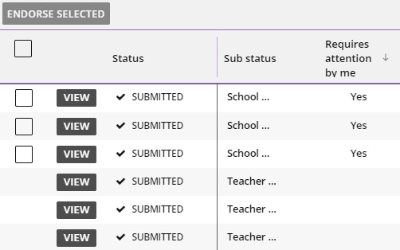
Filter students’ language applications
To retrieve specific applications, use the filter options on the left side of the Language Applications screen. For example, tick the Tamil check box (highlighted below) and click on the Search button (highlighted below) to see all Tamil applications.
To retrieve a specific student’s application, type their Given name and/or Family name, or Student number into the search fields, and then click on the Search button (all highlighted below).
Click on the Reset button (highlighted below) to reset the filters and view all the applications.
You can choose to display the filter options or not by clicking on the Close filter/Open filter command on the left side of the Language Applications screen.
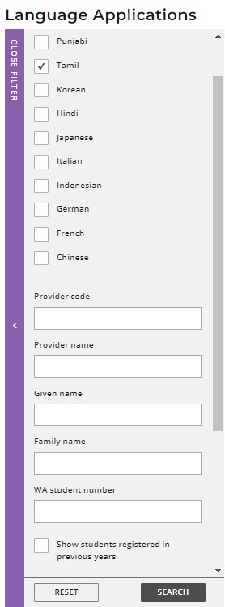
C
Use the Application status check boxes to filter applications by their status. The Submitted and In progress check boxes are preselected to show all submitted applications that are at the school stage and those that are being processed by the Authority (highlighted below).
Tick the New check box to see applications that students have started but not submitted, tick the Info required check box to show all submitted applications where additional information is required from the student or tick the Finalised check box to see all finalised applications.
Tick any of the additional filter check box/es and click on the Search button (both highlighted below) to view these categories of applications.
Click on the Reset button (highlighted below) to reset the filters to the preselected view.

Step 3: View a student’s language application
Click on the View button (highlighted below) to view the details and supporting documents in that student’s application.
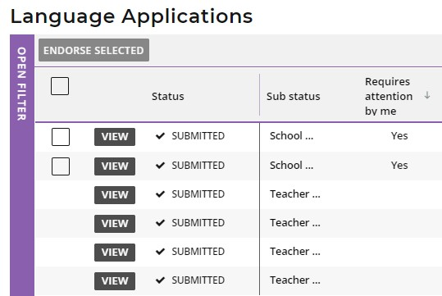

Step 4: Complete principal or deputy principal endorsement
After you have reviewed each student’s application, scroll down to the bottom of the application to the Declaration by the Principal section.
Select either I endorse this application, or I am unable to endorse this application.
It is optional to add a comment if you endorse the student’s application, but you must provide an explanation if you are unable to endorse the application. If you are unable to endorse a student’s application and have not provided a comment, you will not be able to submit your endorsement.
Click on the Submit button (highlighted below) to submit your declaration.
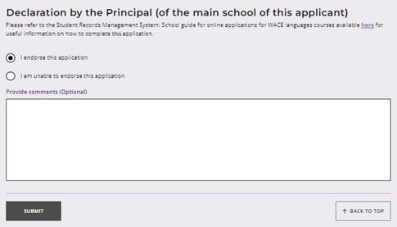
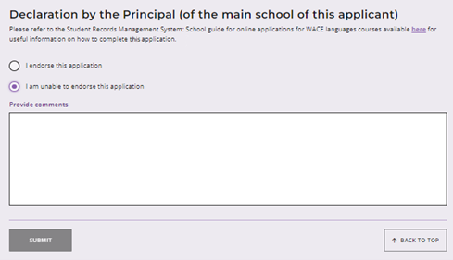

Multiple endorsements
After viewing the applications, if you wish to endorse multiple applications, tick the check box (highlighted below) underneath the Endorse selected button to select multiple applications.
Click on the Endorse selected button (highlighted below). A warning will appear, asking if you wish to endorse the applications of the selected students. Click on the Endorse button (highlighted below) to endorse the selected applications. Alternatively, click on the Cancel button (highlighted below) to cancel this multiple endorsement and endorse the applications individually.
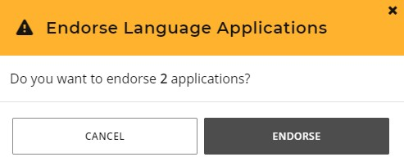
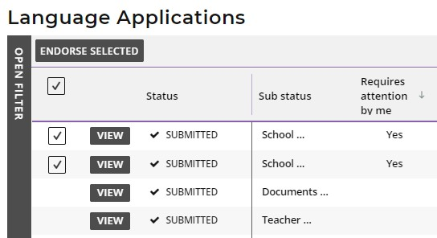
C
You will return to the Language Applications screen. The Status will show as In progress (highlighted below) and the Sub status will show as Received (highlighted below) to show that this application has been received by the Authority. The Requires attention by me column will be blank, indicating that you have endorsed your school’s applications.
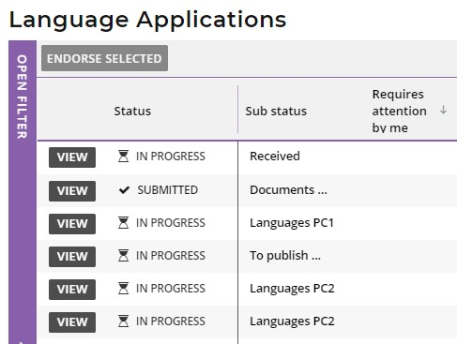
If the Authority requires any further information, or amendments to be made to a student’s application, students will receive an email notifying them of this. The school administrator who has been assigned the SRMS Languages – school officer role will receive a copy of this email. Students will also see this notification in the student portal.
If the Authority requires any further information, or amendments to be made to a student’s application by the school, the school administrator who has been assigned the SRMS Languages – school officer role will receive an email notifying them of this.

Step 5: Check the SRMS portal for WACE language course enrolment status
Principals or deputy principals can check the Language Applications screen in the SRMS portal to monitor the progress of their students’ applications at any time.
The Language Applications screen will update whenever an application advances through the stages of the enrolment process.
Below are terms you will see throughout the language application process that relate to the status of students’ applications
Status
New | Language application has been started, but not submitted
Submitted | Language application has been submitted by the student
In progress | Language application is progressing through the processing stages
Info required | Language application is being amended by the student
Finalised | WACE language course status has been published and received by the student
Cancelled | Language application has been cancelled

Sub status
Documents | School support officer to upload new or amended documents
Teacher | Language teacher to complete declaration of language application
School | Principal or deputy principal to complete endorsement of language application
Received | Language application received by the Authority
Languages PC1 | Principal Consultant 1 to determine which WACE language course the student may enrol in
Languages PC2 | Principal Consultant 2 to determine which WACE language course the student may enrol in
Manager | Manager to review Principal Consultants’ determinations
To publish | Principal Consultant 1 or Principal Consultant 2 to publish WACE language course enrolment determination
Language | Publication of Second Language, Background Language or First Language status for WACE language course enrolment

Appeal process
Should the Authority determine that a student does not meet the enrolment criteria for a course and is therefore not permitted to enrol in a Second or Background Language course, this will be shown in the student portal.
If a student has additional information that shows that they do meet the enrolment criteria for the Second or Background Language course, they can request an appeal with the Authority.
They must do this within two weeks of receiving their WACE language course enrolment notification in the student portal.
The Language pathway for each student is determined as follows:
Second language – a student will be considered for the second language pathway if the information provided in the Language Application satisfies all three criteria for the Second language pathway
Background language – a student will be considered for the background language pathway if the information in the Language Application satisfies at least one criterion for the Background language pathway
First language – a student will be considered for the first language pathway if the information in the Language Application satisfies, in addition to the Use of the language for communication outside the language classroom criterion, at least one other criterion of the First language pathway.
To request an appeal, download and complete the Application form for appeal against languages enrolment determination, which you can find on the Applications and Order forms page of the Authority website. To show that they meet the enrolment criteria, they will need to provide additional information with their Appeal Application form.
Students should email their completed Appeal Application form and additional information to languagesenrolment@scsa.wa.edu.au.
Note: students can lodge only one appeal for each WACE Language Application they submit.
The Languages Enrolment Determinations Appeals Committee will review their Appeal Application form and the additional information.
After the appeal is completed, the Authority will notify the student and their parent/s or guardian/s by email, stating the outcome of the appeal.
At this point, the student should discuss their study options with their school.

