Student portal
Student guide for online EAL/D eligibility applications: international

Student Records Management System
School administrator’s guide for dashboard navigation: international
Acknowledgement of Country
Kaya. The School Curriculum and Standards Authority (the SCSA) acknowledges that our offices are on Whadjuk Noongar boodjar and that we deliver our services on the country of many traditional custodians and language groups throughout Western Australia. The SCSA acknowledges the traditional custodians throughout Western Australia and their continuing connection to land, waters and community. We offer our respect to Elders past and present.
Copyright
© School Curriculum and Standards Authority, 2019
This document – apart from any third party copyright material contained in it – may be freely copied, or communicated on an intranet, for non­commercial purposes in educational institutions, provided that the School Curriculum and Standards Authority (the SCSA) is acknowledged as the copyright owner, and that the SCSA’s moral rights are not infringed.
Copying or communication for any other purpose can be done only within the terms of the Copyright Act 1968 or with prior written permission of the SCSA. Copying or communication of any third party copyright material can be done only within the terms of the Copyright Act 1968 or with permission of the copyright owners.
Any content in this document that has been derived from the Australian Curriculum may be used under the terms of the Creative Commons Attribution 4.0 International licence.
School Curriculum and Standards Authority
Street address: 303 Sevenoaks Street CANNINGTON WA 6107
Postal address: PO Box 816 CANNINGTON WA 6987
Phone: (08) 9273 6300
General email: info@scsa.wa.edu.au
Web: www.scsa.wa.edu.au
Cover photo credit: londoneye via iStock

Contents
Introduction 1
Five steps in the online EAL/D eligibility process 1
Checklist 2
Step 1: Log in to the student portal 4
Set up your personal email address 5
Set up your new password 6
Complete your Student Declaration and Permission 6
Returning to the student portal 7
Step 2: Start your EAL/D eligibility application 8
Your details 8
1: EAL/D application type 9
2: Residential information 10
3: Educational background 11
Step 3: Upload your supporting documents 13
4: Supporting documents 13
Step 4: Submit your EAL/D eligibility application 15
Amend your EAL/D eligibility application 16
Step 5: Check the student portal for your EAL/D eligibility status 17
Review and appeal processes 18
Request a review 18
Request an appeal 19

Introduction
To enrol in the Year 12 Australian Tertiary Admission Rank (ATAR) English as an Additional Language or Dialect (EAL/D) course, you must submit an online EAL/D eligibility application to the School Curriculum and Standards Authority (the SCSA).
This user guide shows you how to submit an EAL/D eligibility application via the student portal (https://studentportal.scsa.wa.edu.au).
Information about the application process for EAL/D eligibility and the submission dates for applications can be found on the EAL/D page
(https://senior-secondary.scsa.wa.edu.au/syllabus-and-support-materials/english/english-as-an-additional-language-or-dialect) of the SCSA website.

Five steps in the online EAL/D eligibility process
As outlined in this guide, there are five steps to follow to apply for EAL/D eligibility:
Step 1: Log in to the student portal
Step 2: Start your EAL/D eligibility application
Step 3: Upload your supporting documents
Step 4: Submit your EAL/D eligibility application
Step 5: Check the student portal for your EAL/D eligibility status

Checklist
Use this checklist to make sure that you have everything you need before you start your application. To complete your online application, you will need to use a computer, either at home or at school. If you have any questions, ask your parent/s or EAL/D teacher to help you.
Logging in to the student portal
1
To log in to the student portal, you will need your WA student number, which you will find on your school report/s. You will also need a personal email address and must be able to access your personal email account when you complete your online application.
Residential information
2
You will need to provide the following details:
- country of birth
- total time you have lived in a predominantly English-speaking country*
- country of birth – mother and father (or carer/s)
- countries you have lived in†
- nationality
- languages you speak at home
* countries where English is the primary and/or official language
† countries where you have lived as a resident, not countries that you have visited on holiday
3
Educational background
Make sure you have:
- details of the schools you attended for every school year from Year 1:
- name of the school
- country where the school is located
- calendar years you attended the school
- international school status‡
- main language of school delivery
- percentage of course delivery in English
- school report/s for years where you attended school where English was not the main medium of course delivery
‡ schools that teach an international curriculum
4
Supporting documents
You will need to photograph or scan the following documents:
- passport identification page or identification card
- school report/s
Save the supporting documents to your computer or mobile device as .pdf, .jpg, .jpeg or .png files, with a maximum size of 4MB for each file. Word documents will not be accepted.
You must use English letters to name your files.

Step 1: Log in to the student portal
Log in to the student portal (https://studentportal.scsa.wa.edu.au).
You will find this link on the SCSA website, under Useful Links (highlighted below).
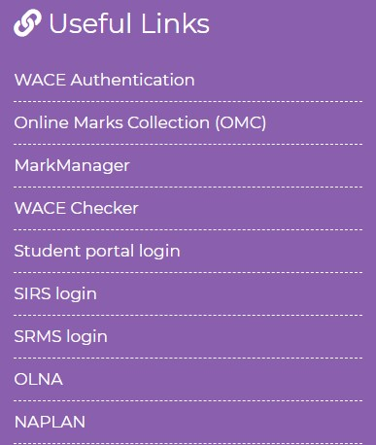
Enter your WA student number, which you will find on your school report/s.
Your initial password is a combination of your family name and date of birth — Nnddmmyyyy:
- Nn = the first two letters of your family name: the first as a capital letter (A–Z) and the second as a lower case letter (a–z), excluding any punctuation or spaces
- ddmmyyyy = your date of birth in day month year format.
Tick the check box (highlighted below) to show that you have read and understand the terms of use and click on the Login button (highlighted below) to enter the student portal.
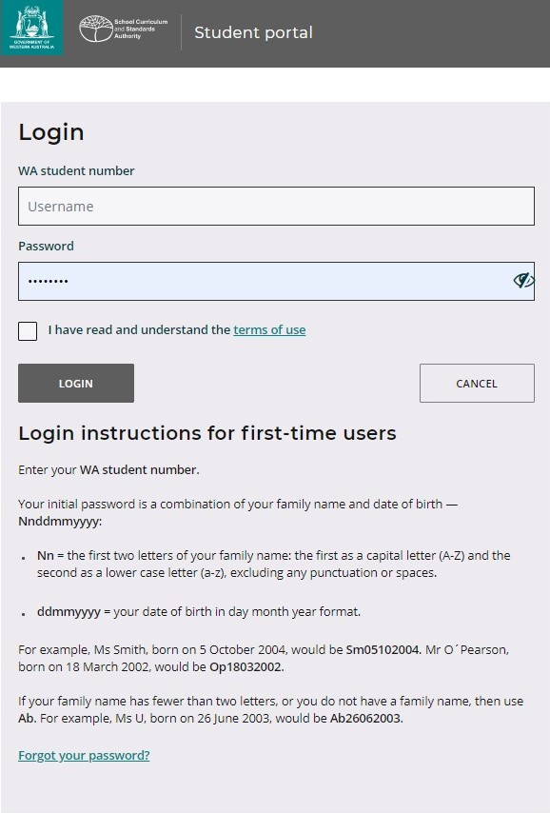

Set up your personal email address
When logging in for the first time, you will be asked to enter your personal email address. Choose an email address that you use frequently and click on the Set button (highlighted below).
Note: you need to use a personal email address so that you will be able to receive emails after you have left school and your school email address has expired.
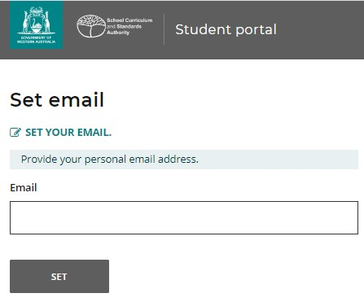
A confirmation email will be sent to this email address.
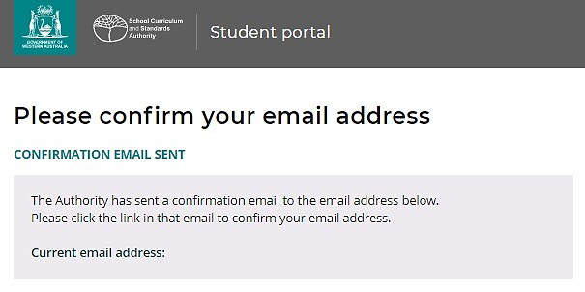
Go to your personal email account and click on the link in the email from the SCSA
to confirm your email address and complete your registration.

Set up your new password
When you have confirmed your email address, you will then be asked to reset your password.
Your new password must contain a minimum of eight characters, with at least one digit (0–9), at least one capital letter (A–Z) and at least one lower case letter (a–z). Choose a new password that is easy to remember and keep it in a secure place.
Re-enter your new password to confirm it. Click on the Reset button (highlighted below) to reset your new password.
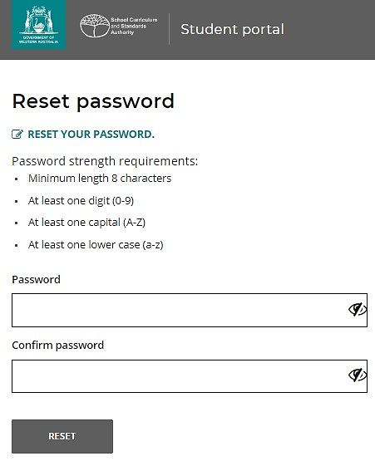

Complete your Student Declaration and Permission
After you have set up your new password, if you are in Year 12, you will be taken to the Student Declaration and Permission page, which includes information about compliance with the Western Australian Certificate of Education (WACE) requirements and rules as set out in the Year 12 Information Handbook and your awareness of the restrictions on eligibility to enrol in the ATAR EAL/D course.
Tick the check box (highlighted below) to confirm that you have read and understand the information, then click on the Submit button (highlighted below).
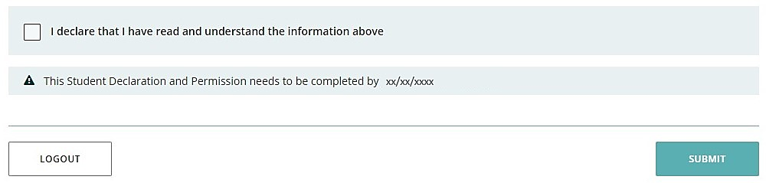
The SCSA also asks permission to use your results (should you win an award), and other
schoolwork (without identifying who you are) in media communications.
Click on either Yes or No (highlighted below) for each statement.
When you have responded to each statement, click on the Submit button (highlighted below) to enter the student portal.
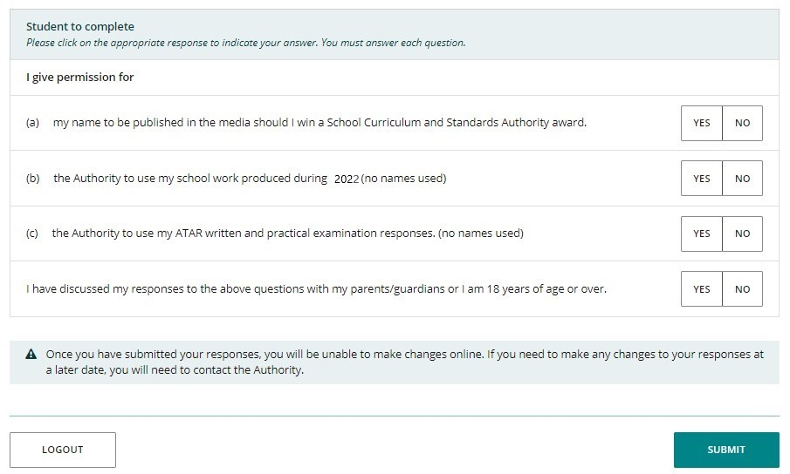

Returning to the student portal
The next time you log in to the student portal, you will only need to enter your WA student number and your new password in the login panel.

Step 2: Start your EAL/D eligibility application
To start your EAL/D application, click on the Applications tab in the green horizontal navigation bar and select EAL/D application from the drop-down list (highlighted below). This will take you to the first screen of the EAL/D eligibility application.
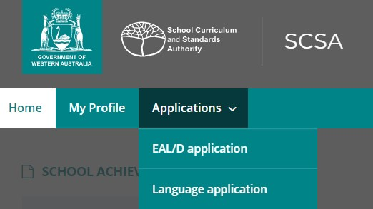

Your details
The personal details you will see cannot be changed as they have been provided by your school to the SCSA. If there are any errors, you must contact your school.
Click on the Start EAL/D application button (highlighted below), which will take you to 1: EAL/D application type.
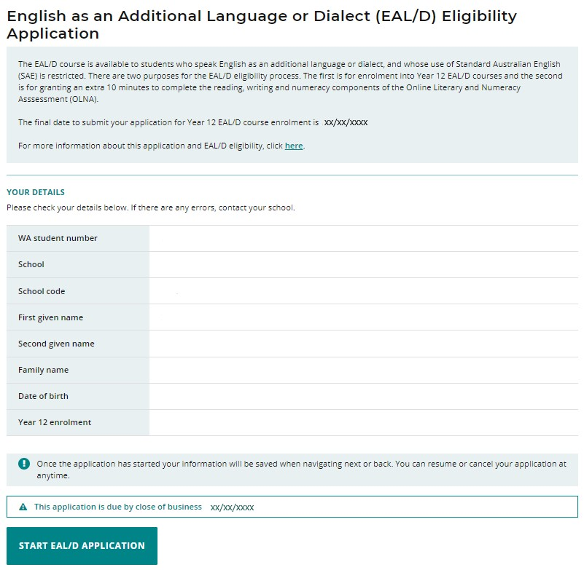

1: EAL/D application type
Select your EAL/D teacher’s name from the Select your EAL/D teacher drop-down list (highlighted below). If you do not see your teacher’s name, select My teacher is not listed here.
The purpose of the EAL/D eligibility application is pre-selected to Both (enrolment in Year 12 EAL/D and OLNA time extension) and the course type is pre-selected to ATAR.
Note: if you would like to apply to enrol in a General or Foundation EAL/D course, you do not need to submit an application to the SCSA. Speak to your school.
There are two criteria for EAL/D eligibility and you must select the one that is applicable to you. Usually, the first criterion (highlighted below) will apply.
Click on the Next button (highlighted below), which will take you to 2: Residential information. If you have not completed all the required information on this page, you will not be able to proceed.
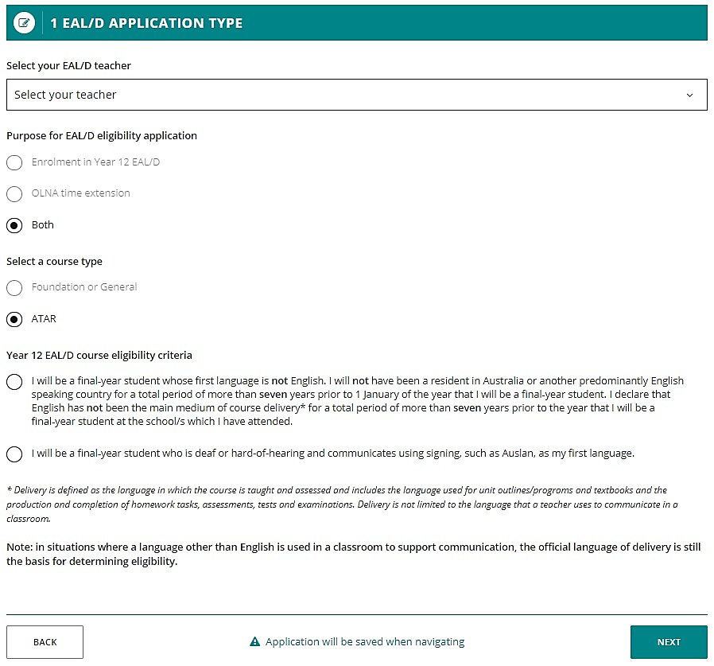
Note: each time you click on the Next or Back buttons, your application will be saved automatically (highlighted below). You can stop at any time and resume your application later (highlighted below).
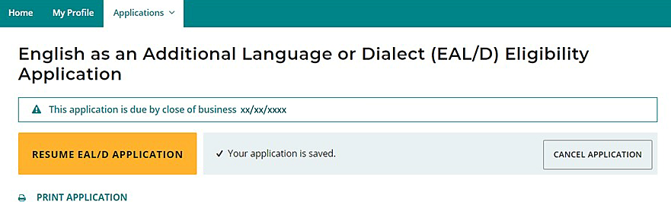

2: Residential information
Enter your country of birth and the overall time spent in a predominantly English-speaking country, using the calendar tool to select the number of years and months.
Note: predominantly English-speaking countries are those where English is the primary and/or official language.
Enter the country of birth of your mother and father (or carer/s).
Enter the countries where you have been a resident. These are countries where you have lived and not countries that you have visited on holiday.
Enter your current nationality, and the languages that are spoken at home (in order of frequency).
Click on the Next button (highlighted below), which will take you to 3: Educational background.
If you have not completed all the required information on this page, you will not be able to proceed.
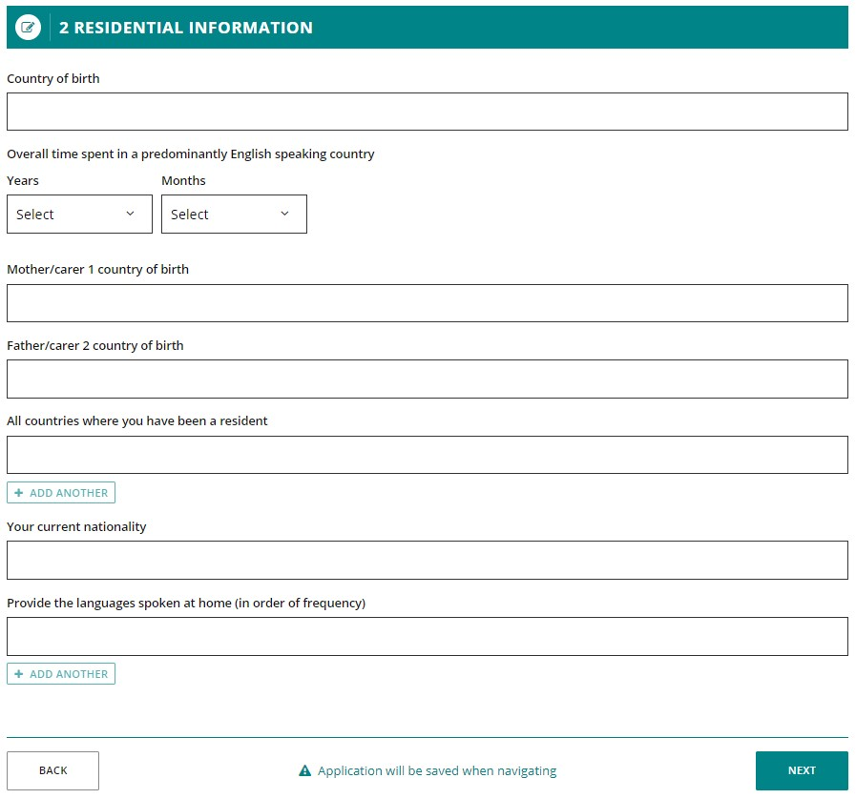

3: Educational background
Complete the table to provide information about all the schools you have attended.
Click on the Add button (highlighted below) next to a calendar year.
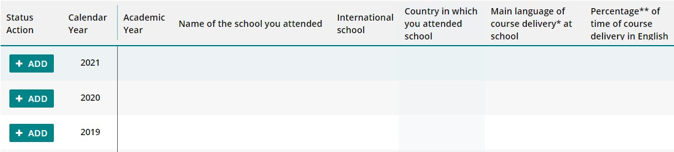
A school details box will appear. Select Yes or No to the question about school attendance in that calendar year.
If you select Yes, you must provide information for all the fields in that calendar year. Click on the Add button (highlighted below) to save these details for that school year.
Repeat the process until you have completed all calendar years.
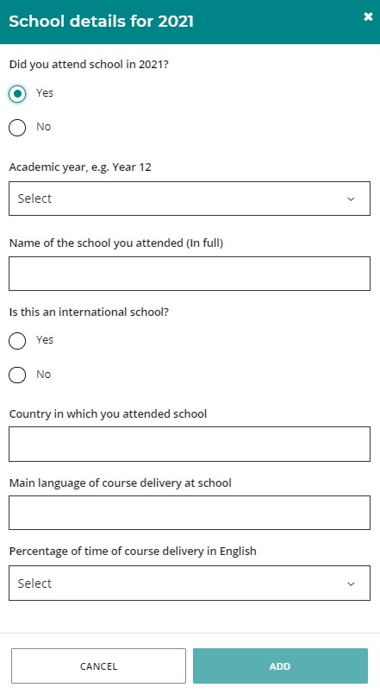
If you did not go to school in a calendar year, select No and click on the Add button (highlighted below). This will show as No schooling for that calendar year.
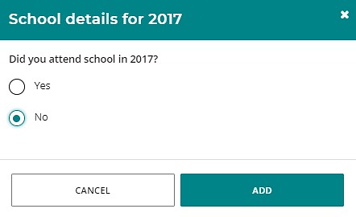
If your school was in a country where the school year ends in June or July (e.g. the UK or the USA), enter the academic year that you finished in that calendar year. For example, if you were in Year 9 from January to June or July, then in Year 10 from September to December, enter Year 9 because that was the academic year that you completed.
If you went to different schools in a calendar year, enter the school you went to in the first six months of that calendar year.
If you select Yes, that you attended an international school in a calendar year, this means that the school teaches an international curriculum, rather than the country’s national curriculum.
If you need to add further details about schools you attended, enter the information in the text box below the table.
Check all the information that you have entered. If you want to change anything, click on the Edit button (highlighted below).
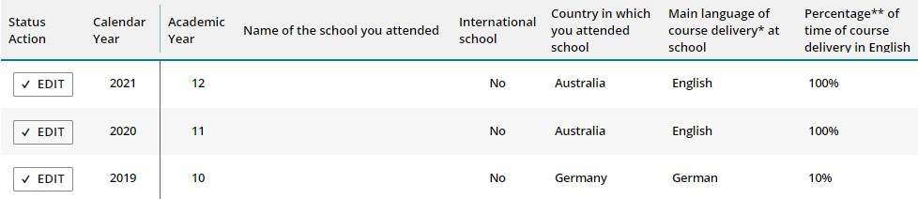
Indicate whether you plan to enrol in any other language course/s and, if so, you must provide the name and type of course (i.e. First Language, Background Language or Second Language).
Click on the Next button (highlighted below) to take you to 4: Supporting documents. If you do not complete all sections where indicated, you will not be able to proceed.
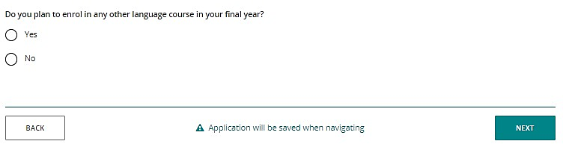

Step 3: Upload your supporting documents

4: Supporting documents
You are required to upload your passport identification page or identification card, and your school report/s as supporting documents.
The purpose of these supporting documents is to prove the following:
Supporting documents | Students studying in Australia | Students studying at a school outside Australia
Passport identification page or identification card | The student’s identity | The student’s identity
Date of entry stamp, visa or international movement record | How long the student has lived in Australia | N/A
School report | The main language of course delivery | The main language of course delivery

School reports
The school report is linked to the information provided in the educational background table.
If a student says that English was the main language of course delivery, the SCSA does not require a school report for that year. However, the SCSA does require the most recent school report from the last school attended where a language other than English was the main medium of course delivery.
A school report or academic transcript must be official and contain the name of the school, with the school stamp or seal and an authorised signature of a school representative.
The school report must also include the student’s name, the academic year, the subjects studied and grades or results achieved.
If more reports are required, the SCSA will request further information.
Photograph or scan each supporting document and save the files to your computer or mobile device. Your supporting documents must be saved as .pdf, .jpg, .jpeg or .png files, with a maximum size of 4MB for each file. Word documents will not be accepted.
You must use English letters to name your files.
Please do not use spaces or unrecognisable characters or symbols, such as < > ? ! / \ " * : , # % & ( ) { } + = @ when naming files.
Select the first document to upload from the drop-down list (highlighted below). Click on the Browse button (highlighted below) to select the file from your computer or mobile device and click on the Open button (Upload button on a Mac) to upload this file.
Repeat this process until you have uploaded all the required documents.
If you want to provide more information, select Other from the drop-down list, and upload another file. You may also enter details in the Additional information section (optional).
To remove a file, if you upload it by mistake, click on the Remove button next to the document.
Click on the Next button (highlighted below) to take you to Step 4: Submit your EAL/D eligibility application.
If you have not uploaded all the required documents, you will not be able to proceed.
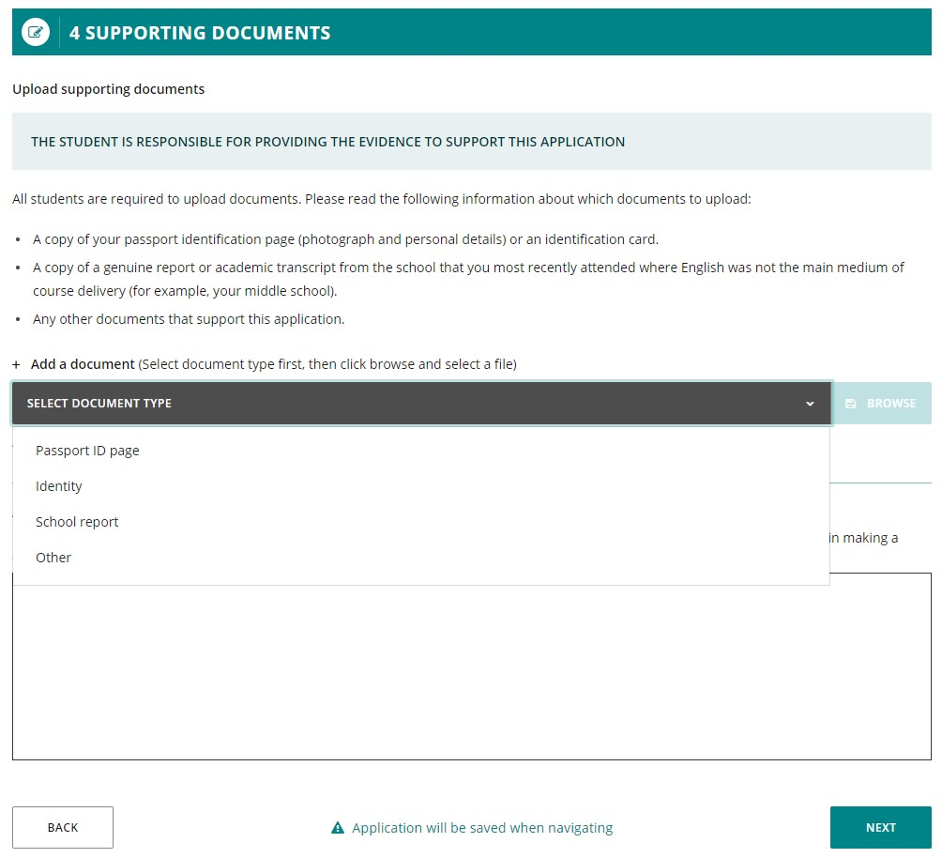

Step 4: Submit your EAL/D eligibility application
Click on the Print application button to print your application and check that all the information is correct. Click on the Back button to make any changes, if required.
Note: after you have submitted your application, you will not be able to change anything until it is reviewed by the SCSA.
Read the student declaration and tick the check box (highlighted below) to confirm that you have provided the requested documents and that, to the best of your knowledge, all the information you have provided is true and correct.
Click on the Submit application button (highlighted below) so that the SCSA can assess your EAL/D eligibility.
Note: your application cannot be processed until you click on the Submit application button.
When you have submitted your EAL/D eligibility application, your EAL/D teacher and your school principal will endorse your application.
Note: after you have submitted your application, you can click on the View or Print buttons to read or print your application.
If you decide to cancel your application, click on the Cancel application button (highlighted below) before you submit it.
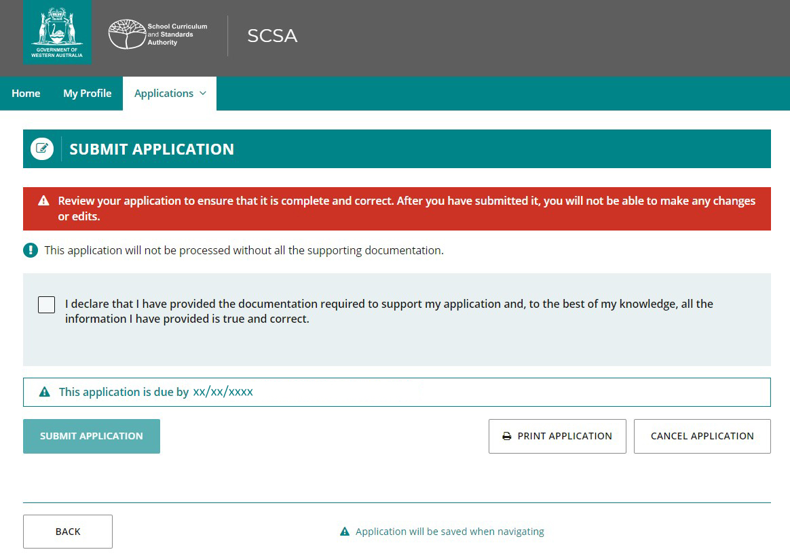

Amend your EAL/D eligibility application
The SCSA will review your EAL/D eligibility application and supporting documents. If the SCSA requires further information or amendment/s to be made to your application, you will receive an email asking you to correct the highlighted fields (highlighted below). Your school will also receive an email.
Log back in to the student portal where you will see the amendment request.
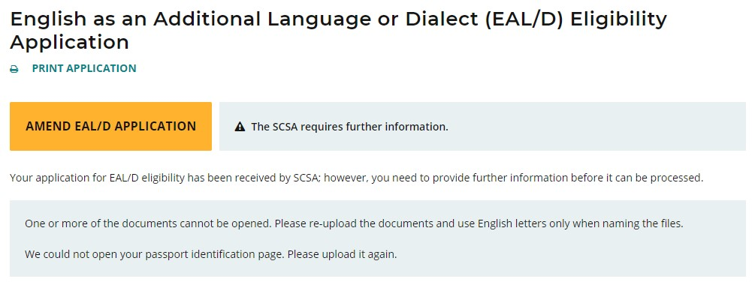
Click on the Next button to move through the application.
You will only be able to change the information identified by the reviewer, which will be highlighted in yellow (example highlighted below).
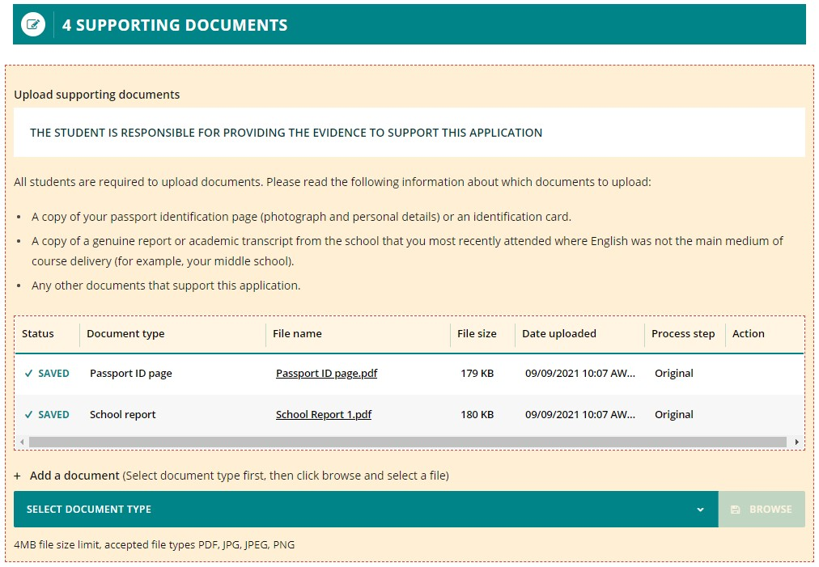
When you have amended your application as requested, you will need to repeat Step 4: Submit your EAL/D eligibility application to submit your amended application.
Note: your amended application cannot be processed until you click on the Submit application button.

Step 5: Check the student portal for your EAL/D eligibility status
You can check the student portal for the SCSA’s decision about your EAL/D eligibility status. This will usually occur between one and five business days after submission. The status of your application will change from In progress to either Eligible or Not eligible.
In progress (highlighted below)
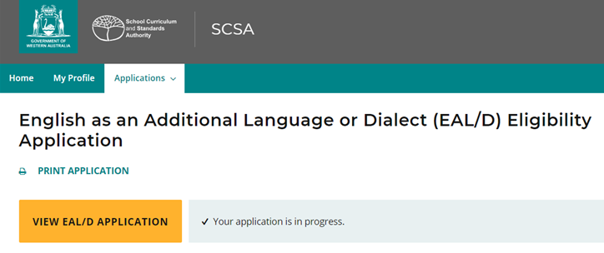
Eligible (highlighted below)
Not eligible (highlighted below)
The SCSA will email the outcome to your school. You can contact your school for further information about this decision.

Review and appeal processes

Request a review
If the SCSA decides that you are Ineligible to enrol, this will be shown in the student portal (highlighted below). If you think that you do meet the criteria, you can request a review of your EAL/D eligibility application by the SCSA. You must do this before the due date, which is shown on the EAL/D notification screen in the student portal.
Note: the review and appeal due dates are also published in the Activities Schedule. If you have any questions, contact your school.
To request a review, click on the Request review button (highlighted below).
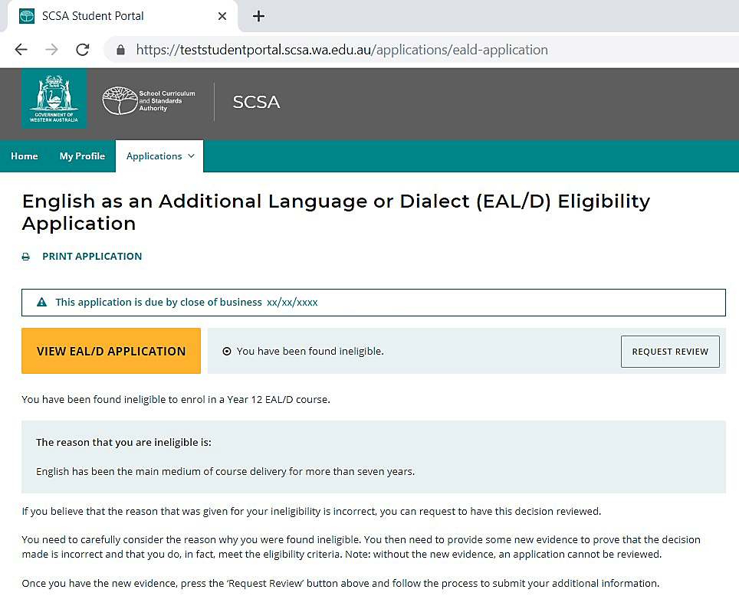
To show that you meet the criteria, you will need to provide additional evidence, by photographing or scanning one or more documents not previously submitted, uploading it/them, and/or typing in additional information. Carefully check your document/s and/or comment/s that you provide because, after submission, you cannot upload other documents or make changes. You can view them in read-only mode.
Once you have uploaded all supporting document/s, click on the Submit button. If you have not uploaded at least one additional document, or provided a comment, the request for a review cannot be submitted.
Note: you can only request one review and it cannot be processed until you click on the Submit button.
The SCSA will review your application and all additional documents and/or supporting evidence. After the review has been completed, the SCSA will notify your school by email, stating the outcome of the review. You can also see the outcome of the review in the student portal. The review eligibility status will be either Eligible or Ineligible and you will see a comment explaining the decision.

Request an appeal
Following the review of your EAL/D eligibility application, if the SCSA decides that you are still Ineligible to enrol (highlighted below), this will be shown in the student portal. After the review has been completed, you can request an appeal by an external EAL/D Eligibility Appeal Panel. You must do this before the due date, which is shown on the EAL/D notification screen in the student portal.
Note: the review and appeal due dates are also published in the Activities Schedule. If you have any questions, contact your school.
To request an appeal of your EAL/D eligibility application, click on the Request appeal button (highlighted below).
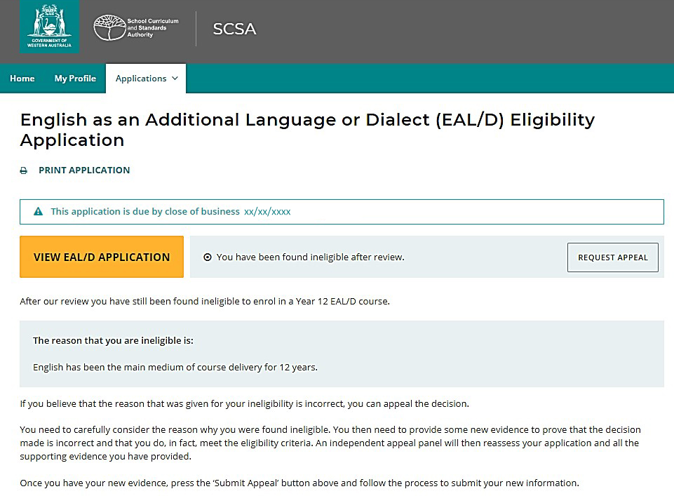
To show that you meet the criteria, you will need to provide additional evidence, by photographing or scanning one or more documents not previously submitted, uploading it/them, and/or typing in additional information. Carefully check the document/s and/or comments that you provide because, after submission of the request, you cannot upload other documents or make changes.
Once you have uploaded all supporting document/s, click on the Submit button. If you have not uploaded at least one additional document, or provided a comment, the request for an appeal cannot be submitted.
Notes: you can only request one appeal and it cannot be processed until you click on the Submit button.
The EAL/D Eligibility Appeal Panel will review your application and all additional documents and/or supporting evidence that you provided for the review and the appeal. After the appeal has been completed, the SCSA will notify your school by email, stating the outcome of the appeal. You can also see the outcome of the appeal in the student portal. The appeal eligibility status will be either Eligible or Ineligible and you will be able to view a comment explaining the decision. At this point, you should contact your school to discuss your study options.

