Guide for online registration of Small Group Moderation partnerships
All schools are required to register their participation or non-participation in small group moderation (SGM) with the School Curriculum and Standards Authority (the Authority) using the online registration link located on the Authority website at https://senior-secondary.scsa.wa.edu.au/moderation/small-group-moderation.
As outlined in section 3.6 of the WACE manual, a school must become involved in a small group moderation partnership where it has a projected number of fewer than six ATAR course examination candidates in an ATAR course. Please note that:
- each small group moderation partnership registered by your school must have been confirmed with all other schools in the partnership
- each school in the partnership must submit their online registration to the Authority before the partnership can be recorded in the Student Information Records System (SIRS)
- partner schools must use an identical Assessment Outline (typically developed collaboratively)
- courses with one student enrolled are still required to form a small group moderation partnership due to the potential statistical risks involved
- the due date to register small group moderation partnerships, or non-participation is Thursday, 8 February 2024.
All schools must complete questions 1–5.
A school not involved in small group moderation, selects No for question 5, then selects Next.
The Principal will receive an email to submit their online declaration.
This is the end of the online registration process for a school not involved in small group moderation.
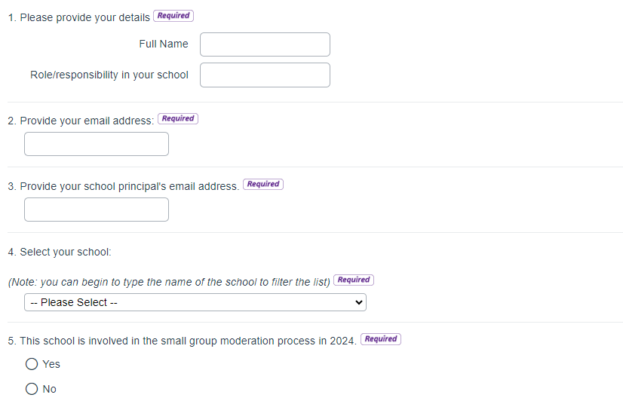

A school that is involved in SGM selects Yes for question 5, then Next, and either one or both options for question 6. Complete question 7 by answering either Yes this is a new registration for 2024 or No this is an update to an existing registration for 2024 if the partner school’s, your school’s teacher or candidate numbers have changed.
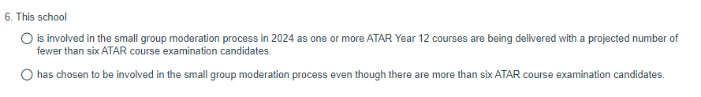
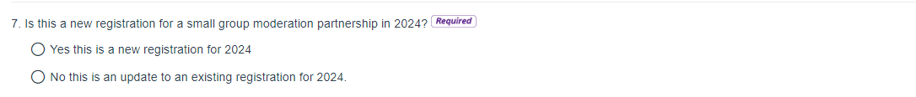
Complete questions 8–10, selecting each ATAR course that is to be registered for small group moderation.
Note: Question 10 will only be displayed if Yes is answered for question 9.
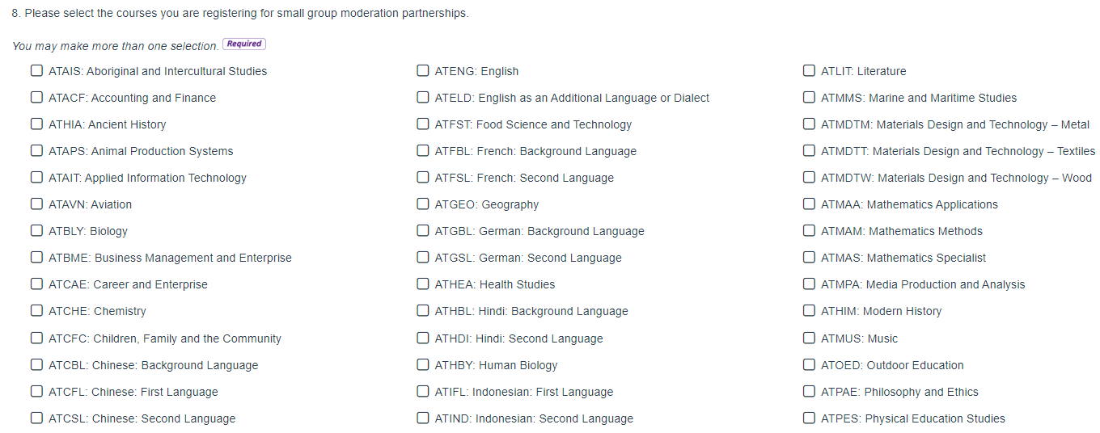
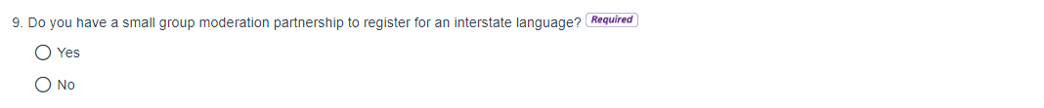
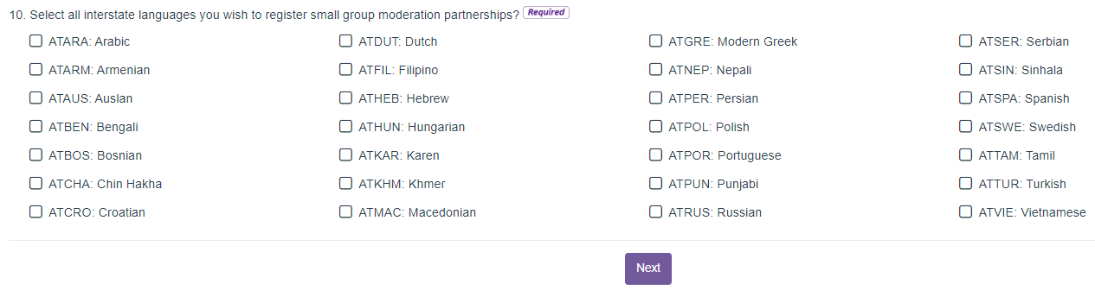

Complete questions 10–13 for each ATAR course small group moderation partnership your school is involved in:
- name and email address of the teacher at your school delivering the course
- number of other schools (excluding your school) in the partnership
- if the course is part of one of the CEWA ViSN or ASC networks, or NA if not applicable
- number of ATAR course examination candidates at your school
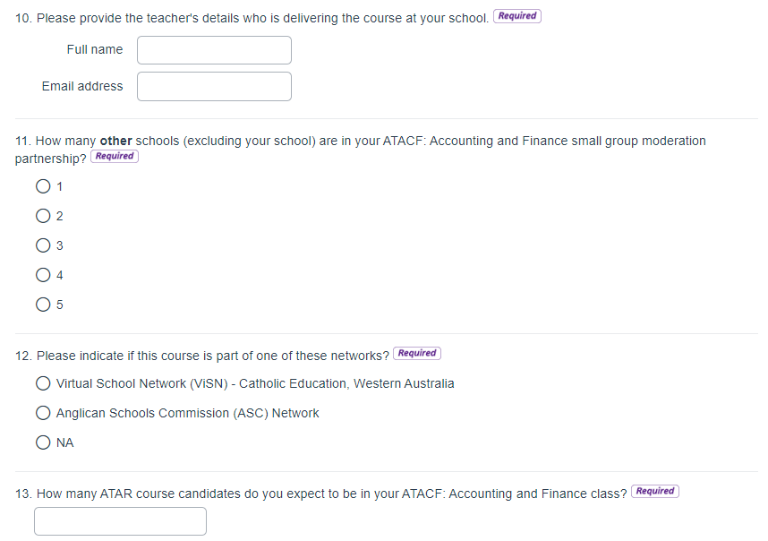
Complete question 14 onwards, (depending on how many partner schools selected in question 11) by selecting the name of each partner school. Provide further details about the partnership if necessary, including if there are more than five other schools in your small group partnership; the details can be listed in the text box. Select Next.
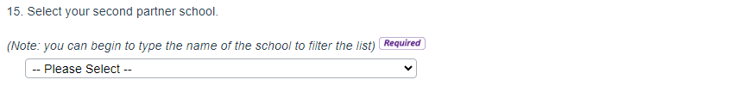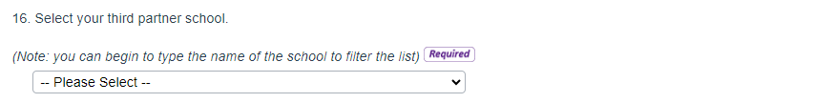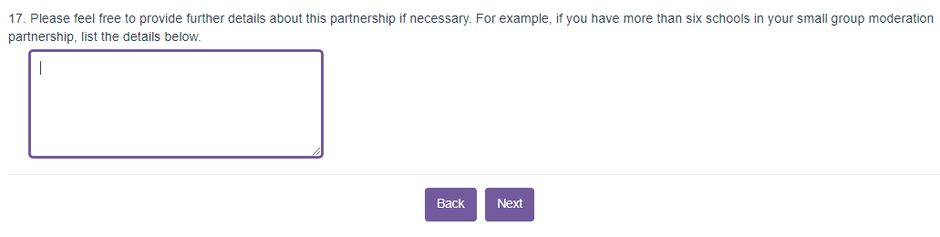
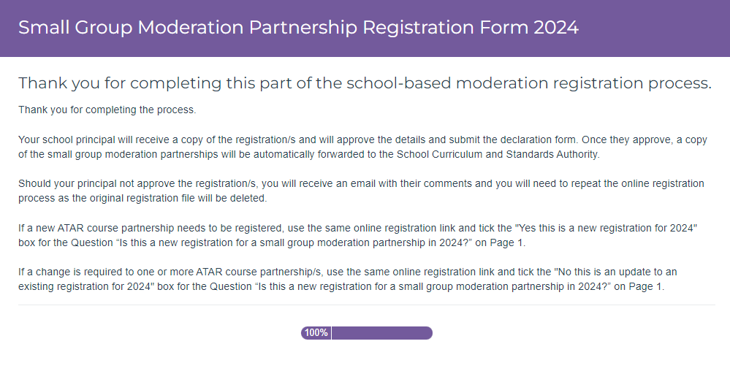
The Principal will receive an email to confirm the small group moderation partnership/s registered and to submit their online declaration as shown below. Upon the Principal’s approval you will receive an email with a PDF attachment of the ATAR course partnerships registered.
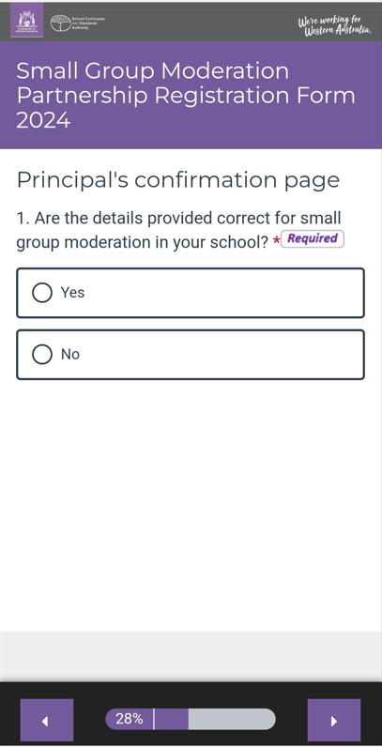 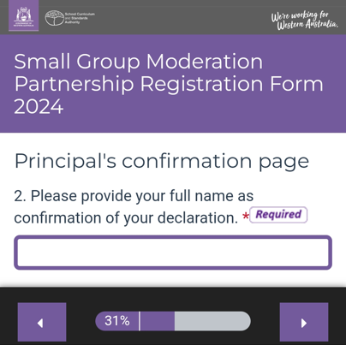 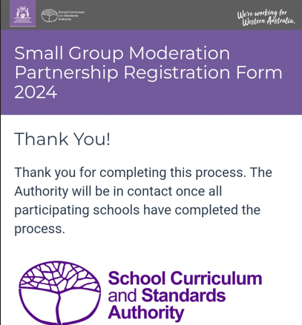
Should the Principal not approve the partnership/s registered, you will receive an email with their comments and a PDF copy of the partnerships to repeat the online registration process.
This is the end of the online registration process for a school involved in small group moderation.
Prior to Thursday, 8 February 2024
- if a new ATAR course partnership has been established since the Principal submitted their approval, use the online registration link to enter the new partnership and tick Yes this is a new registration for 2024 for the question Is this a new registration for a small group moderation partnership in 2024? on page 1.
- if there has been a change to either the teacher delivering the course or number of examination candidates at your school, or to the partner schools, use the online registration link to re-enter the partnership and tick No this is an update to an existing registration for 2024 for the question Is this a new registration for a small group moderation partnership in 2024? on page 1. Note: each school in the partnership which has changed are to re-enter the updated partnership details for the course.
After Thursday, 8 February 2023
- small group moderation partnership data for your school will be collated, entered into SIRS and an email sent to the Principal in due course to advise that the details are ready for review.
Queries regarding comparability of school marks between partner schools should be directed to Adriana Douglas on 9273 6784 or email Adriana.Douglas@scsa.wa.edu.au
Queries regarding partnership details or the online registration process should be directed to Robyn Whisson on 9273 6367 or email Robyn.Whisson@scsa.wa.edu.au

